Improvement Programme for England’s Natura 2000 Sites (IPENS) – Planning for the Future IPENS027
Condition monitoring of the saltmarsh feature of The Wash and the North Norfolk Coast SAC: Volume 1 - The Wash

The Wash and North Norfolk Coast Special Area of Conservation (SAC)



www.gov.uk/government/publications/improvement-programme-for-englands-natura-2000-sites-ipens
First published 30 October 2015

This project is part of the IPENS programme (LIFE11NAT/UK/000384IPENS) which is financially supported by LIFE, a financial instrument of the European Community.
Foreword

The Improvement Programme for England’s Natura 2000 sites (IPENS), supported by European Union LIFE+ funding, is a new strategic approach to managing England’s Natura 2000 sites. It is enabling Natural England, the Environment Agency, and other key partners to plan what, how, where and when they will target their efforts on Natura 2000 sites and areas surrounding them.

As part of the IPENS programme, we are identifying gaps in our knowledge and, where possible, addressing these through a range of evidence projects. The project findings are being used to help develop our Theme Plans and Site Improvement Plans. This report is one of the evidence project studies we commissioned.

Field surveys of the saltmarsh habitat within The Wash and North Norfolk Coast Special Area of Conservation (SAC) were conducted in 2013. The area was surveyed between The River Nene and Gibraltar Point (Skegness).

The aim of the project was to carry out a National Vegetation Classification (NVC) survey and map the saltmarsh plant communities in order to provide evidence for assessing changes within the site and to be able to monitor future changes. Details on management, habitat quality, and issues currently impacting on, or with the potential to impact on features were recorded.

The report identifies changes within the site, such as a decrease in percentage cover of the Annex I habitat ‘Salicornia and other annuals colonising mud and sand’ since 2001/2002. This reduction in pioneer communities may be as a result of erosion at the saltmarsh edge. Other Annex I habitats, such as ‘Mediterranean and thermo-Atlantic halophilous scrubs’, which is a rare habitat in the Wash, have increased in percentage cover.

The study area showed evidence of light to moderate cattle grazing. At all survey points, the vegetation community maintained good structural diversity and the sequence of saltmarsh zonation was intact. The impact was most pronounced close to the seawall where intensity of poaching was higher. Footpaths and recreational access was evident throughout the marsh, but tracks were not heavily worn.

Issues identified within the report have been incorporated into The Wash and North Norfolk Coast Site Improvement Plan.

The key audience for this work is the staff within Natural England and land managers and it will be used to inform management requirements within the site.

Natural England Project officer: Fiona Tibbitt, fiona.tibbitt@naturalengland.org.uk

This publication is published by Natural England under the Open Government Licence v3.0 for public sector information. You are encouraged to use, and reuse, information subject to certain conditions. For details of the licence visit Copyright.
Please note: Natural England photographs are only available for non-commercial purposes. For information regarding the use of maps or data visit www.gov.uk/how-to-access-natural-englands-maps-and-data.
ISBN 978-1-78354-220-8
© Natural England and other parties 2015



Condition monitoring of the saltmarsh feature of The Wash and the North Norfolk Coast SAC: Volume I - The Wash

Client: Natural England
Address: 2nd Floor, Dragonfly House
2 Guilders Way
Norwich
NR3 1UB
Date of Issue: December 2013
Project Manager: Fiona Tibbitt
Report Author/s: Josh Hellon
Field Team: Jonathan Graham
Daryl Robinson
Stephanie Clarke
GIS: Patrick Rickerby

Prepared by:
Ahern Ecology Ltd. 13 Hurricane Close Old Sarum, Salisbury Wiltshire, SP4 6LG Company no. 7289155
Website: www.ahernecology.co.uk Email: info@ahernecology.co.uk Telephone: 01722 580008

Acknowledgements
We would like to thank members of Natural England for their assistance with access and survey planning. Thanks are extended to Fiona Tibbitt and Jennifer Fincham of Natural England for their project management input.
Jonathan Graham, Stephanie Clarke and Daryl Robinson provided expert assistance with the field surveys and invaluable input to planning and reporting.

Summary
Field surveys using combined Common Standards Monitoring (CSM) and National Vegetation Classification (NVC) methodology were conducted in the saltmarsh habitat of The Wash Special Area of Conservation (SAC) during July 2013. The area was surveyed between The River Nene and Gibraltar Point (Skegness). This report presents the results of these surveys.
This project is part of the IPENS programme (LIFE11NAT/UK/000384IPENS) which is financially supported by LIFE, a financial instrument of the European Community. LIFE+, is a new strategic approach to managing England's Natura 2000 sites. It will enable Natural England, the Environment Agency, and other key partners to plan what, how, where and when they will target their efforts on Natura 2000 sites and on land surrounding them. www.naturalengland.org.uk/ipens2000.
The Wash was previously surveyed in 2001/2002 by Posford Haskoning; reported as ‘NVC Survey of Saltmarsh and Other Habitats in The Wash European Marine Site Volume 2’ (Posford Haskoning, 2003). The aim of the 2013 survey was to survey and map the saltmarsh plant communities of the SAC, repeating 14 transect locations from 2001/2002, and additional transects. NVC quadrat data was collected to characterise plant communities at all sites. Field data was processed using MAVIS software (CEH, 2000) to assign NVC communities.
In total, 22 transects were surveyed during 2013, with 640 quadrats recorded and used to construct floristic tables to describe vegetation communities. Target notes were taken at all sites recording points of interest, community transitions and saltmarsh extent. Points of interest included significant saltpans, large creeks, and evidence of management/grazing. Vegetation communities and sub-communities were presented as colour-coded transects on a 1:10,000 OS basemap of the survey site.
Saltmarsh communities recorded included SM6 Spartina anglica saltmarsh community, SM8 Annual Salicornia saltmarsh community, SM10 Transitional low-marsh vegetation with Puccinellia maritima, annual Salicornia species and Suaeda maritima, SM11 Aster tripolium var. discoideus saltmarsh, SM13 Puccinellia maritima saltmarsh community, SM14 Halimione portaculoides saltmarsh community, SM23 Spergularia marina - Puccinellia distans saltmarsh community, SM24 Elymus pycnanthus saltmarsh community, SM25 Suaeda vera drift-line community. Several nationally Notable/Scarce plant species were found during the surveys, including Suaeda vera, Sarcoconia perennis, Limonium humile and Hordeum marinum.

Contents
Acknowledgements 1
Summary 2
List of figures 4
List of tables 6
1. Introduction 10
1.1. Background information 10
1.2. Project aims and objectives 12
Aims 12
Objectives 12
2. Methodology 13
2.1. Personnel, timing and access 13
2.2. Survey location 14
2.3. Transects 16
2.4. Quadrats 17
2.5. Nomenclature and NVC data 18
Field identification limitations 18
Interpretation of NVC data 19
2.6. GIS mapping 20
2.7. Survey limitations 20
3. Results 20
3.1. Transect maps and target notes 20
Area 1 – Snettisham Scalp to River Great Ouse 20
Area 2 – River Great Ouse to River Nene 29
Area 3 – River Nene to Lawyers Creek 37
Area 4 – Lawyers Creek to The Haven 48
Area 5 – The Haven to the Horseshoe 51
Area 6 – The Horseshoe to Gibraltar Point 65
Area 7 – Gibraltar Point to Skegness 75
3.2. NVC communities identified 81
SM6 Spartina anglica saltmarsh community Spartinetum townsendii (Tansley 1939) Corillion 1953 81
SM8 Annual Salicornia saltmarsh community Salicornietum europaeae Warming 1906 83
SM10 Transitional low-marsh vegetation with Puccinellia maritima, annual Salicornia species and Suaeda maritima 86
SM11 Aster tripolium var. discoideus saltmarsh community Asteretum tripolii Tansley 1939 & SM12 Rayed Aster tripolium on saltmarshes 95
SM13 Puccinellia maritima saltmarsh community Puccinellietum maritimae (Warming 1906) Christiansen 1927 97
SM14 Halimione portaculoides saltmarsh community Halimionetum portulacoidis (Kuhnholtz-Lordat 1927) Des Abbayes & Corillion 1949 103
SM23 Spergularia marina - Puccinellia distans saltmarsh community Puccinellietum distantis Feekes (1934) 1945 111
SM24 Elymus pycnanthus saltmarsh community Atriplici-Elymetum pycnanthi Beeftink & Westhoff 1962 112
SM25 Suaeda vera drift-line community Elymo pycnanthi - Suaedetum verae (Arènes 1933) Géhu 1975 116
3.3. Local and Nationally scarce species 119
3.4. Comparison with 2001/2002 Posford Haskoning surveys 126
Annex 1 habitats 126
Evidence of disturbance/damage 131
4. Conclusion 131
4.1. Summary of findings 131
5. Bibliography 132
Appendices 132
Appendix 1 Risk assessment 133
Appendix 2 Glossary 143
Appendix 3 Plant species list 144
Appendix 4 Local and Nationally Scarce Species 145

List of figures
Figure 2-1 Map of survey area and all survey sites showing transect start point 14
Figure 3-1 Transect map for NOB4 Wolferton 12/08/2013 21
Figure 3-2 Photographs of habitat features for NOB4 Wolferton 12/08/2013 (NOB4_376 Shingle area) 23
Figure 3-3 Transect map for NOB5 27/08/2013 24
Figure 3-4 Photographs of habitat features for NOB5 27/08/2013 (NOB5_782 From seawall with houseboat) 26
Figure 3-5 Transect map for NOC4 Wolferton/North Wootton 13/08/2013 27
Figure 3-6 Photographs of habitat features for NOC4 Wolferton/North Wootton (NOC4_386 Farm vehicle tracks at creek edge) 29
Figure 3-7 Transect map for NOD1 Terrington 14/08/2013 30
Figure 3-8 Photographs of habitat features for NOD1 Terrington 14/08/2013 (NOD1_482 Mudflats with sparse Salicornia agg) 32
Figure 3-9 Transect map for NOD4 Terrington 15/08/2013 33
Figure 3-10 Photographs of habitat features for NOD4 Terrington 15/08/2013 (NOD4_539 View of artificial mound from mudflats) 35
Figure 3-11 Transect map for L4A3 Terrington 19/08/2013 36
Figure 3-12 Photographs of habitat features for L4A3 Terrington 19/08/2013 (L4A3_551 SM24 community from seawall) 37
Figure 3-13 Transect map for L4B2 Gedney Drove End 19/08/2013 38
Figure 3-14 Photographs of habitat features for L4B2 19/08/2013 (L4B2_269 From seawall) 40
Figure 3-15 Transect map for L4C4 Holbeach 23/08/2013 (red triangles mark edge of military danger zone) 41
Figure 3-16 Photographs of habitat features for L4C4 Holbeach 23/08/2013 (L4C4_732 From seawall) 43
Figure 3-17 Transect map for L4C5 23/08/2013 44
Figure 3-18 Photographs of habitat features for L4C5 23/08/2013 (L4C5_1 From seawall) 45
Figure 3-19 Transect map for L4C5a 30/08/2013 46
Figure 3-20 Photographs of habitat features for L4C5a 30/08/2013 (L4C5a_901 From seawall) 48
Figure 3-21 Transect map for Frampton 22/08/2013 49
Figure 3-22 Photographs of habitat features for Frampton 22/08/2013 (Frampton_674 Seawall and flooded borrow pits) 51
Figure 3-23 Transect map for L3A3 Freiston 22/08/2013 52
Figure 3-24 Photographs of habitat features for L3A3 Freiston 22/08/2013 (L3A3_3 Heavily poached) 54
Figure 3-25 Transect map for L3A3a 30/08/2013 55
Figure 3-26 Photographs of habitat features for L3A3a 30/08/2013 (L3A3a_102 From seawall) 57
Figure 3-27 Transect map for L3A4 29/08/2013 58
Figure 3-28 Photographs of habitat features for L3A4 29/08/2013 (L3A4_46 From seawall, showing sea barley and poached area) 60
Figure 3-29 Transect map for L3A5 29/08/2013 61
Figure 3-30 Photographs of habitat features for L3A5 29/08/2013 (L3A5_861 From seawall showing borrow pit and track) 62
Figure 3-31 Transect map for L3B6 Wrangle 21/08/2013 63
Figure 3-32 Photographs of habitat features for L3B6 Wrangle 21/08/2013 (L3B6_344 Poached and grazed by cattle and humans) 65
Figure 3-33 Transect map for L3B7 Wrangle 21/08/2013 66
Figure 3-34 Photographs of habitat features for L3B7 Wrangle 21/08/2013 (L3B7_6445 From seawall) 67
Figure 3-35 Transect map for L3B8 28/08/2013 68
Figure 3-36 Photographs of habitat features for L3B8 28/08/2013 (L3B8_832 From seawall showing tarmac access road) 69
Figure 3-37 Transect map for L3C6 Wainfleet 21/08/2013 70
Figure 3-38 Photographs of habitat features for L3C6 Wainfleet 21/08/2013 (L3C6_622 From seawall – restricted area) 72
Figure 3-39 Transect map for L3C7 28/08/2013 73
Figure 3-40 Photographs of habitat features for L3C7 28/08/2013 (L3C7_16 From seawall) 75
Figure 3-41 Transect map for L3D5 Wainfleet 20/08/2013 76
Figure 3-42 Photographs of habitat features for L3D5 Wainfleet 20/08/2013 (L3D5_595 Dune community – not surveyed) 78
Figure 3-43 Transect map for Seacroft 22/08/2013 79
Figure 3-44 Photographs of habitat features for Seacroft 22/08/2013 (Seacroft_319 Flat area with L.binervosum) 80
Figure 3-45 Example quadrats for NVC community SM6 (Frampton_722) 81
Figure 3-46 Example quadrats for NVC community SM8 (L3A3_36) 84
Figure 3-47 Example quadrats for NVC community SM10 (L3D5_605) 87
Figure 3-48 Example quadrats for NVC community SM11/SM12 (L4A3 _582) 96
Figure 3-49 Example quadrats for NVC community SM13 (NOC4_402) 98
Figure 3-50 Example quadrats for NVC community SM14 (L4C4_761) 104
Figure 3-51 Example quadrats for NVC community SM23 (L3A4_54) 111
Figure 3-52 Example quadrats for NVC community SM24 (L3B7_6446) 113
Figure 3-53 Example quadrats for NVC community SM25 (NOB4_351) 117
Figure 3-54 Map showing location of local and nationally scarce species 119
Figure 3-55 Shrubby Sea Blite Suaeda vera 120
Figure 3-56 Perennial Glasswort Sarcocornia perennis 121
Figure 3-57 Lax-flowered Sea-lavender Limonium humile 122
Figure 3-58 Sea Barley Hordeum marinum 123
Figure 3-59 Salicornia species identified during surveys. Yellow Glasswort Salicornia fragilis furthest right 125
Figure 3-60 Map showing extent of saltmarsh feature in south-east area of The Wash 128
Figure 3-61Map showing extent of saltmarsh feature in north-western area of The Wash 129

List of tables
Table 1-1 Annex 1 saltmarsh habitats found within The Wash and North Norfolk Coast SSSI (JNCC 2005) 11
Table 2-1 Site locations showing transect start point and resurveyed transects 15
Table 2-2 Domin scale 17
Table 3-1 Transect target notes for NOB4 Wolferton 12/08/2013 22
Table 3-2 Transect target notes for NOB5 27/08/2013 25
Table 3-3 Transect target notes for NOC4 Wolferton/North Wootton 13/08/2013 28
Table 3-4 Transect target notes for NOD1 Terrington 14/08/2013 31
Table 3-5 Transect target notes for NOD4 Terrington 15/08/2013 34
Table 3-6 Transect target notes for L4A3 Terrington 19/08/2013 37
Table 3-7 Transect target notes for L4B2 Gedney Drove End 19/08/2013 39
Table 3-8 Transect target notes for L4C4 Holbeach 23/08/2013 42
Table 3-9 Transect target notes for L4C5 23/08/2013 45
Table 3-10 Transect target notes for L4C5a 30/08/2013 47
Table 3-11 Transect target notes for Frampton 22/08/2013 50
Table 3-12 Transect target notes for L3A3 Freiston 22/08/2013 53
Table 3-13 Transect target notes for L3A3a 30/08/2013 56
Table 3-14 Transect target notes for L3A4 29/08/2013 59
Table 3-15 Transect target notes for L3A5 29/08/2013 62
Table 3-16 Transect target notes for L3B6 Wrangle 21/08/2013 64
Table 3-17 Transect target notes for L3B7 Wrangle 21/08/2013 67
Table 3-18 Transect target notes for L3B8 28/08/2013 69
Table 3-19 Transect target notes for L3C6 Wainfleet 21/08/2013 71
Table 3-20 Transect target notes for L3C7 28/08/2013 74
Table 3-21 Transect target notes for L3D5 Wainfleet 20/08/2013 77
Table 3-22 Transect target notes for Seacroft 22/08/2013 80
Table 3-23 NOC4 Wolferton SM6 82
Table 3-24 NOD1 Terrington SM6 82
Table 3-25 Frampton SM6 82
Table 3-26 L3A3a SM6 82
Table 3-27 L3A5 SM6 83
Table 3-28 NOB4 Wolferton SM8 84
Table 3-29 NOB5 SM8 84
Table 3-30 NOD1 Terrington SM8 84
Table 3-31 NOD4 Terrington SM8 85
Table 3-32 L4C5a SM8 85
Table 3-33 L3A3 Freiston SM8 85
Table 3-34 L3A4 SM8 85
Table 3-35 L3B7 Wrangle SM8 85
Table 3-36 L3B8 SM8 86
Table 3-37 L3C6 Wainfleet SM8 86
Table 3-38 L3D5 Wainfleet SM8 86
Table 3-39 L3A3a SM8 86
Table 3-40 NOB4 Wolferton SM10 87
Table 3-41 NOD4 Terrington SM10 88
Table 3-42 L4B2 Gedney Drove End SM10 89
Table 3-43 L4C4 Holbeach SM10 89
Table 3-44 L4C5a SM10 89
Table 3-45 L3A3 Freiston SM10 90
Table 3-46 L3A3a SM10 91
Table 3-47 L3A4 SM10 91
Table 3-48 L3B6 Wrangle SM10 92
Table 3-49 L3B7 Wrangle SM10 93
Table 3-50 L3C7 SM10 94
Table 3-51 L3D5 Wainfleet SM10 95
Table 3-52 Seacroft SM10 95
Table 3-53 NOD1 Terrington SM11/12 96
Table 3-54 NOD4 Terrington SM11/12 97
Table 3-55 L4A3 SM11/12 97
Table 3-56 Frampton SM11/12 97
Table 3-57 NOB4 Wolferton SM13b 98
Table 3-58 NOB5 SM13a 99
Table 3-59 NOC4 Wolferton SM13a 99
Table 3-60 NOD1 Terrington SM13a 100
Table 3-61 NOD4 Terrington SM13a 100
Table 3-62 L4A3 SM13a 101
Table 3-63 L4B2 Gedney Drove End SM13a 101
Table 3-64 L4C4 Holbeach SM13a 102
Table 3-65 L3A5 SM13c 102
Table 3-66 L3A5 SM13 102
Table 3-67 L3B6 Wrangle SM13c 103
Table 3-68 L3B8 SM13a 103
Table 3-69 NOB4 Wolferton SM14a 104
Table 3-70 NOB5 SM14 105
Table 3-71 NOC4 Wolferton SM14c 105
Table 3-72 NOD4 Terrington SM14c 105
Table 3-73 L4B2 Gedney Drove End SM14 105
Table 3-74 L4B2 Gedney Drove SM14c 106
Table 3-75 L4C4 Holbeach SM14 106
Table 3-76 L4C5 SM14a 106
Table 3-77 L4C5a SM14 107
Table 3-78 Frampton SM14 107
Table 3-79 Frampton SM14a 107
Table 3-80 L3A3a SM14 107
Table 3-81 L3A4 SM14 108
Table 3-82 L3A5 SM14c 108
Table 3-83 L3B6 Wrangle SM14c 109
Table 3-84 L3B8 SM14c 109
Table 3-85 L3C6 Wainfleet SM14c 110
Table 3-86 L3C6 Wainfleet SM14a 110
Table 3-87 Seacroft SM14a 111
Table 3-88 L3A4 SM23 112
Table 3-89 NOB4 Wolferton SM24 113
Table 3-90 NOB5 SM24 113
Table 3-91 NOC4 Wolferton SM24 114
Table 3-92 NOD1 Terrington SM24 114
Table 3-93 NOD4 Terrington SM24 114
Table 3-94 L4A3 SM24 114
Table 3-95 L4B2 Gedney Drove End SM24 114
Table 3-96 L4C4 Holbeach SM24 115
Table 3-97 L4C5 SM24 115
Table 3-98 L4C5a SM24 115
Table 3-99 Frampton SM24 115
Table 3-100 L3A3a SM24 115
Table 3-101 L3A5 SM24 116
Table 3-102 L3B7 Wrangle SM24 116
Table 3-103 L3C6 Wainfleet SM24 116
Table 3-104 L3D5 Wainfleet SM24 116
Table 3-105 NOB4 Wolferton SM25 118
Table 3-106 NOD4 Terrington SM25b 118
Table 3-107 Total transect length and percentages of NVC communities and Annex 1 habitats in The Wash during 2013 surveys 126
Table 3-108 Comparison of total percentages of Annex 1 habitats in The Wash between Posford (2003) and 2013 surveys 127
Table 0-1 List of saltmarsh plants identified during surveys 144
Table 0-2 Location data for notable plant species 145

Introduction

Background information
The Wash is located on the east coast of England (TF 550400) and is the largest estuarine system in the UK. It is fed by the rivers Witham, Welland, Nene and Great Ouse that drain much of the east Midlands of England. The area comprises very extensive saltmarshes, major intertidal banks of sand and mud, shallow waters and deep channels (JNCC 2001).
This designated Special Area of Conservation (SAC) forms part of The Wash and North Norfolk Coast European Marine Site EMS. It is also a Site of Special Scientific Interest (SSSI) notified under Section 28 of the Wildlife and Countryside Act 1981. The Wash is also classified as an SPA (1988) and Ramsar site (1988). The whole area is of exceptional biological interest. The saltmarsh communities are of considerable botanical interest and the mature saltmarsh is a valuable bird breeding zone. In addition, the area is also very important as a breeding ground for harbour seals (English Nature, 1981).
The habitats within this site are highly sensitive to inorganic fertilisers and pesticides, and their use within and adjacent to the site should either be avoided or carefully controlled. Recreational activities and access are managed to avoid harmful impacts (English Nature 2005). The intertidal zone is being threatened from coastal squeeze as a result of land-claim and coastal defence works as well as sea-level rise and storm-surges. Changes in the sediment budgets also threaten these habitats (JNCC 2005). The saltmarshes of The Wash are also traditionally grazed by cattle. The operations considered likely to damage the saltmarsh element of the site include (Natural England 1981):
- The introduction of grazing and changes in the grazing regime, including type of stock or intensity,seasonal pattern of grazing and cessation of grazing;
- The release into the site of any wild, feral or domestic animal, plant or seed;
- Reclamation of land from sea, estuary or marsh;
- Erection of sea defences or coast protection works;
- Construction, removal or destruction of roads, tracks, walls, fences, hardstands, banks, ditches or other earthworks;
- Use of vehicles or craft likely to damage or disturb features of interest;
- Recreational or other activities likely to damage features of interest such as saltmarsh and mudflats physically or by disturbance to wildlife.
There are three Annex I saltmarsh habitats that are a primary reason for selection of this site as an SAC (JNCC 2005):

Table 1-1 Annex 1 saltmarsh habitats found within The Wash and North Norfolk Coast SSSI (JNCC 2005)
Annex 1 Habitat | NVC comm | Description
Salicornia and other annuals colonising mud and sand | SM6  SM8  SM9 | The largest single area of this vegetation in the UK occurs at this site on the east coast of England, which is one of the few areas in the UK where saltmarshes are generally accreting. The proportion of the total saltmarsh vegetation represented by Salicornia and other annuals colonising mud and sand is high because of the extensive enclosure of marsh in this site. The vegetation is also unusual in that it forms a pioneer community with common cord-grass Spartina anglica in which it is an equal component. The inter-relationship with other habitats is significant, forming a transition to important dune, saltmeadow and halophytic scrub communities. (JNCC, 2005).
Atlantic salt meadows (Glauco-Puccinellietalia maritimae) | SM10  SM11  SM12  SM13  SM14  SM15  SM16  SM17 | This site on the east coast of England is selected both for the extensive ungrazed saltmarshes of the North Norfolk Coast and for the contrasting, traditionally grazed saltmarshes around The Wash. The Wash saltmarshes represent the largest single area of the habitat type in the UK. The Atlantic salt meadows form part of a sequence of vegetation types that are unparalleled among coastal sites in the UK for their diversity and are amongst the most important in Europe. Saltmarsh swards dominated by sea-lavenders Limonium spp. are particularly well-represented on this site. In addition to typical lower and middle saltmarsh communities, in North Norfolk there are transitions from upper marsh to freshwater reedswamp, sand dunes, shingle beaches and mud/sandflats (JNCC, 2005).
Mediterranean and thermo-Atlantic halophilous scrubs (Sarcocornetea fruticosi) | SM25  SM21 | The Wash and North Norfolk Coast, together with the North Norfolk Coast, comprises the only area in the UK where all the more typically Mediterranean species that characterise Mediterranean and thermo-Atlantic halophilous scrubs occur together. The vegetation is dominated by a shrubby cover up to 40 cm high of scattered bushes of shrubby sea-blite Suaeda vera and sea-purslane Atriplex portulacoides, with a patchy cover of herbaceous plants and bryophytes. This scrub vegetation often forms an important feature of the upper saltmarshes, and extensive examples occur where the drift-line slopes gradually and provides a transition to dune, shingle or reclaimed sections of the coast. At a number of locations on this coast perennial glasswort Sarcocornia perennis forms an open mosaic with other species at the lower limit of the sea-purslane community (JNCC, 2005).

Natural England has a duty to monitor and assess the condition of the saltmarsh features in order to report on the conservation status of the habitats once every six years. This report will provide data on the conservation status of habitats in 2013. It will provide monitoring data to enable reporting on the condition of the saltmarsh features of The Wash and North Norfolk Coast SAC. This information will support Natural England’s overall programme of monitoring and surveillance of the site into the future and will ultimately inform Natural England’s condition assessment for the site.
On the 5th December 2013 there was a major tidal surge along the East coast of the UK, exacerbated by exceptionally high tides and gale-force winds. It is likely that this will have led to wide-scale erosion of pioneer vegetation. This may have led to significant changes in saltmarsh extent and plant community structure since these surveys were completed.

Project aims and objectives

Aims
The aim of this project was to provide systematic descriptions of the saltmarsh plant communities present in The Wash, in order to provide data on the conservation status of habitats in 2013. This includes:
- Geographical extent of the saltmarsh feature and its sub-features;
- Physical structure – the patterns of creeks and pans;
- Vegetation composition – characteristic species for different zones, negative indicator species;
- Negative indicators found on site, pollution, poaching, landward constraints and drainage;
- Range of NVC saltmarsh communities present.

Objectives
The following objectives were agreed from the project brief and subsequent discussions with Natural England:
- To survey and map the saltmarsh plant communities of The Wash section of The Wash and North Norfolk Coast SAC. This required repeat surveys of all 14 transects surveyed by Posford Haskoning (2003) and additional transect locations, where considered appropriate. Quadrat data was to be collected to characterise NVC communities at all sites;
- To produce maps of all NVC communities and aggregated saltmarsh zones; including maps of the extent of the saltmarsh feature;
- To produce maps of Locally and Nationally Notable plant species and location of creeks and salt pans;
- To write a report including all maps, representative photographs, NVC floristic tables and target notes;
- To compare the data with the Posford Haskoning surveys and identify any obvious changes occurring within the saltmarsh habitats.
The findings of this report are the views of the surveyors and not necessarily the views of Natural England.

Methodology

Personnel, timing and access
All surveys were conducted over a three week period from 10th July to 30th July 2013. It was essential to complete surveys during this period due to potential disturbances to nesting birds in September. Surveys were conducted by two teams of two surveyors; with one experienced saltmarsh NVC surveyor in each team.
Health and safety is particularly important on saltmarshes and was considered when planning access to the sites and the location of each transect. Transects were planned (using existing maps and aerial photography) to avoid crossing large creeks and other hazardous areas. A thorough risk assessment was conducted (see appendix) and all staff had an on-site induction to make them aware of hazards.
All sites were surveyed by a two person team. This was considered essential due to the potential hazards of lone-working in this environment. In the event of an incident, this meant that one person was available to provide assistance or to make an emergency call. Each team called a supervisor when starting and completing each survey; providing an accurate NGR and access information.
Tide times were checked each day and, where possible, surveys were started at high tide. This enabled surveyors to work from seawall to seaward extent, following the ebbing tide. This meant that surveyors were unlikely to be cut off by creeks that had filled with water during the survey. During the survey period, surveyors experienced unusually high spring tides which restricted access at some sites.
Access to some sites was limited due to military activity, this limited access to the Holbeach area. However, following contact with the RAF, surveyors were able to conduct all planned transects.

Survey location
Figure 2-1 Map of survey area and all survey sites showing transect start point
Table 2-1 Site locations showing transect start point and resurveyed transects
Site ID | Posford Transect (2003) | Area (Posford, 2003) | Transect start point (NGR)
NOB4 Wolferton | Y | Area 1 | TF6508530343
NOB5 | N | Area 1 | TF6332329083
NOC4 Wolferton/North Wootton | Y | Area 1 | TF6116227247
NOD1 Terrington | Y | Area 2 | TF5707325879
NOD4 Terrington | Y | Area 2 | TF5435326320
L4A3 Terrington | Y | Area 2 | TF5022026658
L4B2 Gedney Drove End | Y | Area 3 | TF4796928643
L4C4 Holbeach | Y | Area 3 | TF4093233982
L4C5 | N | Area 3 | TF3492734244
L4C5a | N | Area 3 | TF3873735430
Frampton | Y | Area 4 | TF3611937808
L3A3 Freiston | Y | Area 5 | TF4017442019
L3A3a | N | Area 5 | TF4113143442
L3A4 | N | Area 5 | TF4253845661
L3A5 | N | Area 5 | TF4427448174
L3B6 Wrangle | Y | Area 5 | TF4606650255
L3B7 Wrangle | Y | Area 6 | TF4723850702
L3B8 | N | Area 6 | TF5036253480
L3C6 Wainfleet | Y | Area 6 | TF5177655103
L3C7 | N | Area 6 | TF5320056524
L3D5 Wainfleet | Y | Area 7 | TF5622157724
Seacroft | Y | Area 7 | TF5659760921

A total of 22 locations were surveyed, including the 14 Posford Haskoning (2003) transects and 8 additional sites. Access to the SW area between L4B2 Gedney Drove End and L4C4 Holbeach was restricted due to military activity. It was not possible to add any additional transects in this area. North of NOB4 Wolferton, there were no significant areas of saltmarsh until the North Norfolk coast area (surveyed separately). No additional transects were added in this area.
The Wash site was divided into 7 areas based on Posford Haskoning’s 2003 report:
- Area 1 – Snettisham Scalp to River Great Ouse;
- Area 2 – River Great Ouse to River Nene;
- Area 3 – River Nene to Lawyers Creek;
- Area 4 – Lawyers Creek to The Haven;
- Area 5 – The Haven to The Horseshoe;
- Area 6 – The Horseshoe to Gibraltar Point;
- Area 7 – Gibraltar Point to Skegness.

Transects
Survey methodology was based on JNCC Common Standards Monitoring Guidance for Saltmarsh Habitats (JNCC, 2004) with an additional NVC survey component. This was due to the fact that the surveys were designed to replicate the Posford survey technique. It was agreed with the client (Natural England, pers. comm.) that a structured walk was not required for these surveys. It was considered that vegetation structure, composition and negative indicators could be assessed during the transect surveys. Where possible, the existing Posford Haskoning (2003) transects were followed. Surveyors deviated from these transects where wide creeks prevented access. Surveyors continued beyond the end of these transects where saltmarsh vegetation continued seaward.
New transect locations were planned prior to fieldwork using aerial photography and 1:10,000 OS maps. These additional transects were located based on observation of suitable locations during surveys and from assessment of geographical gaps identified in historical surveys. These transects were planned to be as straight as possible, perpendicular to the seawall, allowing for diversions around uncrossable creeks.
All transects started at beginning of the saltmarsh community, at a point between the top and base of the seawall. At sites without an obvious seawall (L3D5 Wainfleet only), a point was identified that was considered the landward extent of saltmarsh vegetation. Surveys were conducted in a straight line to the seaward extent of plant growth; or as far as possible with consideration of wide creeks and sinking mud.
All surveys were conducted during outgoing/low tidal periods to ensure that the entire marsh extent could be surveyed.
A target note and photograph was taken at the start of each survey, at each point of interest or community transition and at the end of each survey. Points of interest included significant saltpans, large creeks, and evidence of management. The following were recorded at each stopping point:
- National Grid Reference (NGR) – 10 digit, accurate to 2-4m;
- Community information – simple visual estimates of the plant community and relative species composition;
- Biotic impacts - grazing or trampling/poaching by livestock, amenity use; management (fencing/tracks);
- Salt pans & large creeks;
- Nearby communities and creek edge communities.
At each perceived change in NVC community, 2-10 (usually 5) quadrats were taken. Where communities were represented by small patches, a lower number of quadrats were conducted.
Trimble Juno 5 mobile-mappers were used to record all survey data. ArcPad projects were created to enable surveyors to follow the route of the existing Posford transects in the field and to record all field data. 12 megapixel digital cameras were used for all photos.
Transect data is presented as individual tables for each transect detailing each target note with NVC community, NGR and photo reference.

Quadrats
Quadrat surveys were based on standard JNCC National Vegetation Classification (NVC) methodology (Rodwell, 2006). Five quadrats were taken within each homogenous vegetation stand identified during the transects. Where large areas of homogenous vegetation were present, the number of quadrats was increased. In small, isolated patches the number was reduced. Representative survey areas within stands were selected by the surveyors. Where the same community was encountered more than once at a site, it was surveyed separately. A standard 2m x 2m quadrat was used, considered suitable for short herbaceous vegetation (Rodwell, 2006). The following data was recorded for each quadrat:
- NGR – 10 digit, accurate to 2-4m;
- Species (or species aggregate);
- Abundance – for each species estimated using the Domin scale;
- Sward height – estimated mean height in centimetres;
- Photograph of quadrat area and photo reference.
The Domin scale was used to estimate percentage cover values for each taxon:
Table 2-2 Domin scale
Cover (%age) | Domin
91-100% | 10
76-90% | 9
51-75% | 8
34-50% | 7
26-33% | 6
11-25% | 5
4-10% | 4
<4% (many individuals) | 3
<4% (several individuals) | 2
<4% (few individuals) | 1

Due to structural overlap, in many cases the combined Domin value exceeded 100% cover.
A total of 640 quadrats were surveyed over the 22 survey sites in this study.

Nomenclature and NVC data
The plant species and habitat types identified during the surveys are listed in Appendix 3.

Field identification limitations
Due to the limitations of field identification, it was not possible to identify all specimens to species-level. The following issues were found with field identification of certain taxa:
- Spartina spp. All cord grass Spartina plants identified were the larger amphidiploid S.anglica, with softly hairy glumes and anthers 7-10um. The pollen of a large number of plants was also checked microscopically and all were >45um across (50-60) (Stace, 2010). However, it was not possible to check identification of all occurrences; therefore all cord grasses were recorded as Spartina agg.

- Aster tripolium. In the majority of areas it was very difficult to distinguish between the different forms of sea aster Aster tripolium (rayed or rayless), and Stace, 1997, does not make the distinction. Within this study, therefore, the rayless form of aster Aster tripolium var. discoideus and the rayed form Aster tripolium have been recorded as an aggregate, Aster tripolium agg.

- Limonium humile and Limonium vulgare. These are closely related species that grow on saltmarshes around the coasts of northern Europe including the British Isles. Both species occur within East Anglia and can occur as mixed stands within the same marsh. Distinguishing the two species in the field can be challenging as there is strong evidence for hybridization and introgression in sites where both species are present. In addition, one of the frequently cited discriminating characters in floral keys (that of spike length) is of debatable value in eastern England (Dawson & Ingrouille, 1995). Lax-flowered plants were recorded as L.humile in a number of quadrats. However, only a small proportion of these are likely to be L.humile as only a small proportion of collected material turned out to be L.humile (based on microscopic examination of pollen and stigmas). Consequently all plants were recorded as L. vulgare (incl. L.humile) unless confirmed as L. humile based on microscopic examination of flowers (Wainfleet and Gibraltar Point).

- Limonium binervosum. This species can be named as L.binervosum as it is the only species of the L.binervosum agg. that occurs in eastern England (Stace, 2010).

- Sarcocornia perennis. S.perennis was infrequent but recorded from a number of locations within transects and in at least one quadrat (lower marsh, Gibraltar Point). Notable populations were observed within the Bennington and Freiston areas. A small number of plants were observed flowering. The Posford Haskoning report (2003) appears to have included this species within the Salicornia agg. and a comment referring to this species invading and dominating local areas of saltmarsh is likely to be an identification error for large plants of the annual species Salicornia europaeus.

- Salicornia spp. Annual Salicornia species comprise an extremely difficult genus, the problems arising mainly from great phenotypic plasticity and the inbreeding nature of the plants, which tend to form numerous distinctive local populations (Stace, 2010). The survey did not record the single-flowered S.pusilla (usually associated with drier parts of saltmarshes). Purple Glasswort S.ramoisissima and Common Glasswort S.europaea were both recorded extensively. S.ramoisissima was most frequent within the upper marsh (particularly associated with pans adjoining the seaward toe of the main sea wall) occurring as the characteristic red pigmented form with strongly “beaded” stem segments. S. europaea generally occurs lower down the marsh below the S.ramoisissima zone where it can form a dominant cover extending to the lower limits of the marsh. Occasionally, such as at Freiston, S.ramoisissima was local and restricted to the extreme upper marsh. At Wolferton, the characteristic “shining green” form of S.ramoisissima was observed to extend to below the middle of the marsh. Recent work suggests that S.ramoisissima is not a distinct species from S.europaea (Stace, 2010) and indeed the two species were observed to intergrade morphologically at the middle parts of the salt marsh. Consequently, it would be prudent to record these species together (comprising >99% of Salicornia species seen) as S.europaea (incl. S ramoisissima). A small number of collected plants have been confirmed (by microscopic measurement of anthers) as the tetraploid Yellow Glasswort S.fragilis (a species historically recorded from Lincolnshire saltmarshes.). These robust, variably green or yellow/green plants (with immature anthers to 0.9mm) were confirmed from the Frieston and Wainfleet transects and are likely to be present in a few quadrats of the lower marsh. For NVC purposes, all annual Salicornia species were considered together as Salicornia agg.

Interpretation of NVC data
Field data was entered into MAVIS (CEH, 2000). This computer programme is designed to aid the process of assigning an NVC classification to vegetation samples by comparing the collected data with the diagnostic data held in the computer programme. MAVIS calculates the goodness-of-fit between survey data and NVC expected Domin and constancy values for each community type.
The output supplied by MAVIS was examined by hand to verify the communities and sub-communities. Quadrat data was compared with standard floristic tables from Rodwell (2000). Where the probability of group membership was low, or there were several equally probable communities, expert opinion was used above MAVIS outputs.
An issue was encountered with the functionality of MAVIS software, notably the omission of NVC scores for a common saltmarsh aggregate (Spartina agg.). This issue was solved by using an alternative name for the species for the purposes of calculation (Spartina anglica). The developer of the software (CEH) was informed of the omission and we were told that changes would be made to the next version (pers. comm.).
Constancy values from the MAVIS output followed conventional NVC usage (Rodwell, 2006), with percentage species frequency for each group of quadrats given a constancy class I-V (I=1-20%, II=21-40%, III=41-60%, IV=61-80%, V=81-100%). Floristic tables were drawn up for each group of quadrats. Simplified tables for the sites (without individual quadrat data) are presented in the results section. Where the same community was encountered more than once at a site, it was presented as a separate floristic table.

GIS mapping
Groups of quadrats were assigned an NVC community/sub-community using MAVIS and expert check of floristic tables. The overlying sections of each transect were assigned the corresponding community type, verified by interpreting the target notes. The transect line was colour coded based on NVC community code and presented on a 1:10,000 OS basemap of the survey site.
NVC communities were then converted to saltmarsh zone categories; Pioneer, low-mid, upper/drift-line (JNCC 2004). Each transect line was colour coded based on these 3 saltmarsh categories. An attempt was made to join the start and end of each of these communities between all transects within the survey area. However, the relatively low frequency of transects over a large area means that this data should be used only as a rough approximation of zones and saltmarsh extent.
Point data for notable species, large creeks and salt pans was plotted on an overview map of the entire survey area.

Survey limitations
Environmental conditions and health & safety considerations prevented access to some parts of the marsh. In some cases this meant a slight deviation from the Posford Haskoning transects was necessary. During the 2013 surveys, it was possible to complete a transect from the seawall to seaward extent of marsh at all sites.
An experienced saltmarsh surveyor lead each survey team to ensure that surveyors were familiar with the communities found in this environment. Delimiting homogenous stands for NVC can be problematic. Vegetation can be very complex and it can be difficult to differentiate one stand from another.. In some marshes, growth of grasses in ungrazed swards can be misleading as the contribution of other species is not obvious.
Delimiting the boundaries between homogenous stands can be difficult when there is a gradual transition between them or a complicated mosaic habitat is present. Surveyors ensured that they backtracked over these areas to find a clear point where a difference was perceived.

Results

Transect maps and target notes

Area 1 – Snettisham Scalp to River Great Ouse

N0B4 Wolferton
Figure 3-1 Transect map for NOB4 Wolferton 12/08/2013
Table 3-1 Transect target notes for NOB4 Wolferton 12/08/2013
Ref | Target Note |  | NGR | Photo ref.
1 | Seawall - landward extent | SM24 | TF6508030336
2 | Dried up pool with grassy vegetation 5x10m | SM13b | TF6506030335
3 | E.atherica dominant | SM13b | TF6505030332
4 | E.atherica and tall herbs | SM24 | TF6501130343
5 | Transition to dune habitat on gravel bank. | SM24 | TF6499730339
6 | Transition to S.vera community | SM25 | TF6488730400 | NOB4 Wolferton_350
7 | Large creek | SM14a | TF6479430412
8 | Creek edge community, A.portulacoides dominant | SM14a | TF6476430480
9 | A.portulacoides and Aster tripolium agg | SM14a | TF6469630561
10 | Aster tripolium agg dominant- | SM10 | TF6467230711
11 | Raised dry area with Beta vulgaris and S.vera | SM25 | TF6467730731
12 | Shingle sand and grass with B.vulgaris | SM25 | TF6467530747 | NOB4 Wolferton_376
13 | Lower marsh with Salicornia agg and mud flats | SM8 | TF6466630817
14 | Wide mudflat and large creek |  | TF6466930844
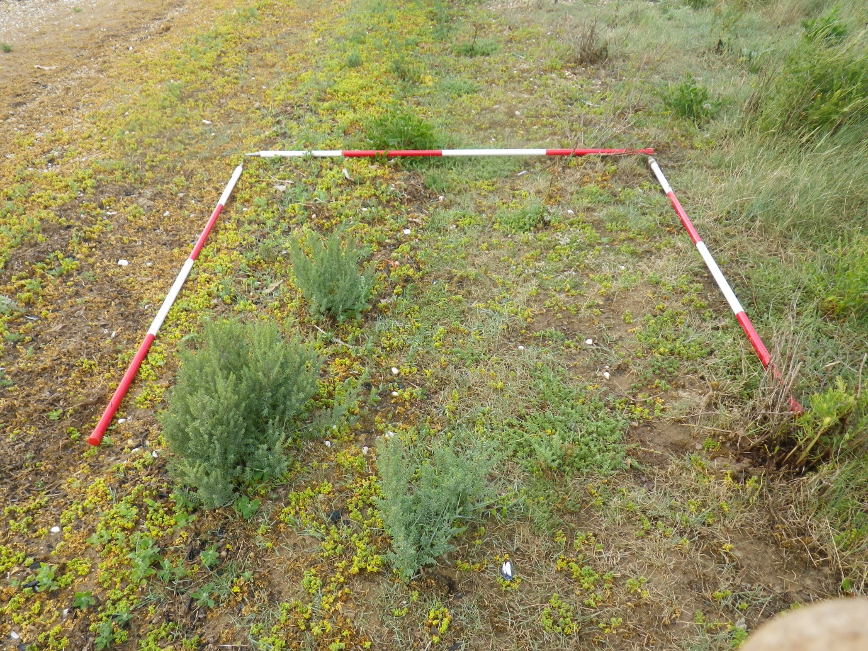
Figure 3-2 Photographs of habitat features for NOB4 Wolferton 12/08/2013 (NOB4_376 Shingle area)

The transect began at the seawall; this was a large shingle bank with a rough shingle track along the top and non-saltmarsh plant community. SM24 community was present at the base of the seawall with a band of SM13b in the lower-lying borrow pit area, before returning to SM24. The transect crossed a shingle/gravel bank before a transition to SM25 S.vera community.
After the SM25 there was a transition to SM14a and SM10. This mid-section of the transect was along the right bank of wide creek, therefore the communities were not representative of wider marsh. Following this lower-lying section, there was a transition back to SM25, then to SM8 and mudflats at the seaward extent. At the seaward extent there were some shingle areas with dune species present.

NOB5
Figure 3-3 Transect map for NOB5 27/08/2013
Table 3-2 Transect target notes for NOB5 27/08/2013
Ref | Target Note |  | NGR | Photo ref.
1 | Top of seawall with E.repens, creeping thistle, hemlock and cow parsley | SM24 | TF6333029073 | NOB5_781
2 | Base of seawall with E.atherica community | SM24 | TF6332529080 | NOB5_782
3 | Header drain/creek. Salicornia agg, Aster tripolium agg, P.maritima, and Spartina agg | SM24 | TF6332029093 | NOB5_788-789
4 | Medium creek and continuation of E.atherica community | SM24 | TF6331429101
5 | Medium creek | SM24 | TF6328829127
6 | Low-lying salt pan with S.maritima, P.maritima, Aster tripolium agg and Salicornia agg | SM24 | TF6327329149 | NOB5_791
7 | Lower lying - P.maritima dominant with S.maritima, Aster tripolium agg | SM14 | TF6326529176 | NOB5_792
8 | Back to E.atherica dominant community | SM24 | TF6320529283 | NOB5_800
9 | Aster tripolium agg, P.maritima, A.portulacoides and Salicornia agg salt pans | SM24 | TF6313229428 | NOB5_805
10 | Medium creek | SM24 | TF6305629556
11 | Salt pan with A.portulacoides and P.maritima | SM24 | TF6305929565 | NOB5_807
12 | Medium creek - transition to Aster tripolium agg, A.portulacoides, P.maritima and Spartina agg community | SM13a | TF6301629638
13 | Salicornia agg mudflats with S.maritima and Spartina agg | SM8 | TF6298729694 | NOB5_819
14 | Seaward extent of saltmarsh. Mudflats with sparse Salicornia agg |  | TF6291129777 | NOB5_825-830
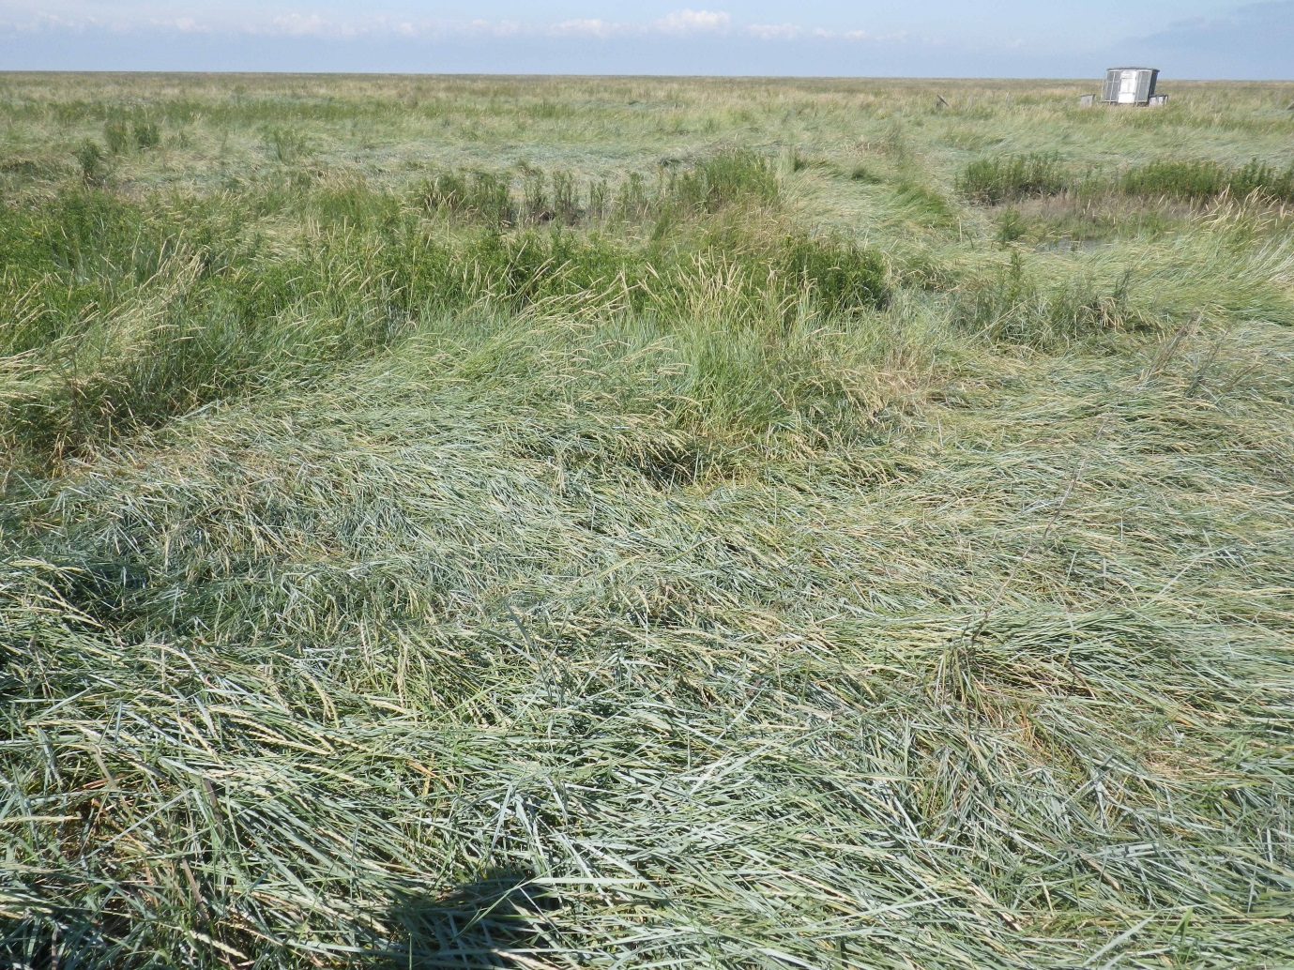
Figure 3-4 Photographs of habitat features for NOB5 27/08/2013 (NOB5_782 From seawall with houseboat)
Transect began at the top of the seawall with tall herbs and terrestrial grasses present. Access tracks and jetties to houseboats were present at the top of the marsh. These were simple worn footpaths and basic wooden jetties without hard-standings. SM24 began at the base of the seawall and continued out into the marsh with a small area of SM14 mosaics in old salt pans and at creek/header drain edges. The transect crossed a creek in the lower marsh with a transition to SM13a then a wide band of SM8 with some A.portulacoides and S.anglica.

N0C4 Wolferton/North Wootton
Figure 3-5 Transect map for NOC4 Wolferton/North Wootton 13/08/2013
Table 3-3 Transect target notes for NOC4 Wolferton/North Wootton 13/08/2013
Ref | Target Note |  | NGR | Photo ref.
1 | Base of seawall | SM14c | TF6116227249
2 | Creek edge. End of seawall. Cattle grazed grass community with car tracks. | SM14c | TF6115527260
3 | Creek edge with P.maritima and E.atherica community. Continues on other side of creek | SM14c | TF6113927266
4 | E.atherica community | SM24 | TF6111327283 | NOC4 Wolferton_387
5 | Cattle grazed P.maritima community | SM13a | TF6100027339
6 | Mosaic with E.atherica patches grazed by cattle | SM13a | TF6090327396
7 | Transition to P.maritima and Aster tripolium agg community | SM13a | TF6067327505
8 | A.portulacoides dominant, reduced P.maritima, wetter underfoot. | SM13a | TF6060227567
9 | Large creek edge | SM13a | TF6053927648
10 | Spartina agg dominant | SM6 | TF6053527653 | NOC4 Wolferton_419
11 | Mosaic habitat with Spartina agg dominant. Salicornia agg patches | SM6 | TF6051327703
12 | Seaward extent |  | TF6050527712

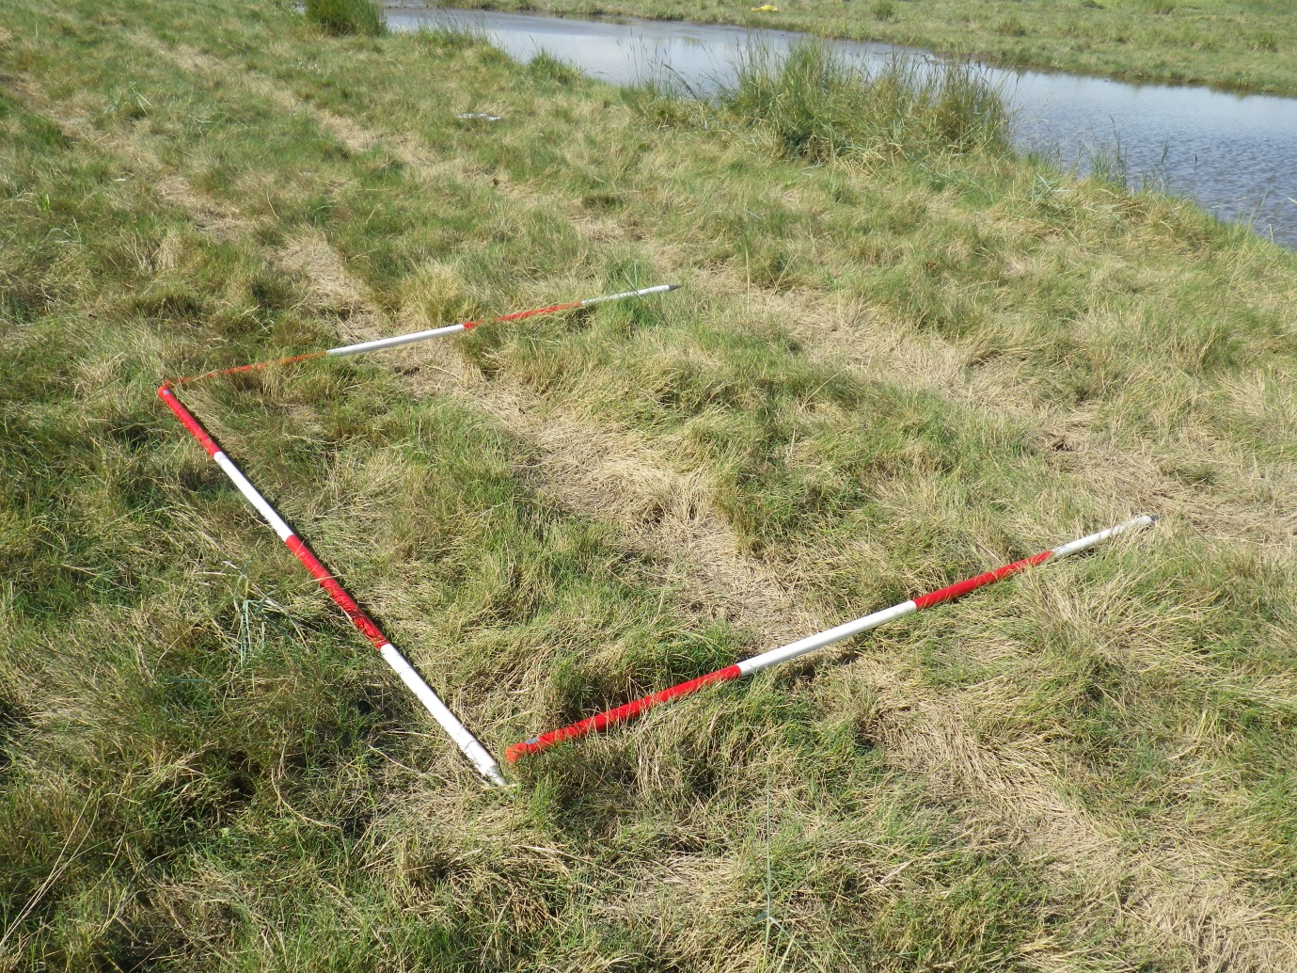
Figure 3-6 Photographs of habitat features for NOC4 Wolferton/North Wootton (NOC4_386 Farm vehicle tracks at creek edge)
House boats with bridges were present at the edge of the header drain/borrow pit. Heavy cattle grazing was obvious in all areas of the marsh with deep poaching. Fencing and car tracks were observed in the mid/upper marsh (TF6115527260). These were rough tracks from a 4x4 vehicle, probably from farm access (fig 3.6). Cattle access the marsh freely via an access point from agricultural land on lthe landward side of the seawall.
The transect began at the base of the seawall (mown) with SM14c in the borrow pit area. This area was heavily grazed by cattle. After a creek, there was a raised area and transition to SM24. After this there was a transition to SM13a for most of the marsh, characterised by cattle grazed P.maritima. After a large creek there was a transition to SM6 with small patches of Salicornia agg present.

Area 2 – River Great Ouse to River Nene

N0D1 Terrington
Figure 3-7 Transect map for NOD1 Terrington 14/08/2013
Table 3-4 Transect target notes for NOD1 Terrington 14/08/2013
Ref | Target Note |  | NGR | Photo ref.
1 | Seawall, E.atherica dominant, base of seawall, change to P.maritima and Aster tripolium agg. Grazed by cattle. | SM24 | TF5708825898
2 | Seawall, E.atherica dominant, base of seawall, change to P.maritima and Aster tripolium agg. Grazed by cattle. | SM13a | TF5709325900
3 | Sea wall - E.atherica dominant | SM24 | TF5711425950
4 | P.maritima dominant, mosaic patches of E.atherica and A.portulacoides. | SM13a | TF5712825956
5 | E.atherica and A.portulacoides community with P.maritima patches | SM24 | TF5715425994
6 | Large creek P.maritima and Aster tripolium agg co-dominant. | SM13a | TF5734626194
7 | Increased Spartina. Wetter area with salt pans | SM13a | TF5754726284
8 | Spartina agg and Aster tripolium agg and A.portulacoides co-dominant | SM13a | TF5759826307
9 | P.maritima and A.portulacoides community | SM12 | TF5767026344
10 | Spartina and Aster tripolium agg dominant with patches of P.maritima | SM12 | TF5785226438
11 | Spartina agg and Salicornia agg community with salt pans | SM6 | TF5791426546 | NOD1 Terrington_475
12 | Salicornia agg mudflats and patches of Spartina agg | SM8 | TF5802726765 | N0D1 Terrington_482
13 | Salicornia agg mudflats - estimated to continue 200m seaward |  | TF5804826808
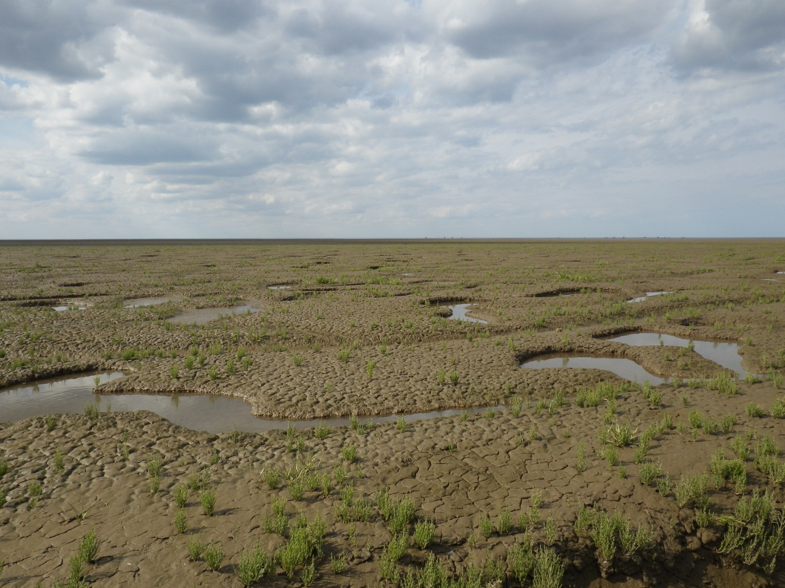
Figure 3-8 Photographs of habitat features for NOD1 Terrington 14/08/2013 (NOD1_482 Mudflats with sparse Salicornia agg)
This was a long transect, surveyed diagonally from seawall. The Nationally Scarce species Sea Barley (Hordeum marinum) was present at the base of the seawall. The marsh was grazed by cattle.
A thin band of SM24 was present at the base of the seawall followed by a transition to a narrow band of SM13a in the borrow pit area. The transect continued into SM24 for approximately 300m before a transition back to grazed SM13a. An increase in Aster spp to SM11/SM12 was followed by a transition to the pioneer communities SM6 then SM8.
The transect followed the left bank of a large creek and was not considered representative of the wider marsh. The transect skirts the edge of the dominant Spartina/Puccinellia community visible to the left.

N0D4 Terrington
Figure 3-9 Transect map for NOD4 Terrington 15/08/2013
Table 3-5 Transect target notes for NOD4 Terrington 15/08/2013
Ref | Target Note |  | NGR | Photo ref.
1 | Top of seawall - terrestrial grass | SM24 | TF5435726321
2 | Base of seawall E.atherica dominant | SM24 | TF5435526327
3 | Transition to P.maritima and Aster tripolium agg community | SM13a | TF5434926342
4 | Wide creek with marginal A.portulacoides community. | SM13a | TF5434126368
5 | Creek edge with marginal A.portulacoides community. | SM13a | TF5434126372
6 | Mosaic habitat with raised areas and pans. E.atherica patches on high ground | SM10 | TF5433926380 | N0D4 Terrington_495
7 | Transition to A.portulacoides community with Aster tripolium agg and S.vera | SM25b | TF5431726465 | N0D4 Terrington_504
8 | Aster tripolium agg dominant | SM12 | TF5429926571 | N0D4 Terrington_510
9 | Wide creek -transition back to A.portulacoides community and P.maritima | SM14c | TF5429526610 | N0D4 Terrington_514
10 | Wide creek | SM14c | TF5427926769
11 | Aster tripolium agg dominant and S.maritima | SM10 | TF5426326935 | N0D4 Terrington_519
12 | E.atherica community at base of mound – remnant from Wash water storage project | SM24 | TF5427626967 | N0D4 Terrington_530
13 | Seaward side of large mound. Dune vegetation | SM24 | TF5427727038 | N0D4 Terrington_534
14 | Seaward side of mound with artificial boulders as sea defence | SM24 | TF5427627064 | N0D4 Terrington_537
15 | Spartina agg and Salicornia agg community, multiple creeks and mudflats | SM8 | TF5427727088 | N0D4 Terrington_538
16 | Approximately 500m of mudflats with Spartina agg |  | TF5426727170 | N0D4 Terrington_549
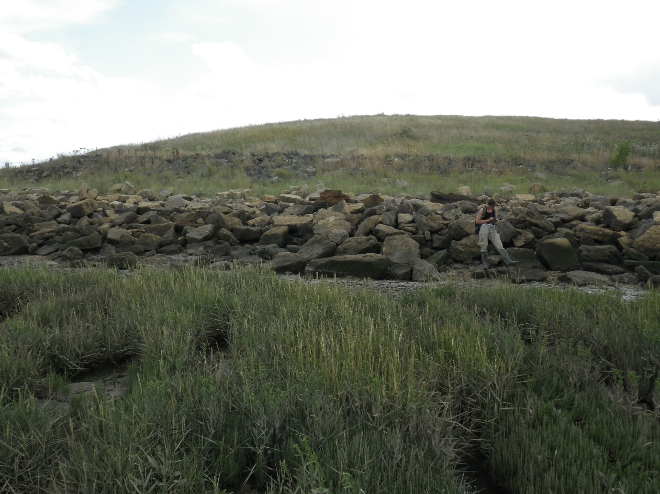
Figure 3-10 Photographs of habitat features for NOD4 Terrington 15/08/2013 (NOD4_539 View of artificial mound from mudflats)
A man-made mound (remnant from The Wash water storage project) was present at the seaward extent of marsh with dune community and artificial boulder defences on seaward slope (Sue Rees, 2014, pers. comm.).
The transect began at the base of the seawall with a band of SM24 and transition to SM13a in the lower-lying borrow pit area. The transect then passed through a variety of mid-marsh communities and a band of SM25b before a raised area of SM24 at the base of the mound. At the opposite side of the mound there was a sharp transition to a SM8 pioneer community with tussocks of Spartina spp.
From the end of the transect surveyors could see extensive mudflats with small patches of Spartina and Salicornia extending out >1km.

L4A3 Terrington
Figure 3-11 Transect map for L4A3 Terrington 19/08/2013
Table 3-6 Transect target notes for L4A3 Terrington 19/08/2013
Ref | Target Note |  | NGR | Photo ref.
1 | E.atherica dominant | SM24 | TF5022526654 | L4A3 Terrington_551
2 | Creek edge | SM24 | TF5021926677
2 | Creek edge. P.maritima and A.prostrata dominant | SM13a | TF5022426683
3 | Peninsula of E.atherica | SM13a | TF5025326824 | L4A3 Terrington_562
4 | A.portulacoides dominant | SM13a | TF5024026840 | L4A3 Terrington_563
5 | Spartina agg now frequent | SM13a | TF5024127006 | L4A3 Terrington_571
6 | Aster tripolium agg dominant and Salicornia agg frequent. P.maritima low cover | SM12 | TF5021427284 | L4A3 Terrington_581
7 | Mudflats with Salicornia agg | SM8 (no quads) | TF5016627477
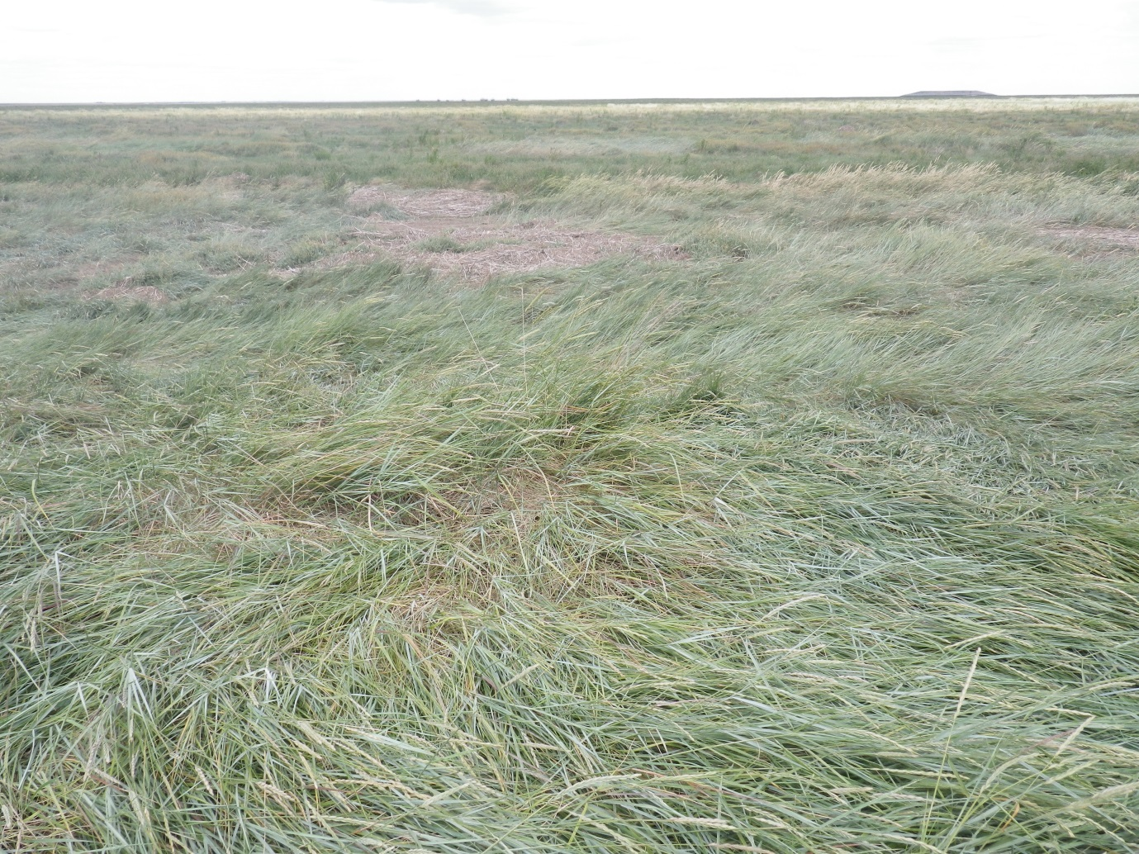
Figure 3-12 Photographs of habitat features for L4A3 Terrington 19/08/2013 (L4A3_551 SM24 community from seawall)
The transect started at the base of the seawall with a narrow band of SM24 at the drift-line. SM13a was extensive for approximately 600m before a transition to SM11/SM12. There was an abrupt start to the pioneer zone; predominantly bare mud, algal mat and open water with some Salicornia agg.

Area 3 – River Nene to Lawyers Creek

L4B2 Gedney Drove End
Figure 3-13 Transect map for L4B2 Gedney Drove End 19/08/2013
Table 3-7 Transect target notes for L4B2 Gedney Drove End 19/08/2013
Ref | Target Note |  | NGR | Photo ref.
1 | Top of seawall | SM24 | TF4797928632 | L4B2_269
2 | Base of seawall - E.atherica dominated community | SM24 | TF4798828643 | L4B2_270
3 | End of E.atherica community. Heavily poached by cattle. Aster tripolium agg and P.maritima dominated community. | SM10 | TF4799428648 | L4B2_273
4 | Wide creek - edge community dominated by A.portulacoides, S.maritima, and Salicornia agg | SM10 | TF4800428654 | L4B2_277
5 | Opposite side of wide creek - return to Aster tripolium agg and P.maritima community | SM10 | TF4800628661 | L4B2_278
6 | P.maritima and E.atherica community | SM14 | TF4801628673 | L4B2_281
7 | Creek and transition back to E.atherica community | SM14 | TF4802328690 | L4B2_285
8 | Species poor P.maritima community | SM13a | TF4806128726 | L4B2_288
9 | P.maritima and Aster tripolium agg co-dominant | SM13a | TF4819128782 | L4B2_294
10 | Abundant creeks and increased A.portulacoides | SM14c | TF4828928809 | L4B2_300
11 | Aster tripolium agg and A.portulacoides community | SM10 | TF4836828835 | L4B2_306
12 | Salicornia agg and S.maritima. Salt pans | SM10 | TF4849628926 | L4B2_6424
13 | Mudflats and Salicornia agg. Multiple creeks and salt pans | SM10 | TF4861028972 | L4B2_6430
14 | Unvegetated mudflats |  | TF4864028989 | L4B2_6431

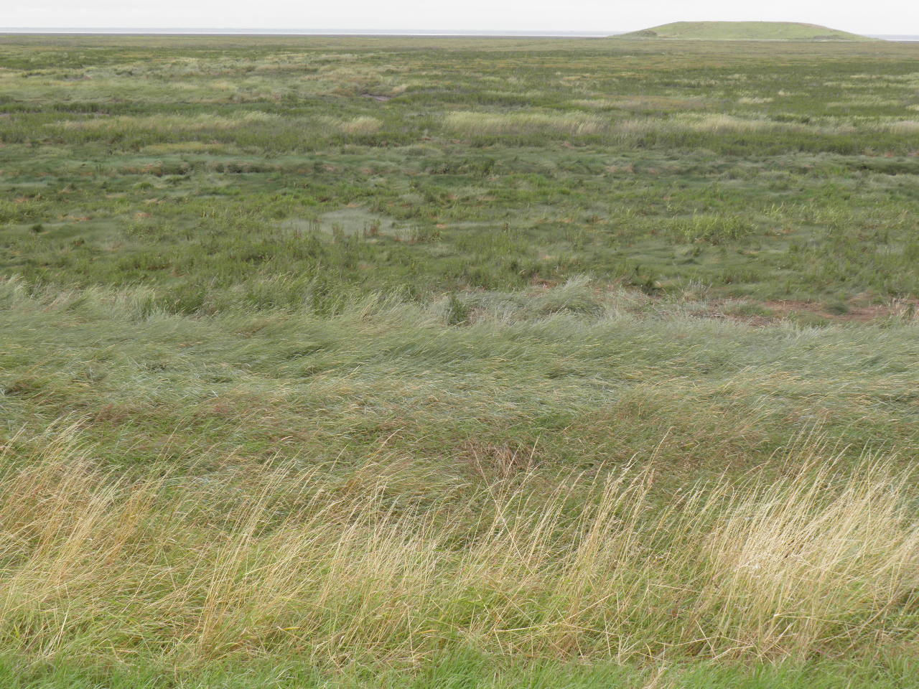
Figure 3-14 Photographs of habitat features for L4B2 19/08/2013 (L4B2_269 From seawall)
The transect started at the base of the seawall with a narrow band of SM24 at the drift-line. The community changed to SM10 in the lower-lying borrow pits; this area was heavily poached and grazed by cattle. Poaching was extensive, with deep indentations and patches of bare earth throughout the upper marsh. The mid marsh was dominated by SM13a with bands of SM14 where more A.portulacoides was present. There was a transition back to SM10 in the lower marsh before a narrow band of pioneer vegetation dominated by Salicornia and bare mud (no quadrats).

L4C4 Holbeach
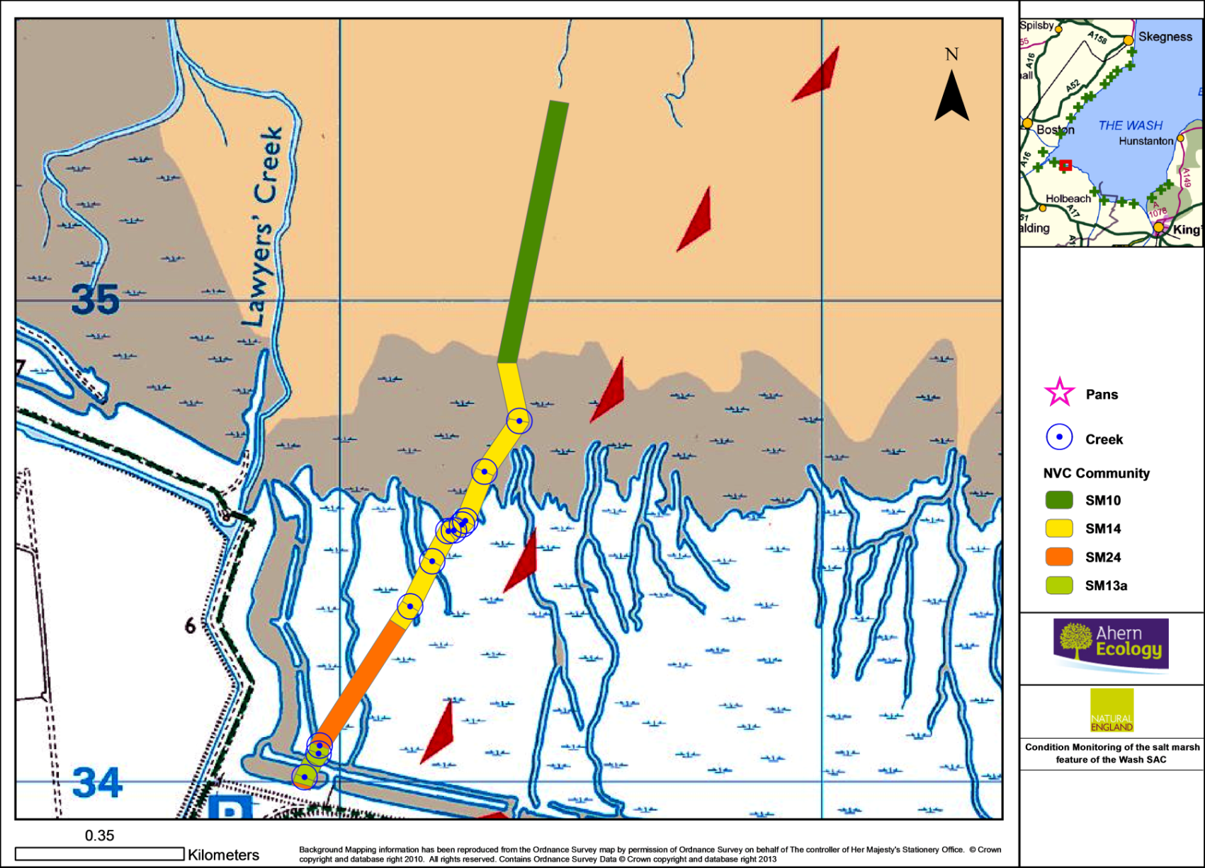
Figure 3-15 Transect map for L4C4 Holbeach 23/08/2013 (red triangles mark edge of military danger zone)
Table 3-8 Transect target notes for L4C4 Holbeach 23/08/2013
Ref | Target Note |  | NGR | Photo ref.
1 | Bottom of seawall grazed by cattle. E.atherica dominant. | SM24 | TF4092033988 | L4C4 Holbeach_732
2 | Transition to A.portulacoides and Aster tripolium agg community with S.maritima and P.maritima. Sharp transition from E.atherica | SM13a | TF4092333995 | L4C4 Holbeach_738
3 | Medium creek. P.maritima edge community | SM13a | TF4092834009 | L4C4 Holbeach_
4 | Sea wall community - E.atherica dominant with some A.portulacoides. | SM13a | TF4094434039 | L4C4 Holbeach_745
5 | Large creek with A.portulacoides and S.maritima edge community. | SM13a | TF4095734058 | L4C4 Holbeach_747
6 | E.atherica community. Some Aster tripolium agg, A.prostrata. Creek edge | SM24 | TF4095934075 | L4C4 Holbeach_750
7 | Transition to A.portulacoides community with P.maritima, S.maritima and Aster tripolium agg. | SM14 | TF4112134326 | L4C4 Holbeach_758
8 | Large creek. | SM14 | TF4114734365 | L4C4 Holbeach_760
9 | Large creek with A.portulacoides edge community and S.maritima. | SM14 | TF4119334458 | L4C4 Holbeach_762
10 | Medium creek | SM14 | TF4122734521
11 | Medium creek | SM14 | TF4123834523 | L4C4 Holbeach_764
12 | Medium creek | SM14 | TF4125434534
13 | Medium creek | SM14 | TF4126234542
14 | Wide creek with A.portulacoides edge community | SM14 | TF4130134644 | L4C4 Holbeach_765
15 | Wide creek | SM14 | TF4137434750 | L4C4 Holbeach_767
16 | Community change - increased S.maritima, Aster tripolium agg and Salicornia agg. Some Spartina agg and decreased P.maritima. | SM10 | TF4134734870 | L4C4 Holbeach_769
17 | Seaward extent of saltmarsh. Mudflats and creeks |  | TF4145735414 | L4C4 Holbeach_774-779
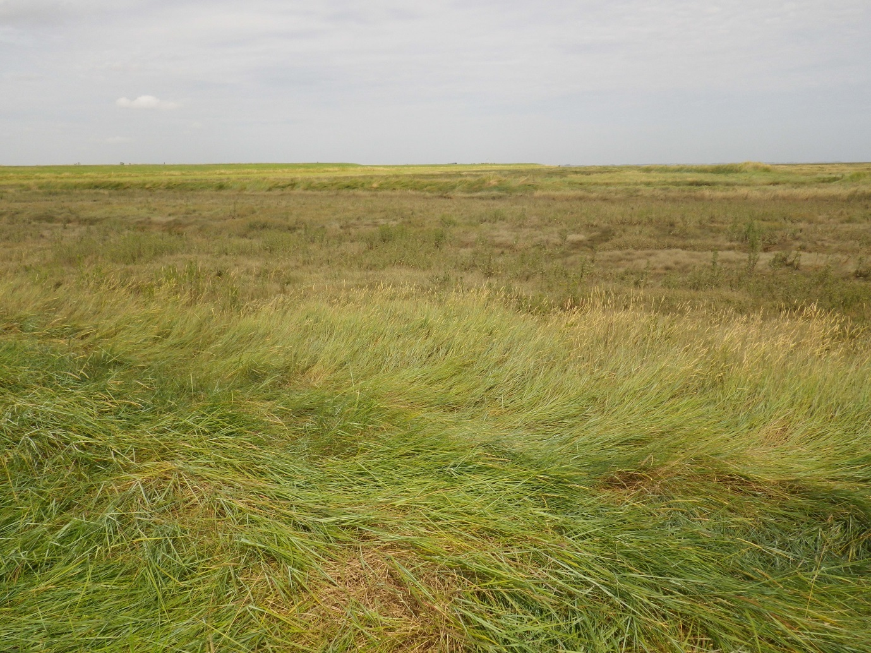
Figure 3-16 Photographs of habitat features for L4C4 Holbeach 23/08/2013 (L4C4_732 From seawall)
This was a particularly wide area of marsh with a long transect crossing multiple large creeks. A narrow band of SM24 was present at the base of the seawall with a transition to SM13a in the borrow pit area before returning to SM24 for approximately 300m of higher ground. After this, an increase in A.portulacoides meant a transition to SM14 for approximately 500m in an area with an extensive network of creeks. After this there was a transition to SM10 to the seaward extent of the transect with no clear pioneer community.

L4C5
Figure 3-17 Transect map for L4C5 23/08/2013
Table 3-9 Transect target notes for L4C5 23/08/2013
Ref | Target Note |  | NGR | Photo ref.
1 | Top of sea wall with no species of significant value. |  | TF3494534228 | L4C5_1
2 | Base of sea wall. E.atherica dominant community. 10 meters in width. | SM24 | TF3493834238 | L4C5_2
3 | End of E.atherica margin. E.atherica, A.portulacoides, Aster tripolium agg and Limonium spp | SM24 | TF3493034251 | L4C5_8
4 | Edge of river, E.atherica and A.portulacoides dominant community | SM14a | TF3489134300 | L4C5_15

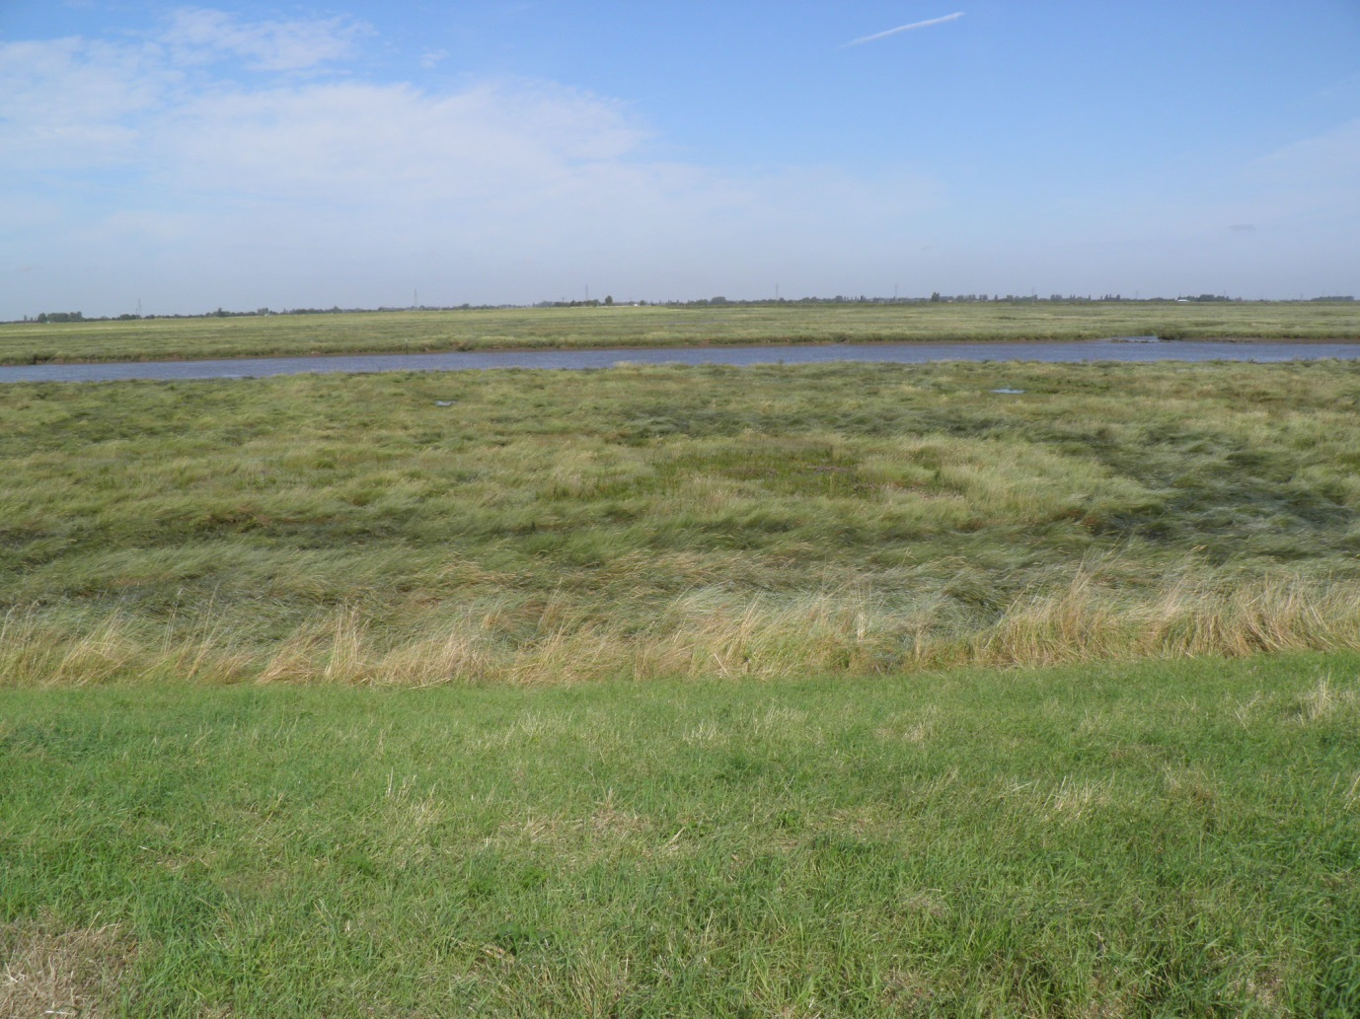
Figure 3-18 Photographs of habitat features for L4C5 23/08/2013 (L4C5_1 From seawall)
This was a short transect added due to access issues in the military area. The intention was to survey an inland area of marsh fringing the river. A narrow band of SM24 was present at the seawall, followed by a transition to SM14 reaching to the river edge. No pioneer community was present.

L4C5a
Figure 3-19 Transect map for L4C5a 30/08/2013
Table 3-10 Transect target notes for L4C5a 30/08/2013
Ref | Target Note |  | NGR | Photo ref.
1 | Top of seawall E.atherica, hogweed, cow parsley and broad dock | SM24 | TF3873835431 | L4C5a_901
2 | E.atherica community at base of seawall | SM24 | TF3874635441 | L4C5a_902
3 | Change towards P.maritima and Aster tripolium agg and A.portulacoides community with Spartina agg and S.maritima | SM14 | TF3875435452 | L4C5a_908
4 | Creek edge and remnants seawall community. E.atherica dominant with A.portulacoides community on creek edges | SM14 | TF3876335474
5 | Continuation of P.maritima and Aster tripolium agg community after creek and seawall | SM14 | TF3881135559
6 | Large creek with A.portulacoides edge community | SM14 | TF3904935788 | L4C5a_917
7 | Increase in Spartina agg | SM10 | TF3924836028 | L4C5a_921
8 | Loss of P.maritima. Salicornia agg and Spartina agg dominant | SM8 | TF3950036212
9 | Wide creeks | SM8 | TF3955036260
10 | Large creek and mudflats | SM8 | TF3959836295 | L4C5a_935
11 | Saltmarsh extent. Very large creek and mudflats. Seal colony present 200+ individuals. |  | TF4003136495 | L4C5a_939t-944
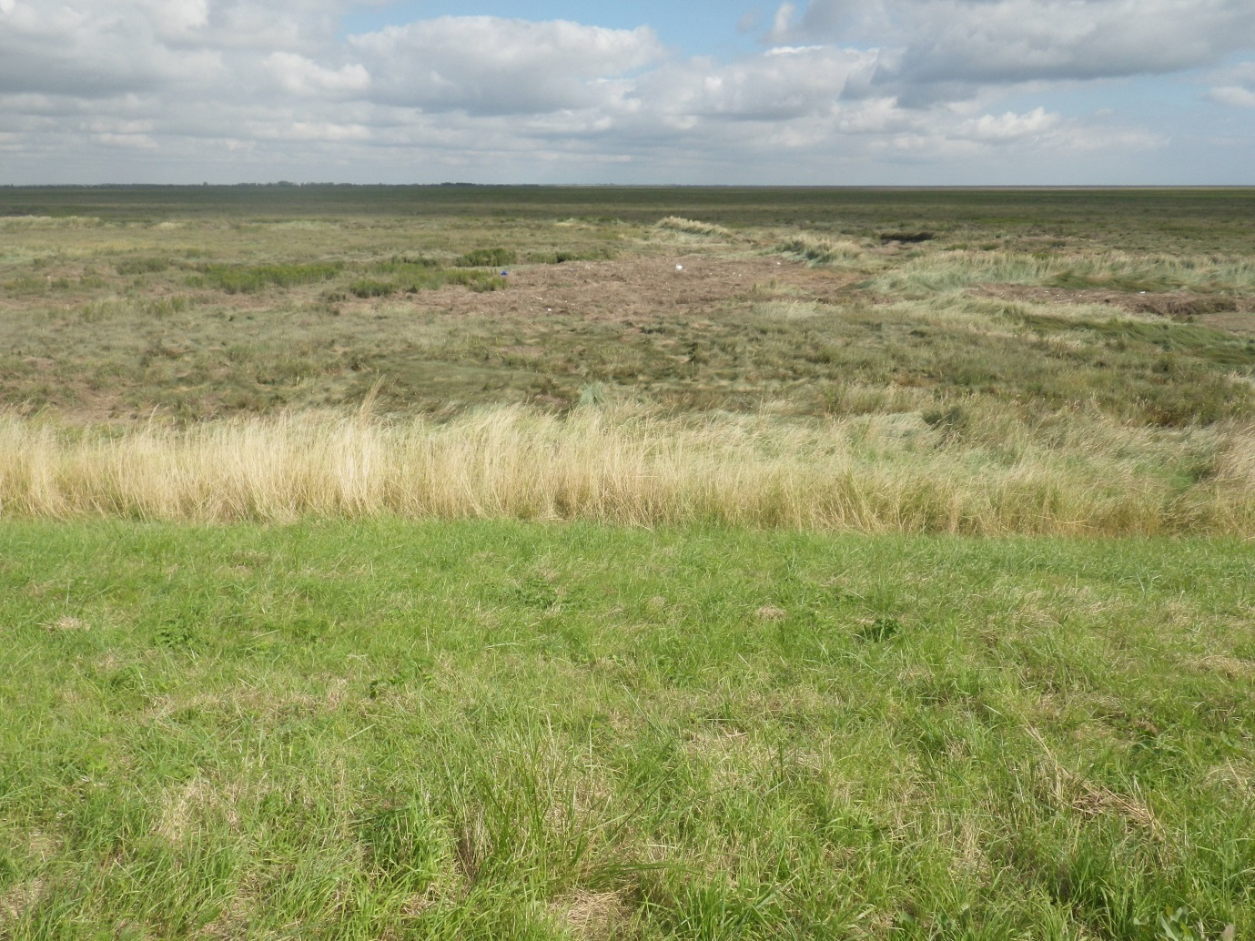
Figure 3-20 Photographs of habitat features for L4C5a 30/08/2013 (L4C5a_901 From seawall)
Transect started at the seawall with a narrow band of SM24. There was an abrupt transition to a wide band of SM14 for approximately 700m followed by 300m of SM10. The SM8 pioneer community began here and extended 500m to the end of the transect. This broad pioneer zone had extensive creeks and bare mud. A large colony of seals was present numbering approximately 200 individuals.

Area 4 – Lawyers Creek to The Haven

Frampton
Figure 3-21 Transect map for Frampton 22/08/2013
Table 3-11 Transect target notes for Frampton 22/08/2013
Ref | Target Note | NVC Com | NGR | Photo ref.
1 | Large flooded creek landward. Cattle grazed P.maritima community to seawall. Transition to E.atherica community. | SM24 | TF3612937801 | Frampton_674-675
2 | Creek area with increased P.maritima but no community change. | SM12 | TF3618237784
3 | Edge of creek, back to E.atherica community | SM12 | TF3619837773
4 | Low lying salt pan habitat with creek edge community. Limonium spp and A.portulacoides community at creek edge. E.atherica dominant. | SM12 | TF3622637737 | Frampton_681
5 | E.atherica dominant | SM14 | TF3623437725 | Frampton_683
6 | E.atherica community with salt pans of Salicornia agg, A.portulacoides and Aster tripolium agg present. | SM14 | TF3631037638 | Frampton_684
7 | E.atherica dominant with increase in A.portulacoides | SM14 | TF3638237549 | Frampton_691
8 | Large creek. E.atherica dominant with P.maritima in low-lying areas. | SM14 | TF3639937539 | Frampton_692&693
9 | E.atherica dominant | SM14 | TF3649037489 | Frampton_697
10 | Large creek | SM14 | TF3652737467 | Frampton_698
11 | Far side of creek, E.atherica dominant | SM14 | TF3654237412
12 | P.maritima and Aster tripolium agg in low-lying areas. Some patches of Limonium spp. | SM14 | TF3666837275 | Frampton_699
13 | E.atherica dominant | SM14 | TF3673537272 | Frampton_703
14 | E.atherica dominant but increase in Aster tripolium agg and A.portulacoides | SM14 | TF3676837251 | Frampton_704
15 | Wide creek edge to right, Spartina agg and P.maritima salt pan community | SM14 | TF3695737113 | Frampton_707-706
16 | Impossible to cross huge creek to right. Previous transect is in the creek bottom. | SM14 | TF3699837069
17 | Medium creek | SM14 | TF3709337023
18 | A.portulacoides, P.maritima and Aster tripolium agg community | SM14 | TF3710337003 | Frampton_709
19 | Large creek | SM14 | TF3733736776 | Frampton_714
20 | Increase in Aster tripolium agg, A.portulacoides and S.maritima. P.maritima dominant. | SM14a | TF3738936716 | Frampton_716
21 | Spartina agg dominant. Some patches of Salicornia agg. | SM6 | TF3748236635 | Frampton_722
22 | Estuary bank with Salicornia agg on mudflats |  | TF3747036602 | Frampton_728

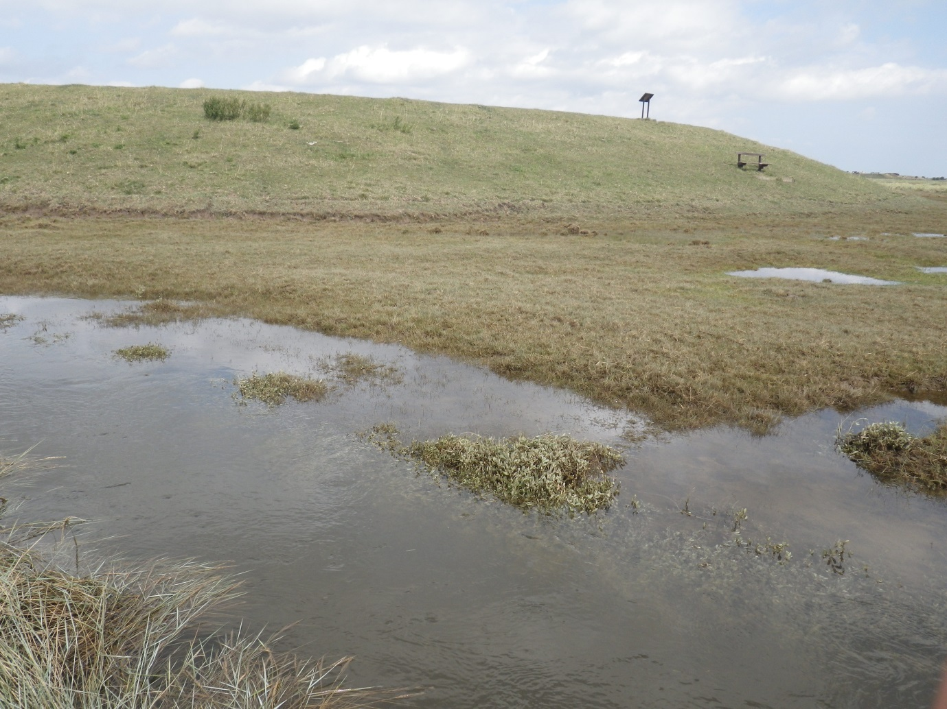
Figure 3-22 Photographs of habitat features for Frampton 22/08/2013 (Frampton_674 Seawall and flooded borrow pits)
This was a wide, homogenous marsh dominated by A.portulacoides and E.atherica. The marsh was very wet underfoot with an extensive network of large creeks and borrow pits.
A narrow band of SM24 was present at the base of the seawall. Salt pan areas in the mid/upper marsh and the borrow bits at the base of the seawall were more biodiverse. Due to flooding it was not possible to survey the borrow pits.
A narrow band of Aster SM11/SM12 was present before transition to SM14/SM14a for >1km. This area had an extensive creek network and was dominated by A.portulacoides.
A very steep, narrow band of the pioneer community SM6 was present at the river bank. A narrow band of mudflat was visible in the river with sparse patches of Salicornia agg.

Area 5 – The Haven to the Horseshoe

L3A3 Freiston
Figure 3-23 Transect map for L3A3 Freiston 22/08/2013
Table 3-12 Transect target notes for L3A3 Freiston 22/08/2013
Ref | Target Note | NVC | NGR | Photo ref.
1 | Sea wall. E.atherica dominant with tall herbs. Transition zone very narrow with Artemisia maritima and A.portulacoides. | SM24 (no quads) | TF4016042024 | L3A3 Freiston_2
2 | Heavily poached by cattle. P.maritima community with Salicornia agg and S.maritima. | SM10 | TF4017042021 | L3A3 Freiston_3
3 | Aster tripolium agg, P.maritima and A.portulacoides community with Salicornia agg and Spartina agg frequently showing. Low-lying, wet underfoot. Medium creek with A.portulacoides community growing alongside. | SM10 | TF4019242026 | L3A3 Freiston_9
4 | Salicornia agg. community with S.maritima, P.maritima. Salt pans in zone. Low-lying, wet underfoot. Small raised areas throughout with A.portulacoides and Aster tripolium agg. | SM10 | TF4022441996 | L3A3 Freiston_15
5 | A.portulacoides and Aster tripolium agg community with Salicornia agg. A.portulacoides dominant. Large creek in zone with A.portulacoides on creek edges. | SM10 | TF4028141943 | L3A3 Freiston_21
6 | Large creek with A.portulacoides and Salicornia agg dominant. Aster tripolium agg and A.portulacoides increasing. | SM10 | TF4028941916 | L3A3 Freiston_23
7 | Aster tripolium agg community with P.maritima and S.maritima. A. port decreasing and Spartina agg increasing. Salt pans abundant and small creeks increasing. | SM10 | TF4040641873 | L3A3 Freiston_28
8 | Medium creek with A.portulacoides community | SM10 | TF4047741855 | L3A3 Freiston_31
9 | Medium creek with Sarcocornia perennis | SM8 | TF4056441818 | L3A3 Freiston_34
10 | Salicornia agg dominant community. Some Spartina agg. | SM8 | TF4074241725 | L3A3 Freiston_37
11 | End of Salicornia agg growth. Mud flats. |  | TF4096441565 | L3A3 Freiston_43-48
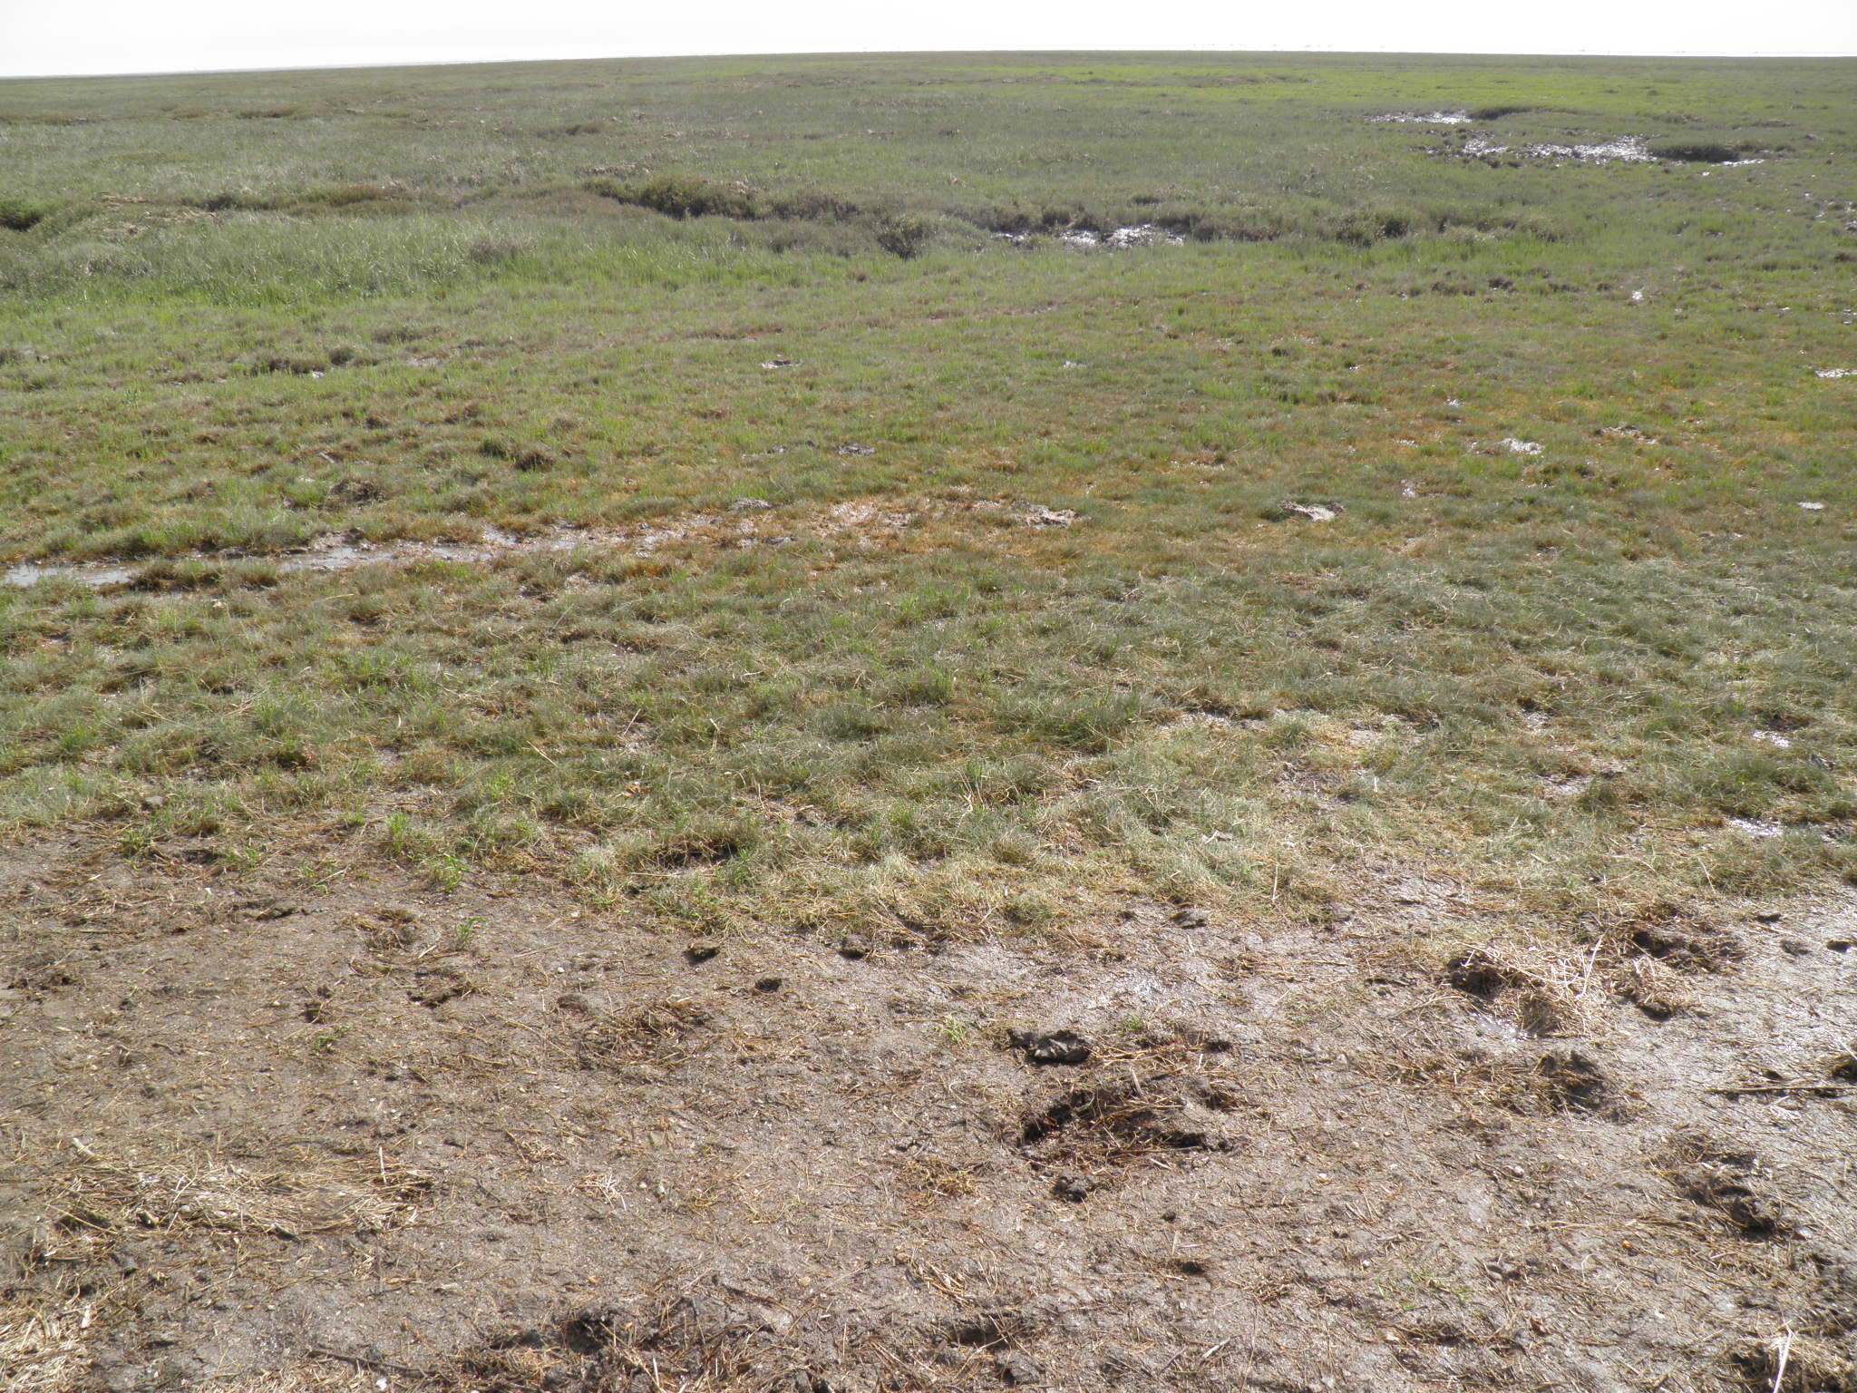
Figure 3-24 Photographs of habitat features for L3A3 Freiston 22/08/2013 (L3A3_3 Heavily poached)
The marsh was dominated by a diverse SM10 community. The upper marsh was heavily poached by cattle, with extensive bare mud and tussocks. A wide (approx. 200m) SM8 pioneer community was present.

L3A3a
Figure 3-25 Transect map for L3A3a 30/08/2013
Table 3-13 Transect target notes for L3A3a 30/08/2013
Ref | Target Note | NVC | NGR | Photo ref.
1 | Top of sea wall. Various grasses. Nothing of significant value. Wall barley prominent. | SM24 | TF4114143443 | L3A3a_102
2 | Base of sea wall. Species include E.atherica, P.maritima,and A.prostrata. Length is 4m. Because of narrow zone only 2 quadrats. | SM24 | TF41149 43444 | L3A3a_103
3 | Transition into P.maritima, Spartina, Aster tripolium agg, A.portulacoides. Some Salicornia agg coming through. Heavily poached and grazed by cattle. Large creek within 20 meters of sea wall. | SM10 | TF4115843437 | L3A3a_107
4 | Large creek. Zone change into A.portulacoides and Aster tripolium agg dominant community. S.maritima also present. | SM14a | TF4117943423 | L3A3a_114
5 | Transition zone into Aster tripolium agg dominant community with Spartina and P.maritima. Salt pans and creeks throughout. Salicornia agg increasing. A.portulacoides disappears. | SM6 | TF4150843263 | L3A3a_120
6 | Zone change into Salicornia agg dominant community. Numerous salt pans. | SM8 | TF4172543144 | L3A3a_126
7 | Zone change into mud flats. |  | TF4204342998 | L3A3a_136-142
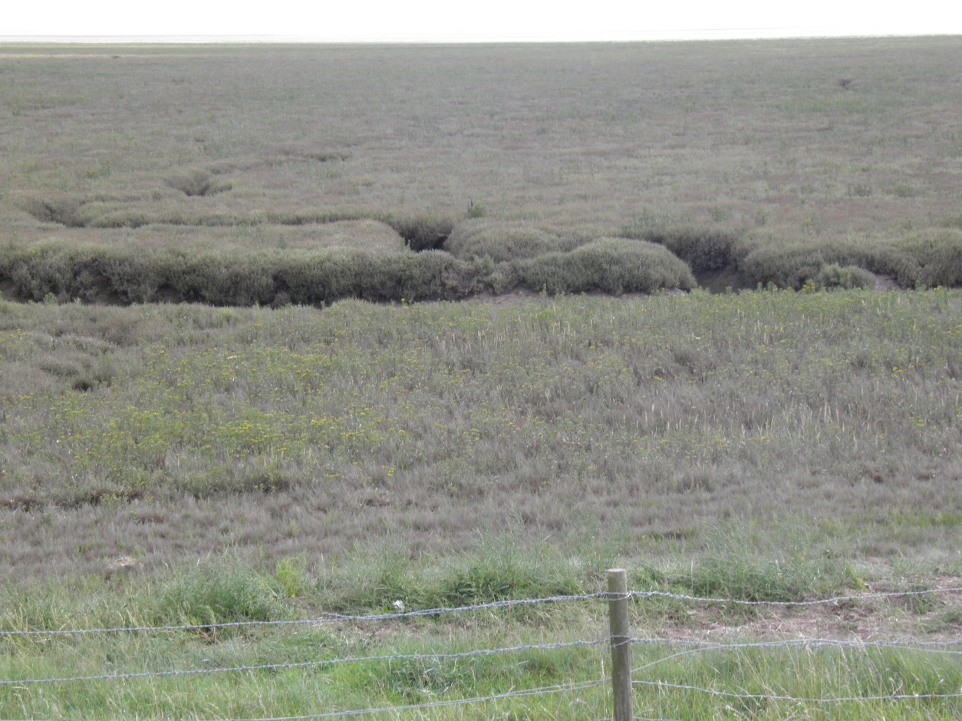
Figure 3-26 Photographs of habitat features for L3A3a 30/08/2013 (L3A3a_102 From seawall)
A narrow band of SM24 (<4m) was present at the base of the seawall. A narrow band of SM10 in the borrow pits was heavily grazed and poached by cattle, with bare mud allowing Salicornia agg to become more frequent.
After a large creek there was a transition to SM14a, dominated by A.portulacoides. In the mid/lower marsh, salt pans were frequent, with communities of Salicornia agg around the edges. Sarcocornia perennis was infrequent in mid-marsh along the steep sides of creeks.
Abundant algal mat was present on bare mud in the lower/pioneer marsh with SM6 followed by SM8 pioneer communities.

L3A4
Figure 3-27 Transect map for L3A4 29/08/2013
Table 3-14 Transect target notes for L3A4 29/08/2013
Ref | Target Note | NVC | NGR | Photo ref.
1 | Top of sea wall. Variety of grasses including wall barley. Cows on marsh. Cattle poached zone at base of sea wall. | SM23 | TF4253145666 | L3A4_46
2 | Transition zone. Sea barley occurring in good numbers. Zone extends for 10m. Flotsam debris extensive. | SM23 | TF4253845665 | L3A4_47
3 | Transition zone into P.maritima, Spartina agg and Aster tripolium agg dominant. Many creeks in the area. Heavily cattle poached area. Earth ridge in transect zone perhaps an old sea defence. Zone extends to mudflats. | SM14 | TF4254945661 | L3A4_56
4 | Large creek with A.portulacoides and Aster tripolium agg dominant. | SM14 | TF4258145653 | L3A4_58
5 | Large creek with A.portulacoides and S.maritima dominant. | SM14 | TF4277645598 | L3A4_62
6 | Transition into Spartina and Aster tripolium agg dominant community. Medium creeks in the zone. Reduction of A.portulacoides and P.maritima. | SM10 | TF4288945569 | L3A4_64
7 | Transition into S.maritima dominant community with Salicornia agg and Spartina in places. Large creek on zone change. | SM10 | TF4299845542 | L3A4_70
8 | Transition into Salicornia agg dominant community. Odd patches of Spartina and S.maritima. Increasing mud flats and creeks. | SM8 | TF4308445513 | L3A4_76
9 | End of Salicornia agg and mud flats begin. |  | TF4325545449 | L3A4_82-87
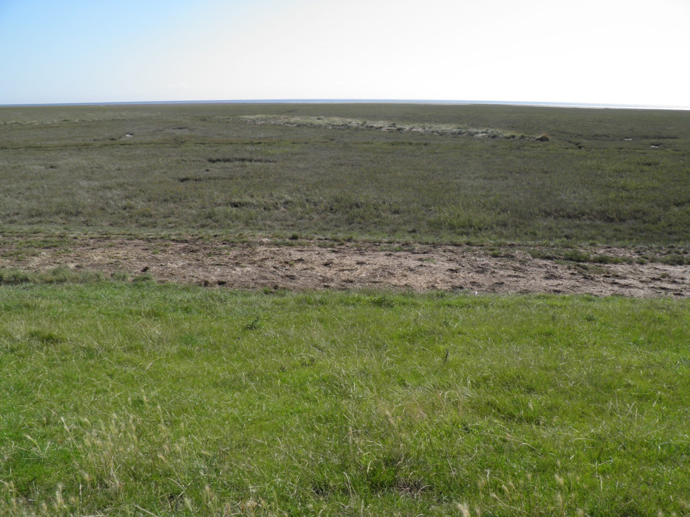
Figure 3-28 Photographs of habitat features for L3A4 29/08/2013 (L3A4_46 From seawall, showing sea barley and poached area)
No SM24 community was present at the base of the seawall. A band of SM23 was present due to extensive grazing by cattle. The notable species H. marinum was locally abundant in this zone. The marsh was dominated by SM14 and SM10 with abundant creeks and some grazing throughout. SM8 pioneer community was present at the seaward extent.

L3A5
Figure 3-29 Transect map for L3A5 29/08/2013
Table 3-15 Transect target notes for L3A5 29/08/2013
Ref | Target Note |  | NGR | Photo ref.
1 | Top of seawall, heavily cattle-grazed E.atherica | SM14c | TF4426948183 | L3A5_861
2 | Base of seawall, no E.atherica. Salicornia agg, P.maritima and A.portulacoides | SM14c | TF4427448176 | L3A5_862
3 | Borrow pit, lower lying ground adjacent to small creek | SM14c | TF4428548165 | L3A5_868
4 | E.atherica dominant community | SM24 | TF4429448152 | L3A5_871
5 | P.maritima, Limonium spp and A.portulacoides | SM13c | TF4433848112 | L3A5_877
6 | Increase in A.portulacoides | SM13 | TF4441448026 | L3A5_883
7 | S.maritima and Salicornia agg dominant | SM6 | TF4452847906 | L3A5_889
8 | End of transect, mudflats |  | TF4461647835 | L3A5_895-898

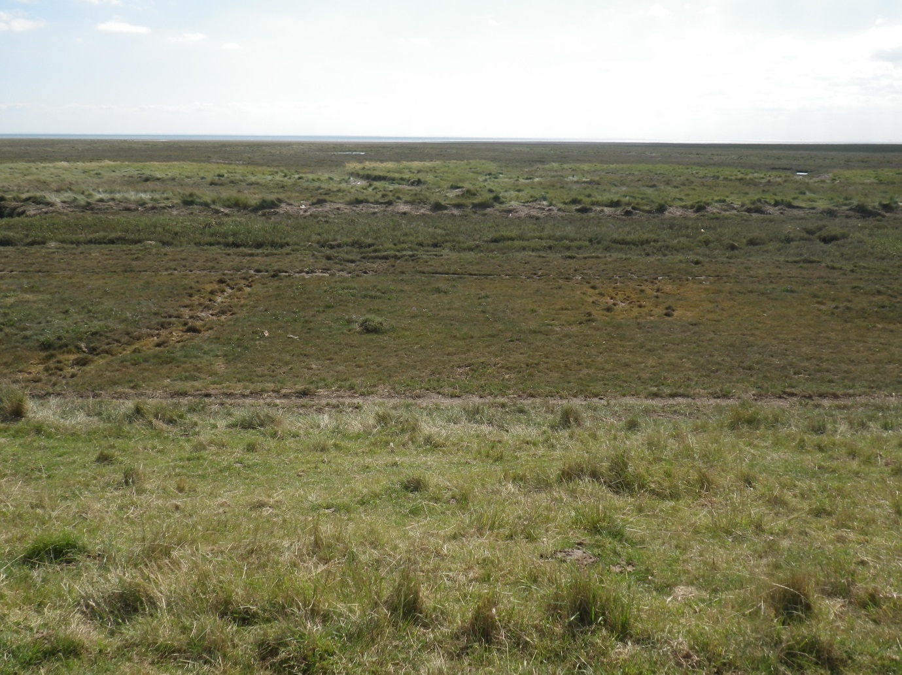
Figure 3-30 Photographs of habitat features for L3A5 29/08/2013 (L3A5_861 From seawall showing borrow pit and track)

No SM24 community was present at the seawall base. This area of borrow pits was heavily grazed by cattle with a bare mud access track, and SM14c community. A narrow band of SM24 was present in an area of higher ground beyond this before a transition to SM13/SM13c grassland. A significant SM6 pioneer community was present.

L3B6 Wrangle
Figure 3-31 Transect map for L3B6 Wrangle 21/08/2013
Table 3-16 Transect target notes for L3B6 Wrangle 21/08/2013
Ref | Target Note | NVC | NGR | Photo ref.
1 | Base of seawall. Heavily poached & grazed by cattle. P.maritima dominant with some A.portulacoides & A.prostrata. | SM10 | TF4604850270 | L3B6 Wrangle_344
2 | Wetter area with multiple creeks. Increased Limonium spp and S.maritimum on creeks | SM13c | TF4610950259 | L3B6 Wrangle_356
3 | Increased Spartina agg. Decreased Limonium spp. Wetter area with multiple salt pans. | SM10 | TF4635650055
4 | Drier area with large creek. P.maritima increase & A.portulacoides on creeks. | SM14c | TF4643549998 | L3B6 Wrangle_367
5 | Large creek edge. No community change | SM14c | TF4645249985
6 | Large creek edge dominated by A.portulacoides and Aster tripolium agg. Salt pans nearby | SM14c | TF4658649846 | L3B6 Wrangle_373
7 | Spartina spp, Aster tripolium agg, Salicornia agg community | SM10 | TF4660849878 | L3B6 Wrangle_6434
8 | Same community but decreased Aster tripolium agg and Spartina spp | SM10 | TF4665549861 | L3B6 Wrangle_6438
9 | Sea ward extent of salt marsh - mud flats |  | TF4672749840 | L3B6 Wrangle_6641&6642
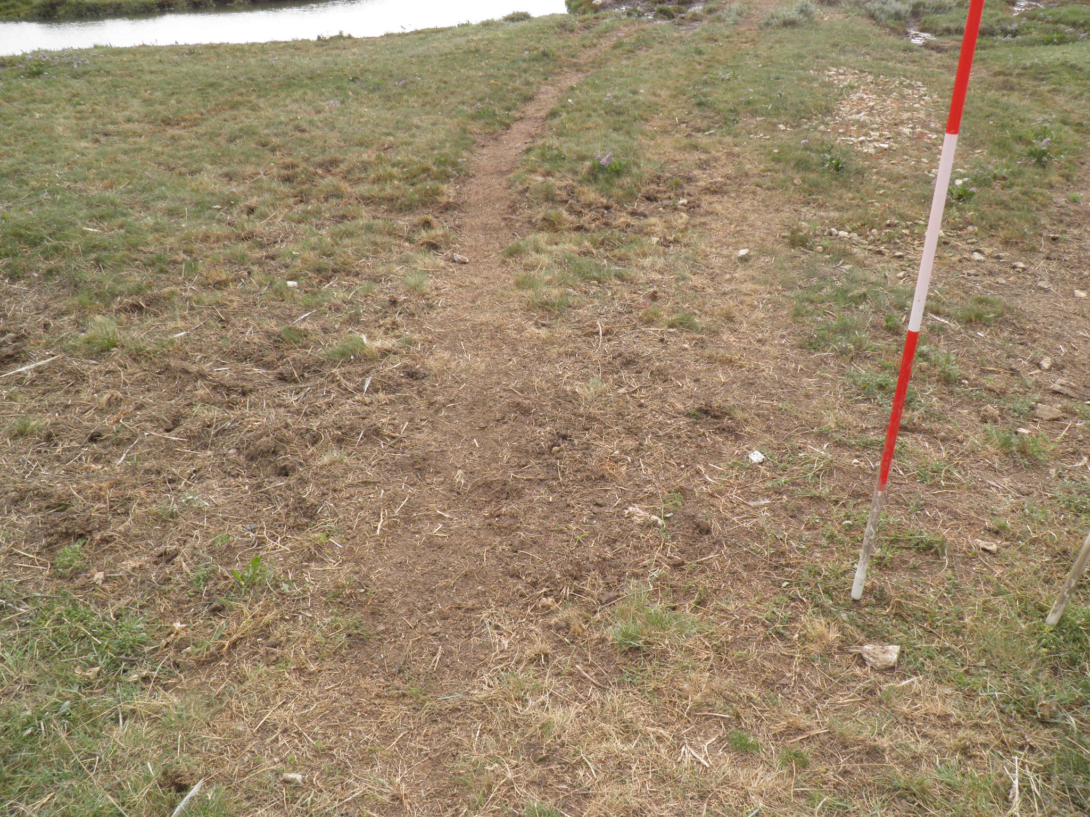
Figure 3-32 Photographs of habitat features for L3B6 Wrangle 21/08/2013 (L3B6_344 Poached and grazed by cattle and humans)
No SM24 community at base of seawall. Area was heavily grazed and poached by cattle with SM10 community then transition to SM13c. Increase in A.portulacoides and transition to SM14c was followed by return to SM190 to mudflats. No true pioneer community present.

Area 6 – The Horseshoe to Gibraltar Point

L3B7 Wrangle
Figure 3-33 Transect map for L3B7 Wrangle 21/08/2013
Table 3-17 Transect target notes for L3B7 Wrangle 21/08/2013
Ref | Target Note | NVC | NGR | Photo ref.
1 | Top of seawall. E.atherica dominant to base of sea wall. | SM24 | TF4724550695 | L3B7 Wrangle_6445
2 | P.maritima dominant community. Limonium spp and Aster tripolium agg | SM10 | TF4725350685 | L3B7 Wrangle_6448
3 | Medium creek, transition toward P.maritima and A.portulacoides. | SM10 | TF4726250671 | L3B7 Wrangle_6651
4 | Medium creek with same community. | SM10 | TF4732450609
5 | Large creek with Aster tripolium agg and Spartina community change. Salicornia agg increased. | SM10 | TF4739950552 | L3B7 Wrangle_6451
6 | Change to salt pans, with S.maritima and Salicornia agg and Spartina spp. Increased bare mud. | SM8 | TF4744350510 | L3B7 Wrangle_6452
7 | Change to mud flats. |  | TF4748150475 | L3B7 Wrangle_6453-6454

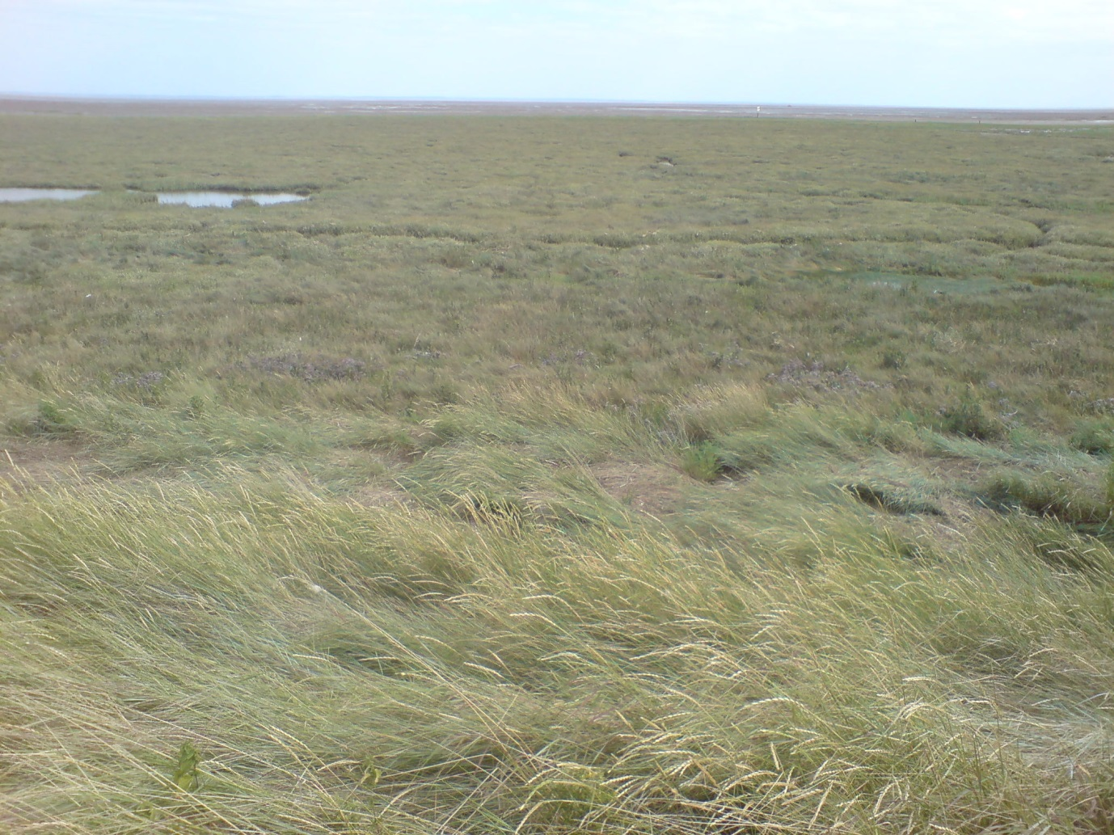
Figure 3-34 Photographs of habitat features for L3B7 Wrangle 21/08/2013 (L3B7_6445 From seawall)
The marsh was narrow at this point (<400m) with abundant creeks. A narrow band of SM24 was present at the base of the seawall followed by a transition to SM10 then SM8 pioneer vegetation with abundant salt pans.

L3B8
Figure 3-35 Transect map for L3B8 28/08/2013
Table 3-18 Transect target notes for L3B8 28/08/2013
Ref | Target Note |  | NGR | Photo ref.
1 | Top of seawall, E.atherica dominant community | SM24 (no quads) | TF5034453490 | L3B8_832
2 | Base of seawall, Limonium spp, S.maritima, and A.portulacoides | SM13a | TF5035653482 | L3B8_833
3 | Tarmac road | SM13a | TF5037453474 | L3B8_835
4 | Creek edge | SM13a | TF5039253449
5 | Increase in A.portulacoides | SM13a | TF5042653456 | L3B8_840
6 | Medium creek, E.atherica edge community | SM14c | TF5052353371 | L3B8_845
7 | Change towards Salicornia agg and S.maritima | SM14c | TF5071053162 | L3B8_850
8 | Mudflats with Salicornia agg | SM8 | TF5089652919 | L3B8_857-860

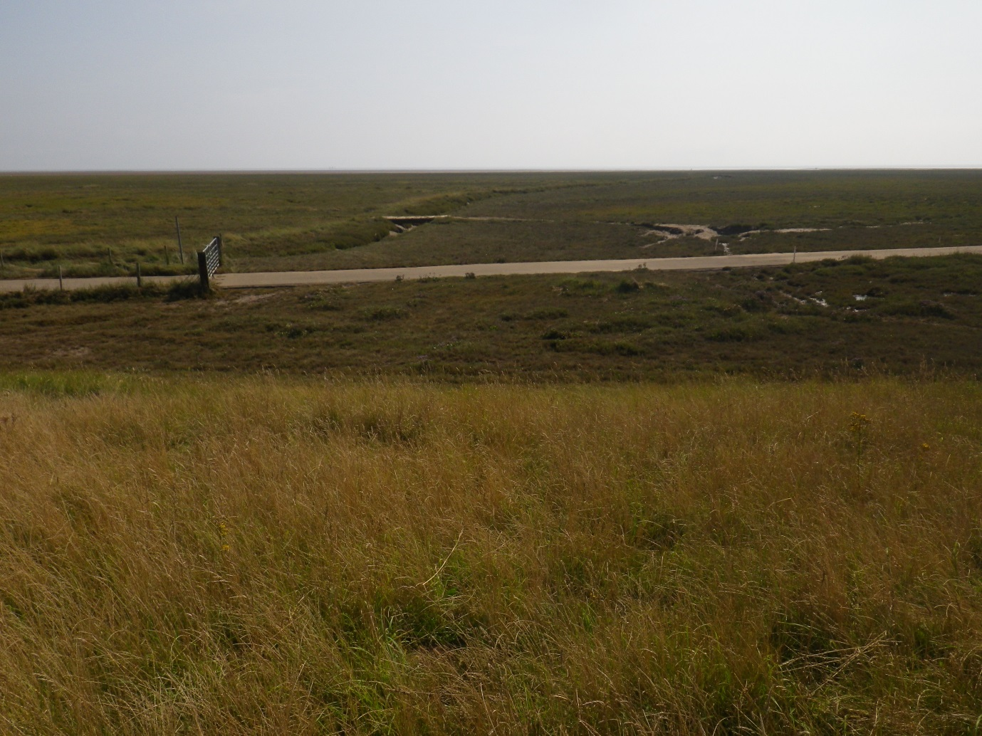
Figure 3-36 Photographs of habitat features for L3B8 28/08/2013 (L3B8_832 From seawall showing tarmac access road)
SM24 was present on the seawall only (no quadrats). At the base of the seawall was SM13a grassland interrupted by a tarmac access road. In the mid-marsh, increased creeks and A.portulacoides meant a transition to SM14c before a wide SM8 pioneer zone.

L3C6 Wainfleet
Figure 3-37 Transect map for L3C6 Wainfleet 21/08/2013
Table 3-19 Transect target notes for L3C6 Wainfleet 21/08/2013
Ref | Target Note |  | NGR | Photo ref.
1 | Top of seawall, E.atherica dominant with some common false-oat grass other herbs in low abundance | SM24 | TF5177655101 | L3C6 Wainfleet_622-624
2 | Vehicle track on seawall. Frequent E.atherica with cox foot and some red fescue | SM24 | TF5178055097 | L3C6 Wainfleet_625-627
3 | Base of seawall | SM24 | TF5178655090 | L3C6 Wainfleet_628
4 | End of E.atherica margin. Wet underfoot, sharp division between E.atherica and P.maritima | SM14c | TF5180055083 | L3C6 Wainfleet_634
5 | Creek edge, bands of E.atherica. | SM14c | TF5180655069
6 | Creek edge, band of E.atherica | SM14c | TF5180655066
7 | Isolated flooded area of P.maritima | SM14c | TF5181855053 | L3C6 Wainfleet_639
8 | 3m band of E.atherica, Limonium spp on seaward side | SM14c | TF5182555052 | L3C6 Wainfleet_640
9 | Continuation of P.maritima, Limonium spp community. Wet underfoot. | SM14c | TF5183055047 | L3C6 Wainfleet_641
10 | E.atherica dominant with A.portulacoides | SM24 | TF5190954997 | L3C6 Wainfleet_644
11 | Crossed over narrow creek, new community with P.maritima and Aster tripolium agg dominant, Limonium spp reduced and E.atherica lined creek edge | SM14c | TF5196854960 | L3C6 Wainfleet_650
12 | 8m of E.atherica at creek edge | SM14c | TF5207354889
13 | Aster tripolium agg and P.maritima dominant with A.portulacoides and less than 1 percent Limonium spp and Spartina agg | SM14a | TF5212654871 | L3C6 Wainfleet_656
14 | Salicornia agg and S.maritima dominant | SM8 | TF5228254792 | L3C6 Wainfleet_662
15 | Salicornia agg zone ends, mudflats/intertidal zone - Salicornia agg less than 1 percent |  | TF5257354645
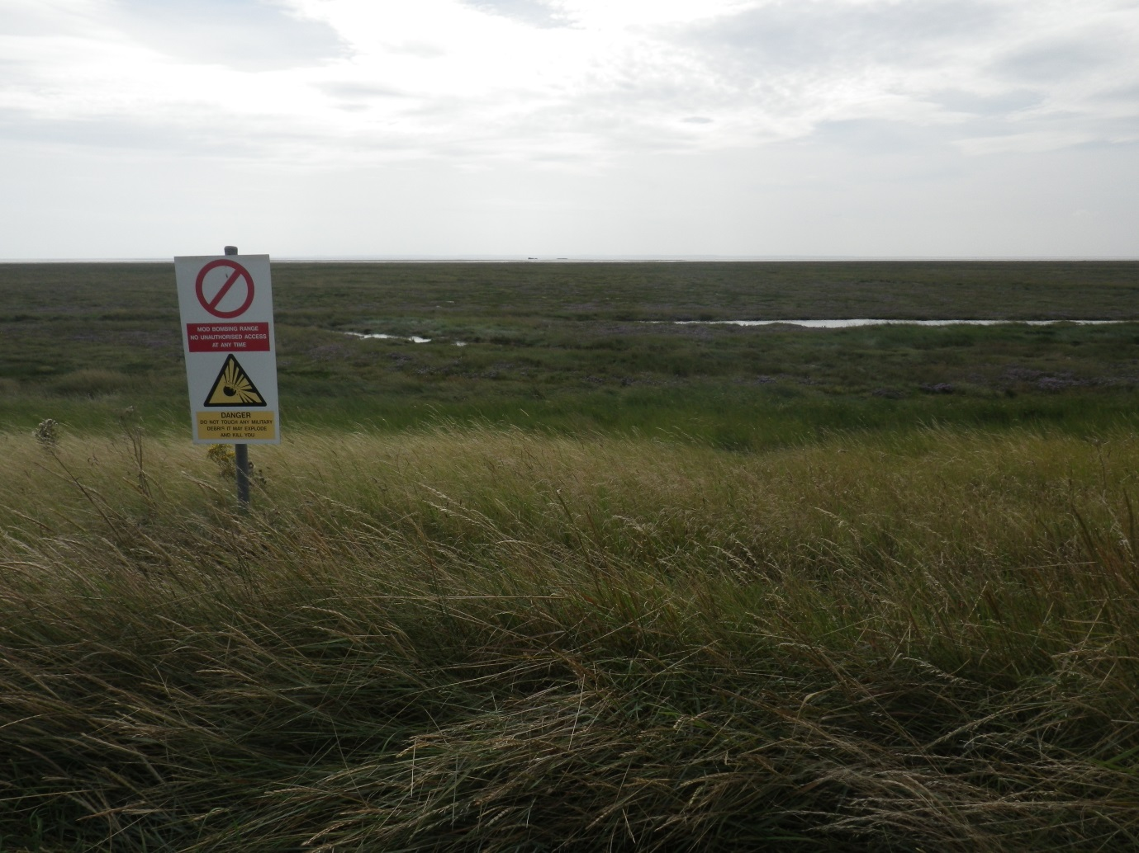
Figure 3-38 Photographs of habitat features for L3C6 Wainfleet 21/08/2013 (L3C6_622 From seawall – restricted area)
A narrow band of SM24 was present at the base of the seawall with a transition to SM14c in the lower-lying borrow pits. This community was interrupted by a band of SM24 in a higher area, (possibly a remnant sea defence) before returning to SM14c. A wide SM8 pioneer zone was present before mudflats.

L3C7
Figure 3-39 Transect map for L3C7 28/08/2013
Table 3-20 Transect target notes for L3C7 28/08/2013
Ref | Target Note |  | NGR | Photo ref.
1 | Shallow sea wall with variety of grasses and herbs. E.atherica and common false oat. | SM10 | TF5319156529 | L3C7_16
2 | E.atherica dominant community with salt pan right at base of sea wall. Extends out into the marsh. Large creek nearby. | SM10 | TF5319956522 | L3C7_17
3 | A.portulacoides dominant community with P.maritima co-dominant. Some patches of E.atherica still present. S.maritima and Aster tripolium agg also present. Extends towards mud flats. | SM10 | TF5327356473 | L3C7_25
4 | Large creek with A.portulacoides dominant alongside. | SM10 | TF5339256378 | L3C7_29
5 | Large creek with A.portulacoides and Aster tripolium agg. | SM10 | TF5345856317 | L3C7_31
6 | P.maritima dominant community with Spartina agg and Salicornia agg. Numerous salt pans and a large creek nearby. A.portulacoides and Aster tripolium agg <1%. 50 wide zone then mud flats. | SM10 | TF5360656137 | L3C7_34
7 | Mud flats |  | TF5365456074 | L3C7_40-45
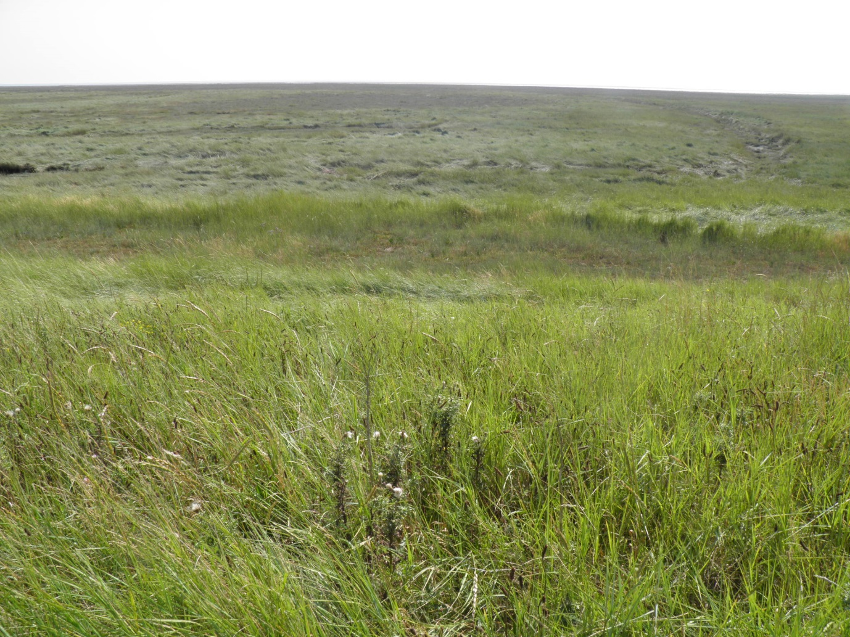
Figure 3-40 Photographs of habitat features for L3C7 28/08/2013 (L3C7_16 From seawall)
The seawall here was shallow and dominated by tall herbs. This area of marsh was characterised by extensive habitat mosaics. The entire transect was classified as SM10 with no true pioneer community present.

Area 7 – Gibraltar Point to Skegness

L3D5 Wainfleet
Figure 3-41 Transect map for L3D5 Wainfleet 20/08/2013
Table 3-21 Transect target notes for L3D5 Wainfleet 20/08/2013
Ref | Target Note |  | NGR | Photo ref.
1 | Dune grassland community: E.atherica, Limonium spp and marram grass |  | TF5621757720 | L3D5 Wainfleet_595
2 | Shingle path | SM24 | TF5621357705
3 | E.atherica grass margin | SM24 | TF5621557702 | L3D5 Wainfleet_598
4 | Limonium spp, P.maritima dominant | SM10 | TF5621557694 | L3D5 Wainfleet_602
5 | Raised area with E.atherica dominant - approximately 15m wide | SM10 | TF5618857536 | L3D5 Wainfleet_608
6 | Back to A.portulacoides community to creek edge | SM10 | TF5618757531
7 | Large creek | SM10 | TF5618857519
8 | Dune community with sea holly, sea sandwort, sand sedge and common cats ear, red fescue, some marram grass, sedum spp., lyme grass | N/A | TF5612657505 | L3D5 Wainfleet_609
9 | Edge of dune community | SM10 | TF5610957488 | L3D5 Wainfleet_610
10 | Return to A.portulacoides community | SM10 | TF5610057480 | L3D5 Wainfleet_611
11 | Salicornia agg and S.maritima community | SM8 | TF5602157447 | L3D5 Wainfleet_615
12 | End of Salicornia agg community - mudflats |  | TF5592157290
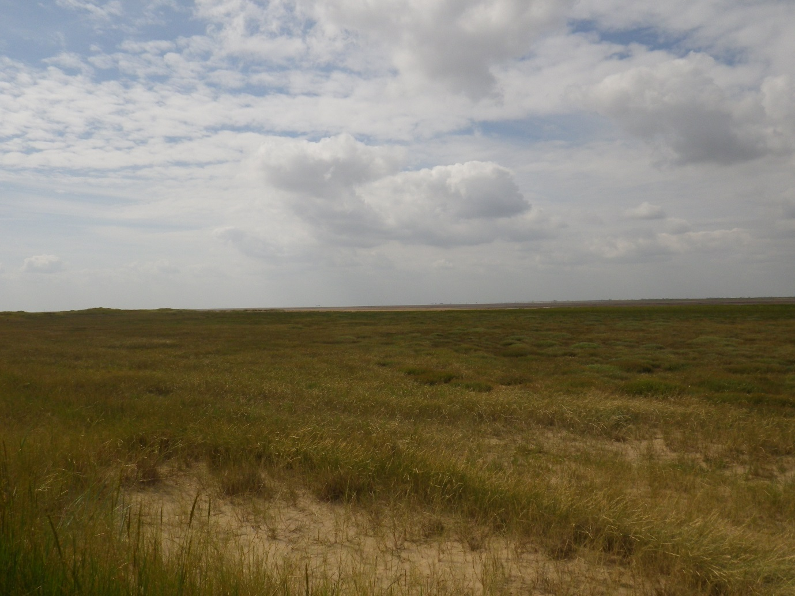
Figure 3-42 Photographs of habitat features for L3D5 Wainfleet 20/08/2013 (L3D5_595 Dune community – not surveyed)
No seawall was present at this site. The transect started in dune grassland before crossing a shingle path to SM24 grassland. The mid/upper marsh was classified as SM10 interrupted by another band of dune community (not sampled). A wide band of SM8 pioneer vegetation was present at the seaward extent.

Seacroft
Figure 3-43 Transect map for Seacroft 22/08/2013
Table 3-22 Transect target notes for Seacroft 22/08/2013
Ref | Target Note |  | NGR | Photo ref.
1 | Dune community. First sea wall from road. sea buckthorn and E.atherica | SM10 | TF5661461014 | Seacroft_318
2 | Flat area behind dune. Limonium binervosum present | SM10 | TF5662461009 | Seacroft_319
3 | Dune community. Not surveyed. | N/A | TF5672660940 | Seacroft_327
4 | End of dune community. A.portulacoides and S.maritima | SM14a | TF5683160864 | Seacroft_328
5 | Medium creek. A.portulacoides communities around creek. | SM14a | TF5687560853
6 | Wide creek with S.maritima, P.maritima and bare mud. | SM14a | TF5690560842
7 | Dune community with E.atherica, L.binervosum and sea buckthorn | N/A | TF5695560815

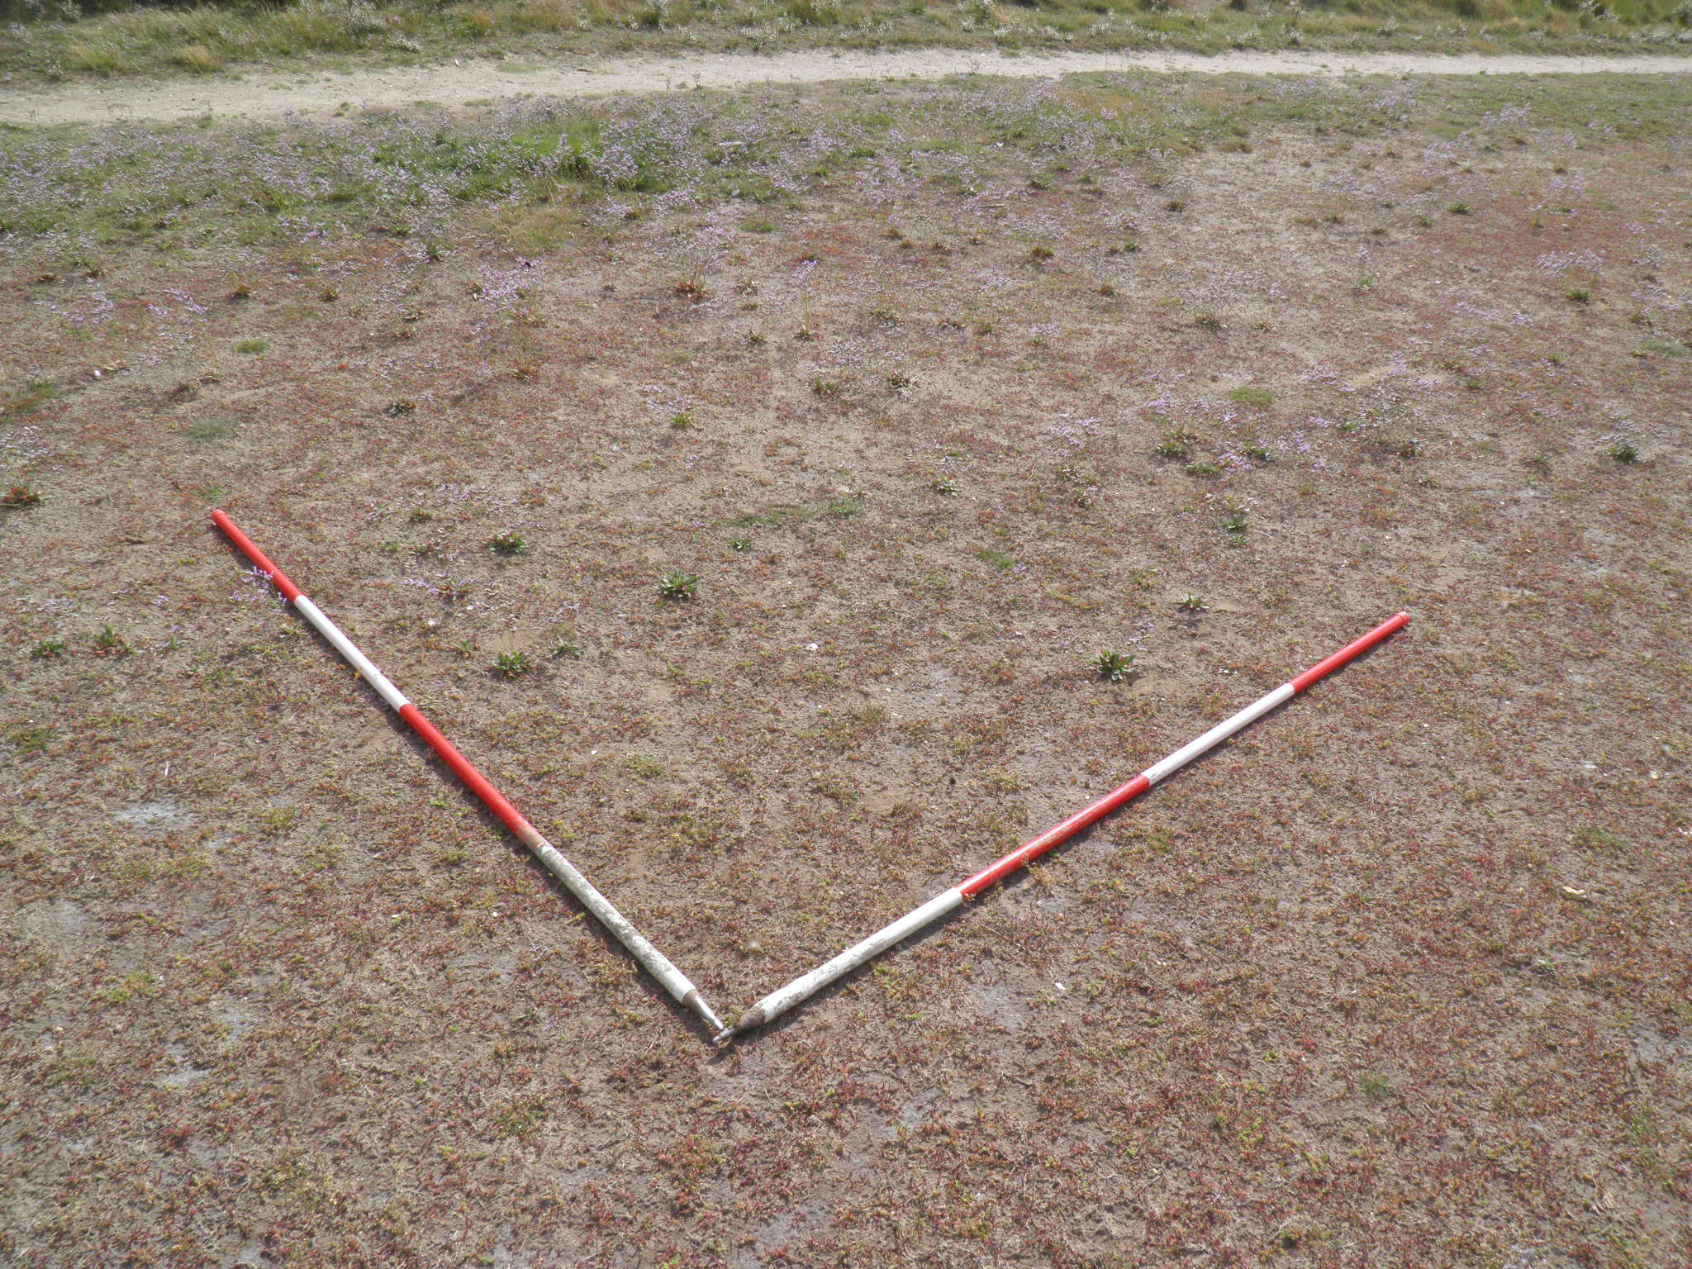Figure 3-44 Photographs of habitat features for Seacroft 22/08/2013 (Seacroft_319 Flat area with L.binervosum)

This transect surveyed an area of marsh between dune communities. The transect started at the seawall and road with a dune community before a transition to a borrow pit/header channel area with SM10 low-lying vegetation. The transect then passed through a second area of dune grassland before a transition to SM14a marsh with abundant creeks. Following this, the transect passed into dune grassland before a sandy cliff and beach area.

NVC communities identified
The plant species and habitat types identified during the surveys are listed in Appendix 3.

SM6 Spartina anglica saltmarsh community Spartinetum townsendii (Tansley 1939) Corillion 1953
This is a species-poor community dominated by S.anglica with a variety of associate species. It is found at the seaward fringes of marshes, on creek sides and in old salt pans of the upper marsh (Rodwell, 2000).
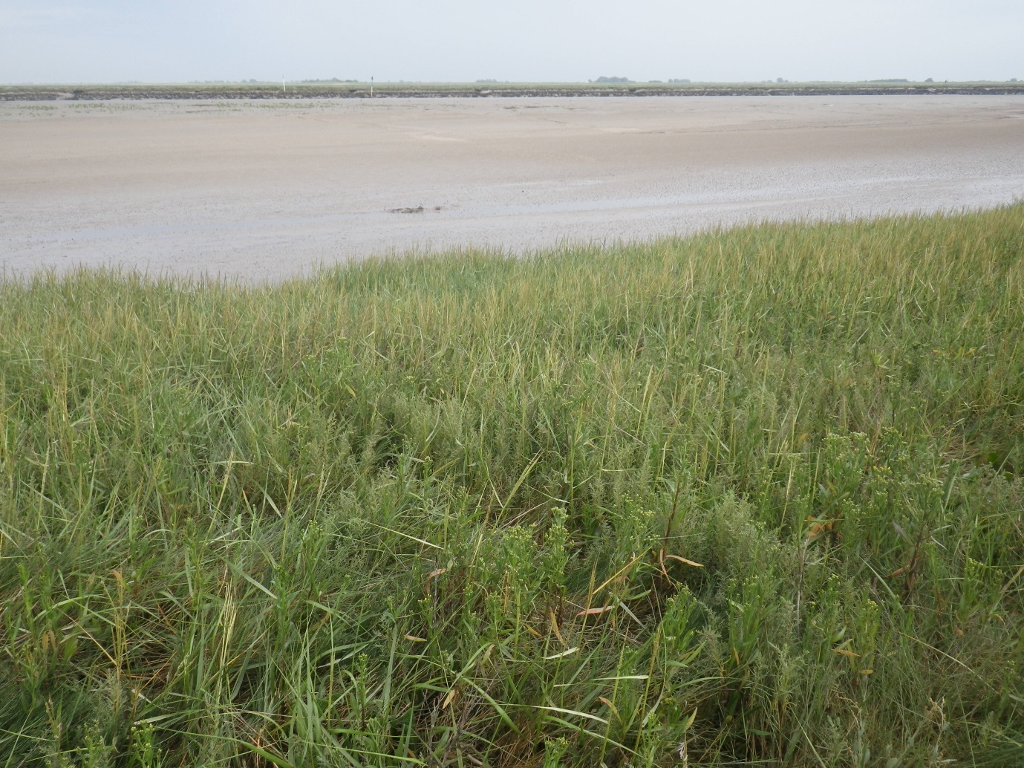
Figure 3-45 Example quadrats for NVC community SM6 (Frampton_722)

Table 3-23 NOC4 Wolferton SM6
 | MAVIS species | Constancy
 | Aster tripolium | V
 | Puccinellia maritima | V
 | Spartina anglica | V
 | Suaeda maritima | IV
 | Atriplex prostrata | II
 | Salicornia europaea | II

Table 3-24 NOD1 Terrington SM6
 | MAVIS species | Constancy
 | Aster tripolium | V
 | Puccinellia maritima | I
 | Spartina anglica | V
 | Suaeda maritima | III
 | Atriplex prostrata | I
 | Salicornia europaea | V
 | Bare ground/litter/water/rock/mud | IV

Table 3-25 Frampton SM6
 | MAVIS species | Constancy
 | Sarcocornia perennis | I
 | Spartina anglica | V
 | Suaeda maritima | III
 | Salicornia europaea | III
 | Bare ground/litter/water/rock/mud | V

Table 3-26 L3A3a SM6
 | MAVIS species | Constancy
 | Aster tripolium | V
 | Atriplex portulacoides | I
 | Puccinellia maritima | I
 | Spartina anglica | V
 | Suaeda maritima | IV
 | Salicornia europaea | IV
 | Bare ground/litter/water/rock/mud | V

Table 3-27 L3A5 SM6
 | MAVIS species | Constancy
 | Algal mat | II
 | Aster tripolium | III
 | Cochlearia anglica | I
 | Glaux maritima | I
 | Atriplex portulacoides | I
 | Plantago maritima | I
 | Puccinellia maritima | I
 | Spartina anglica | V
 | Spergularia media | I
 | Suaeda maritima | IV
 | Salicornia europaea | V
 | Bare ground/litter/water/rock/mud | V

This community was found infrequently throughout The Wash, usually in small patches or as a narrow pioneer community, often above a band of SM8 and mudflats. In almost all occurrences, other plant species were associated with the community, but at very low abundance.

SM8 Annual Salicornia saltmarsh community Salicornietum europaeae Warming 1906
This community is species poor, often annual Salicornia species are the only vascular plants present. Occasional associate species include P.maritima, S.maritima and S.anglica. On mud substrates in The Wash, the percentage cover of Salicornia can be high, but algal mat and bare mud are usually present. SM8 community is found in the lower marsh but may also form a mosaic within mid-marsh communities. It is also present in old salt pans, borrow pits and on creek sides throughout the marsh (Rodwell, 2000).
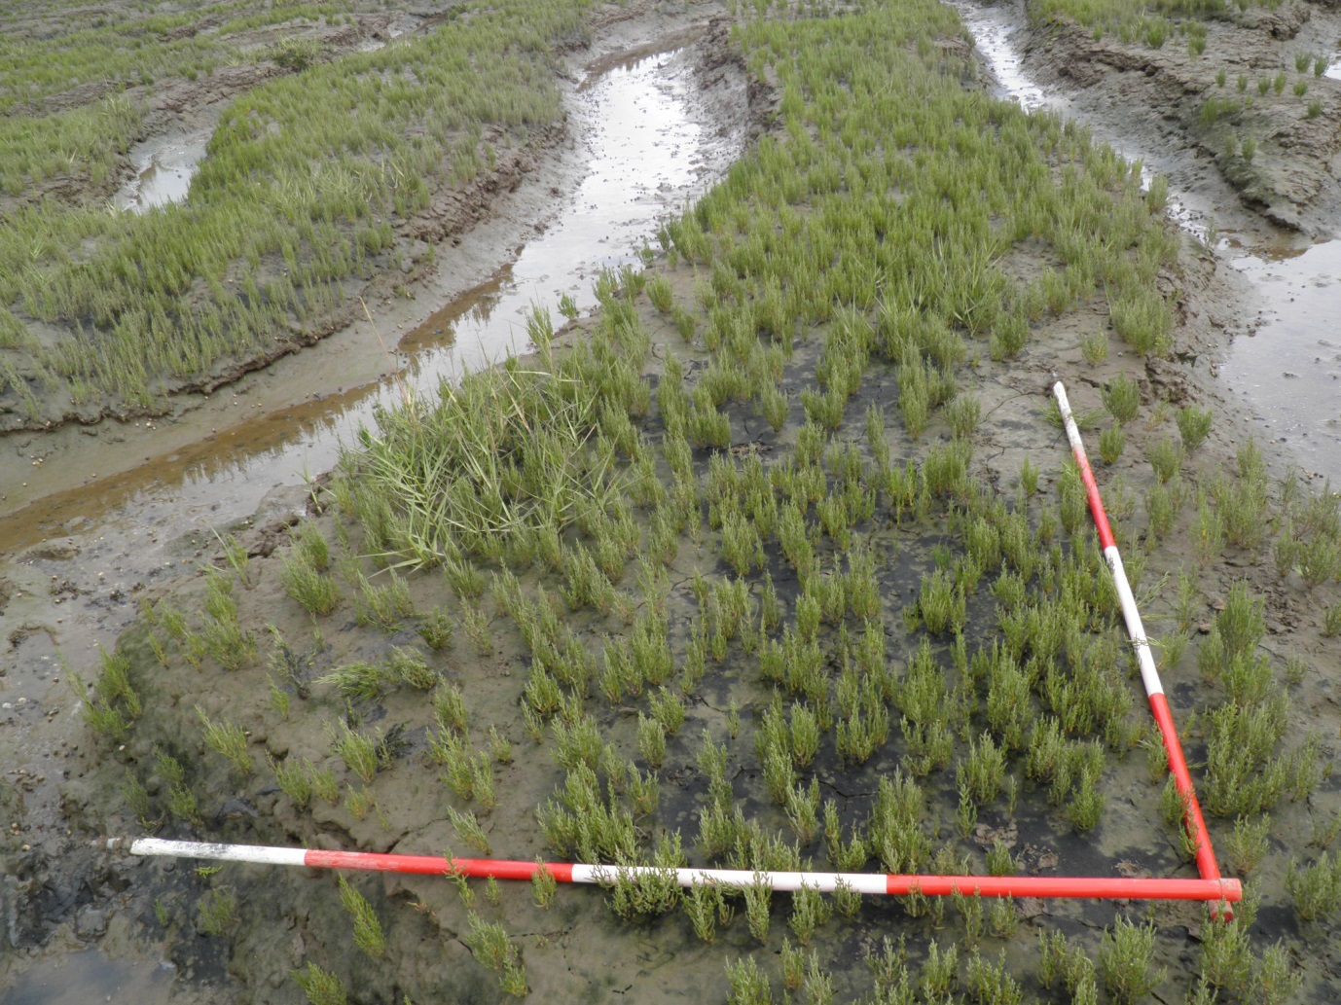
Figure 3-46 Example quadrats for NVC community SM8 (L3A3_36)
Table 3-28 NOB4 Wolferton SM8
 | MAVIS species | Constancy
 | Spergularia media | V
 | Salicornia europaea | V
 | Bare ground/litter/water/rock/mud | V

Table 3-29 NOB5 SM8
 | MAVIS species | Constancy
 | Aster tripolium | I
 | Spartina anglica | IV
 | Suaeda maritima | V
 | Salicornia europaea | V
 | Bare ground/litter/water/rock/mud | V

Table 3-30 NOD1 Terrington SM8
 | MAVIS species | Constancy
 | Spartina anglica | IV
 | Suaeda maritima | I
 | Salicornia europaea | V
 | Bare ground/litter/water/rock/mud | V

Table 3-31 NOD4 Terrington SM8
 | MAVIS species | Constancy
 | Algal mat | II
 | Aster tripolium | II
 | Spartina anglica | V
 | Suaeda maritima | III
 | Salicornia europaea | V
 | Bare ground/litter/water/rock/mud | V

Table 3-32 L4C5a SM8
 | MAVIS species | Constancy
 | Algal mat | II
 | Aster tripolium | III
 | Spartina anglica | IV
 | Suaeda maritima | III
 | Salicornia europaea | V
 | Bare ground/litter/water/rock/mud | IV

Table 3-33 L3A3 Freiston SM8
 | MAVIS species | Constancy
 | Algal mat | III
 | Spartina anglica | II
 | Salicornia europaea | IV
 | Bare ground/litter/water/rock/mud | V

Table 3-34 L3A4 SM8
 | MAVIS species | Constancy
 | Algal mat | V
 | Puccinellia maritima | I
 | Spartina anglica | I
 | Suaeda maritima | I
 | Salicornia europaea | V
 | Bare ground/litter/water/rock/mud | V

Table 3-35 L3B7 Wrangle SM8
 | MAVIS species | Constancy
 | Aster tripolium | III
 | Atriplex portulacoides | II
 | Spartina anglica | IV
 | Suaeda maritima | III
 | Salicornia europaea | IV
 | Bare ground/litter/water/rock/mud | V

Table 3-36 L3B8 SM8
 | MAVIS species | Constancy
 | Algal mat | I
 | Aster tripolium | I
 | Puccinellia maritima | III
 | Spartina anglica | II
 | Suaeda maritima | III
 | Salicornia europaea | V
 | Bare ground/litter/water/rock/mud | IV

Table 3-37 L3C6 Wainfleet SM8
 | MAVIS species | Constancy
 | Algal mat | IV
 | Puccinellia maritima | I
 | Suaeda maritima | III
 | Salicornia europaea | V
 | Bare ground/litter/water/rock/mud | V

Table 3-38 L3D5 Wainfleet SM8
 | MAVIS species | Constancy
 | Algal mat | V
 | Aster tripolium | III
 | Atriplex portulacoides | I
 | Puccinellia maritima | I
 | Sarcocornia perennis | I
 | Spartina anglica | III
 | Suaeda maritima | III
 | Salicornia europaea | V
 | Bare ground/litter/water/rock/mud | V

Table 3-39 L3A3a SM8
 | MAVIS species | Constancy
 | Algal mat | I
 | Suaeda maritima | I
 | Salicornia europaea | V
 | Bare ground/litter/water/rock/mud | V

SM8 was found at almost all sites in The Wash, on creek sides, in salt pans and as wide pioneer communities at the seaward extent. This community was notably not present at sites where the marsh ended abruptly at a steep creek edge or dune habitat.

SM10 Transitional low-marsh vegetation with Puccinellia maritima, annual Salicornia species and Suaeda maritima
This transitional community is characterised by the three co-dominant species: P.maritima, Salicornia spp and A.portulacoides, in varying abundance. Aster spp may be frequent but not abundant. In The Wash, the community tends to occur in depressions within other mid-marsh communities and on creek sides.
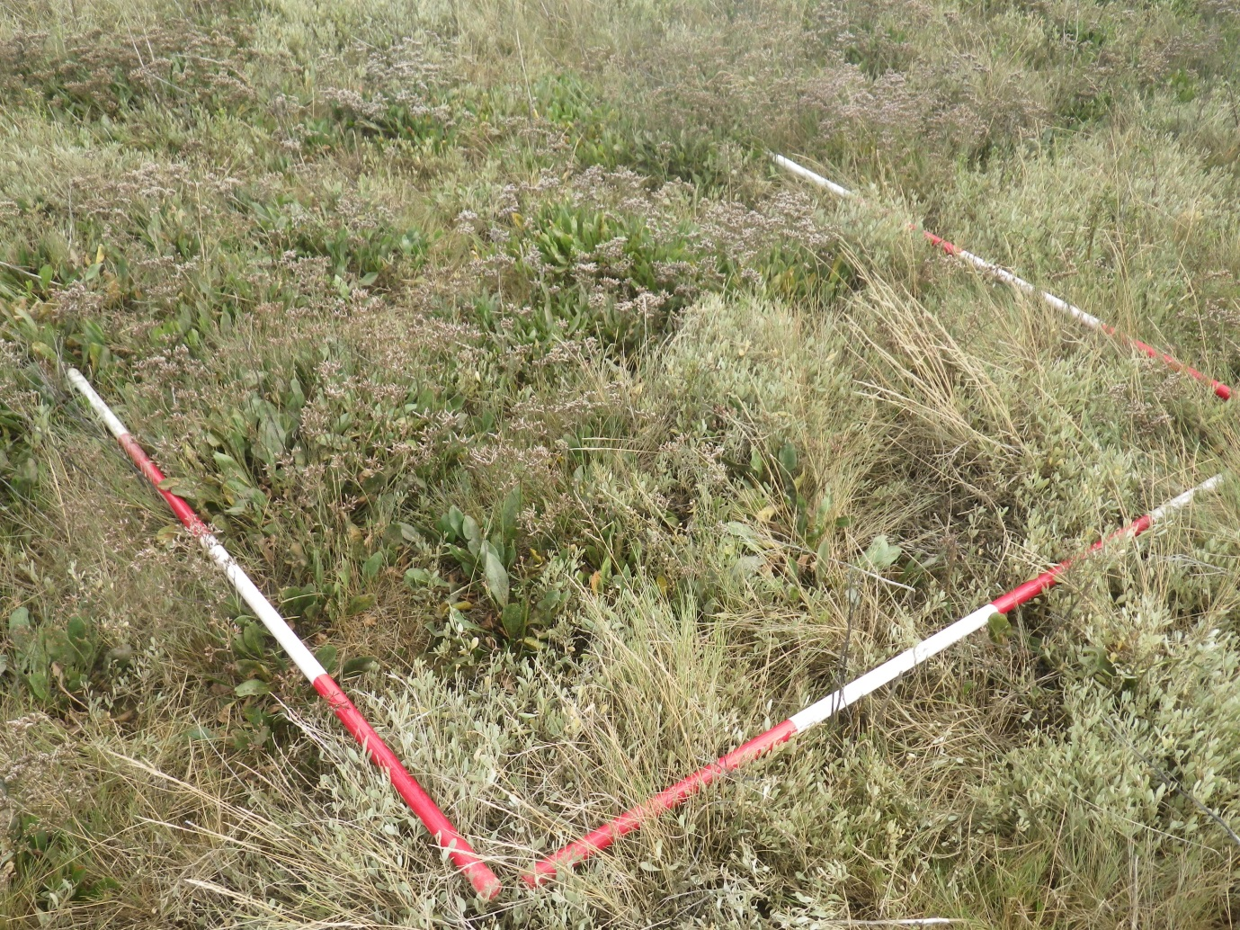
Figure 3-47 Example quadrats for NVC community SM10 (L3D5_605)
Table 3-40 NOB4 Wolferton SM10
 | MAVIS species | Constancy
 | Aster tripolium | IV
 | Suaeda maritima | V
 | Atriplex prostrata | IV
 | Salicornia europaea | V
 | Bare ground/litter/water/rock/mud | IV

Table 3-41 NOD4 Terrington SM10
 | MAVIS species | Constancy
 | Elytrigia atherica | I
 | Aster tripolium | V
 | Cochlearia anglica | II
 | Atriplex portulacoides | V
 | Puccinellia maritima | V
 | Spartina anglica | I
 | Suaeda maritima | V
 | Cochlearia officinalis | IV
 | Salicornia europaea | III
 | Bare ground/litter/water/rock/mud | V
 | MAVIS species | Constancy
 | Elytrigia atherica | I
 | Aster tripolium | V
 | Atriplex portulacoides | V
 | Puccinellia maritima | III
 | Suaeda maritima | IV
 | Atriplex prostrata | I
 | Salicornia europaea | V
 | Bare ground/litter/water/rock/mud | V

Table 3-42 L4B2 Gedney Drove End SM10
 | MAVIS species | Constancy
 | Aster tripolium | V
 | Atriplex portulacoides | II
 | Puccinellia maritima | V
 | Spartina anglica | II
 | Suaeda maritima | V
 | Salicornia europaea | V
 | Bare ground/litter/water/rock/mud | V
 | MAVIS species | Constancy
 | Algal mat | IV
 | Aster tripolium | V
 | Atriplex portulacoides | IV
 | Puccinellia maritima | III
 | Spartina anglica | I
 | Suaeda maritima | V
 | Salicornia europaea | V
 | Bare ground/litter/water/rock/mud | V
 | MAVIS species | Constancy
 | Algal mat | III
 | Aster tripolium | III
 | Spartina anglica | III
 | Suaeda maritima | V
 | Salicornia europaea | V
 | Bare ground/litter/water/rock/mud | V

Table 3-43 L4C4 Holbeach SM10
 | MAVIS species | Constancy
 | Aster tripolium | IV
 | Puccinellia maritima | II
 | Spartina anglica | IV
 | Suaeda maritima | V
 | Salicornia europaea | V
 | Bare ground/litter/water/rock/mud | III

Table 3-44 L4C5a SM10
 | MAVIS species | Constancy
 | Aster tripolium | V
 | Atriplex portulacoides | III
 | Puccinellia maritima | V
 | Spartina anglica | V
 | Suaeda maritima | V
 | Salicornia europaea | III

Table 3-45 L3A3 Freiston SM10
 | MAVIS species | Constancy
 | Aster tripolium | V
 | Atriplex portulacoides | IV
 | Puccinellia maritima | V
 | Suaeda maritima | IV
 | Salicornia europaea | IV
 | Bare ground/litter/water/rock/mud | V
 | MAVIS species | Constancy
 | Aster tripolium | V
 | Atriplex portulacoides | I
 | Puccinellia maritima | V
 | Spartina anglica | IV
 | Suaeda maritima | III
 | Salicornia europaea | V
 | Bare ground/litter/water/rock/mud | V
 | MAVIS species | Constancy
 | Algal mat | I
 | Aster tripolium | IV
 | Atriplex portulacoides | III
 | Limonium vulgare | I
 | Puccinellia maritima | V
 | Spartina anglica | II
 | Spergularia media | III
 | Suaeda maritima | V
 | Salicornia europaea | V
 | Bare ground/litter/water/rock/mud | V
 | MAVIS species | Constancy
 | Algal mat | I
 | Aster tripolium | V
 | Atriplex portulacoides | V
 | Puccinellia maritima | V
 | Spartina anglica | III
 | Spergularia media | I
 | Suaeda maritima | V
 | Salicornia europaea | V
 | Bare ground/litter/water/rock/mud | V

Table 3-46 L3A3a SM10
 | MAVIS species | Constancy
 | Aster tripolium | V
 | Atriplex portulacoides | V
 | Puccinellia maritima | V
 | Spartina anglica | V
 | Suaeda maritima | V
 | Triglochin maritimum | III
 | Salicornia europaea | V
 | Bare ground/litter/water/rock/mud | V

Table 3-47 L3A4 SM10
 | MAVIS species | Constancy
 | Aster tripolium | V
 | Puccinellia maritima | III
 | Spartina anglica | II
 | Suaeda maritima | V
 | Salicornia europaea | V
 | Bare ground/litter/water/rock/mud | III
 | MAVIS species | Constancy
 | Algal mat | II
 | Aster tripolium | IV
 | Spartina anglica | III
 | Suaeda maritima | V
 | Salicornia europaea | V
 | Bare ground/litter/water/rock/mud | V

Table 3-48 L3B6 Wrangle SM10
 | MAVIS species | Constancy
 | Seriphidium maritimum | II
 | Aster tripolium | IV
 | Cochlearia anglica | I
 | Glaux maritima | IV
 | Atriplex portulacoides | IV
 | Limonium vulgare | V
 | Plantago maritima | I
 | Puccinellia maritima | V
 | Suaeda maritima | V
 | Triglochin maritimum | III
 | Salicornia europaea | V
 | Bare ground/litter/water/rock/mud | IV
 | MAVIS species | Constancy
 | Aster tripolium | V
 | Atriplex portulacoides | II
 | Limonium vulgare | V
 | Plantago maritima | I
 | Puccinellia maritima | V
 | Spartina anglica | V
 | Spergularia media | II
 | Suaeda maritima | II
 | Triglochin maritimum | I
 | Salicornia europaea | V
 | Bare ground/litter/water/rock/mud | III
 | MAVIS species | Constancy
 | Aster tripolium | IV
 | Puccinellia maritima | II
 | Spartina anglica | III
 | Spergularia media | I
 | Suaeda maritima | III
 | Salicornia europaea | V
 | Bare ground/litter/water/rock/mud | V

Table 3-49 L3B7 Wrangle SM10
 | MAVIS species | Constancy
 | Aster tripolium | V
 | Atriplex portulacoides | IV
 | Limonium vulgare | I
 | Puccinellia maritima | III
 | Spartina anglica | I
 | Suaeda maritima | V
 | Salicornia europaea | V
 | Bare ground/litter/water/rock/mud | II
 | MAVIS species | Constancy
 | Aster tripolium | V
 | Atriplex portulacoides | II
 | Puccinellia maritima | II
 | Spartina anglica | II
 | Suaeda maritima | V
 | Salicornia europaea | V
 | Bare ground/litter/water/rock/mud | V

Table 3-50 L3C7 SM10
 | MAVIS species | Constancy
 | Elytrigia atherica | V
 | Agrostis stolonifera | II
 | Aster tripolium | III
 | Atriplex portulacoides | III
 | Limonium vulgare | I
 | Puccinellia maritima | III
 | Sonchus arvensis | II
 | Spergularia media | II
 | Suaeda maritima | IV
 | Cochlearia officinalis | I
 | Salicornia europaea | III
 | Bare ground/litter/water/rock/mud | II
 | MAVIS species | Constancy
 | Elytrigia atherica | I
 | Aster tripolium | V
 | Atriplex portulacoides | V
 | Puccinellia maritima | V
 | Spartina anglica | IV
 | Suaeda maritima | V
 | Salicornia europaea | V
 | Bare ground/litter/water/rock/mud | I
 | MAVIS species | Constancy
 | Algal mat | V
 | Aster tripolium | I
 | Atriplex portulacoides | I
 | Puccinellia maritima | V
 | Spartina anglica | III
 | Suaeda maritima | IV
 | Salicornia europaea | V
 | Bare ground/litter/water/rock/mud | V

Table 3-51 L3D5 Wainfleet SM10
 | MAVIS species | Constancy
 | Algal mat | II
 | Aster tripolium | IV
 | Cochlearia anglica | II
 | Festuca rubra | I
 | Atriplex portulacoides | IV
 | Limonium vulgare | II
 | Plantago maritima | I
 | Puccinellia maritima | III
 | Spartina anglica | I
 | Spergularia media | II
 | Stellaria media | I
 | Suaeda maritima | IV
 | Salicornia europaea | IV
 | Bare ground/litter/water/rock/mud | IV

Table 3-52 Seacroft SM10
 | MAVIS species | Constancy
 | Spergularia media | II
 | Suaeda maritima | V
 | Limonium binervosum | II
 | Salicornia europaea | V
 | Bare ground/litter/water/rock/mud | V

This community was widespread and abundant throughout The Wash saltmarshes often covering large areas of the mid-marsh and borrow pit areas. At some sites, this community reached to the seaward extent, with no true pioneer community present.

SM11 Aster tripolium var. discoideus saltmarsh community Asteretum tripolii Tansley 1939 & SM12 Rayed Aster tripolium on saltmarshes
Due to identification issues with Aster spp, SM11 and SM12 are considered together. These communities are dominated by Aster spp with some Salicornia agg, P.maritima and S.maritima. It forms an extensive zone in the low marsh or creek sides throughout the marsh, occasionally reaching to the seaward extent (Rodwell, 2000).
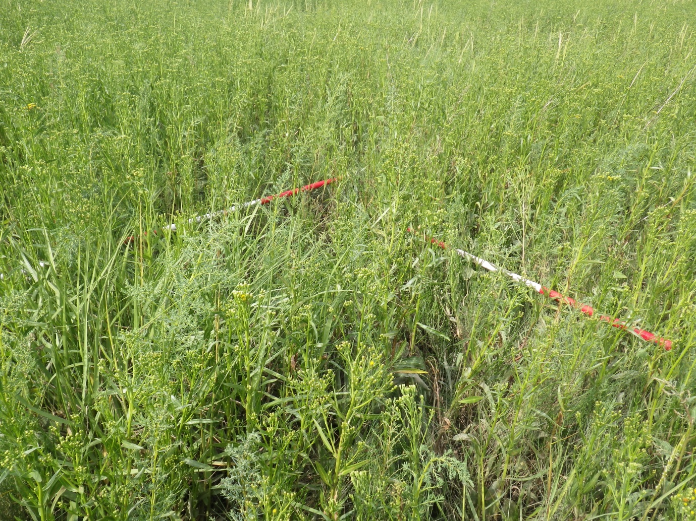
Figure 3-48 Example quadrats for NVC community SM11/SM12 (L4A3 _582)
Table 3-53 NOD1 Terrington SM11/12
 | MAVIS species | Constancy
 | Aster tripolium | III
 | Atriplex portulacoides | II
 | Puccinellia maritima | V
 | Spartina anglica | III
 | Atriplex prostrata | V
 | MAVIS species | Constancy
 | Aster tripolium | V
 | Puccinellia maritima | V
 | Spartina anglica | V
 | Suaeda maritima | V
 | Atriplex prostrata | V
 | Salicornia europaea | V
 | Bare ground/litter/water/rock/mud | IV

Table 3-54 NOD4 Terrington SM11/12
 | MAVIS species | Constancy
 | Aster tripolium | V
 | Atriplex portulacoides | IV
 | Puccinellia maritima | II
 | Suaeda maritima | V
 | Atriplex prostrata | IV
 | Bare ground/litter/water/rock/mud | V

Table 3-55 L4A3 SM11/12
 | MAVIS species | Constancy
 | Armeria maritima | I
 | Aster tripolium | V
 | Puccinellia maritima | I
 | Spartina anglica | V
 | Suaeda maritima | IV
 | Atriplex prostrata | II
 | Salicornia europaea | V
 | Bare ground/litter/water/rock/mud | V

Table 3-56 Frampton SM11/12
 | MAVIS species | Constancy
 | Elytrigia atherica | V
 | Aster tripolium | V
 | Puccinellia maritima | V
 | Triglochin maritimum | V
 | Atriplex prostrata | V
 | Bare ground/litter/water/rock/mud | V

SM11/SM12 was present in the low marsh, but was not abundant in The Wash. Other communities with abundant Aster spp were classified as SM10 due to the frequent presence of co-dominant species.

SM13 Puccinellia maritima saltmarsh community Puccinellietum maritimae (Warming 1906) Christiansen 1927
- Includes sub-communities SM13a, SM13b & SM13c
P.maritima is the single constant species of this community, there are 6 sub-communities with a variety of associate taxa. SM13 usually occurs as species-poor grassland but is highly variable, it is differentiated from pioneer and upper marsh communities by the reduced frequency and abundance of associate species. SM13 is the most widespread and extensive perennial lower saltmarsh community in the UK. It is found above the pioneer zone, creek sides, in old pans and in disturbed areas of the upper marsh. Grazing is important in the maintenance of this community, maintaining the dominance of grasses against tall herbs.
Communities were classified as SM13a (P.maritima dominant) where P.maritima was clearly the dominant species with few associates. In The Wash, this community is often found in the upper marsh with the occasional associate A. prostrata.
Sub-community SM13b (Glaux maritima sub-community) featured G.maritima as a constant associate. It is found in areas of regular disturbance and at transitions to dune communities. Sub-community SM13c (Limonium vulgare-Armeria maritima sub-community) is characterised by relatively low abundance of P.maritima and a variety of herbaceous dicotyledons, including L.vulgare and L.humile. It is generally found in the mid/upper marsh as isolated stands between creeks.
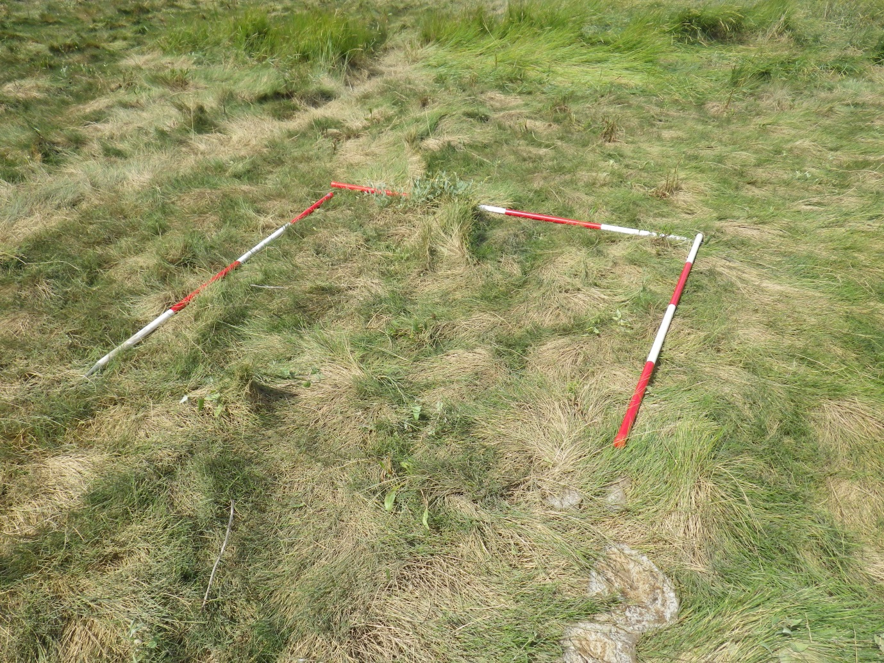
Figure 3-49 Example quadrats for NVC community SM13 (NOC4_402)
Table 3-57 NOB4 Wolferton SM13b
 | MAVIS species | Constancy
 | Elytrigia atherica | II
 | Glaux maritima | IV
 | Puccinellia maritima | IV
 | Spergularia media | III
 | Bare ground/litter/water/rock/mud | V

Table 3-58 NOB5 SM13a
 | MAVIS species | Constancy
 | Aster tripolium | V
 | Atriplex portulacoides | II
 | Puccinellia maritima | V
 | Spartina anglica | IV
 | Suaeda maritima | III
 | Atriplex prostrata | I
 | Salicornia europaea | III

Table 3-59 NOC4 Wolferton SM13a
 | MAVIS species | Constancy
 | Aster tripolium | V
 | Atriplex portulacoides | III
 | Puccinellia maritima | V
 | Spartina anglica | IV
 | Spergularia media | I
 | Atriplex prostrata | I
 | MAVIS species | Constancy
 | Elytrigia atherica | II
 | Aster tripolium | V
 | Atriplex portulacoides | IV
 | Puccinellia maritima | V
 | Spartina anglica | I
 | Atriplex prostrata | V
 | MAVIS species | Constancy
 | Aster tripolium | V
 | Atriplex portulacoides | I
 | Puccinellia maritima | V
 | Spartina anglica | IV
 | Atriplex prostrata | V
 | Bare ground/litter/water/rock/mud | I
 | MAVIS species | Constancy
 | Aster tripolium | V
 | Atriplex portulacoides | I
 | Puccinellia maritima | V
 | Spartina anglica | V
 | Atriplex prostrata | V
 | Bare ground/litter/water/rock/mud | I

Table 3-60 NOD1 Terrington SM13a
 | MAVIS species | Constancy
 | Elytrigia atherica | I
 | Aster tripolium | III
 | Atriplex portulacoides | IV
 | Puccinellia maritima | V
 | Spergularia media | III
 | Cochlearia officinalis | II
 | Atriplex prostrata | IV
 | MAVIS species | Constancy
 | Aster tripolium | V
 | Cochlearia anglica | III
 | Atriplex portulacoides | II
 | Puccinellia maritima | V
 | Spartina anglica | III
 | Cochlearia officinalis | I
 | Atriplex prostrata | V
 | Bare ground/litter/water/rock/mud | I

Table 3-61 NOD4 Terrington SM13a
 | MAVIS species | Constancy
 | Aster tripolium | V
 | Atriplex portulacoides | I
 | Puccinellia maritima | V
 | Spartina anglica | III
 | Suaeda maritima | V
 | Bare ground/litter/water/rock/mud | II
 | MAVIS species | Constancy
 | Elytrigia atherica | II
 | Aster tripolium | III
 | Cochlearia anglica | II
 | Atriplex portulacoides | II
 | Puccinellia maritima | V
 | Spartina anglica | I
 | Cochlearia officinalis | III
 | Atriplex prostrata | V

Table 3-62 L4A3 SM13a
 | MAVIS species | Constancy
 | Aster tripolium | III
 | Atriplex portulacoides | I
 | Puccinellia maritima | V
 | Suaeda maritima | I
 | Atriplex prostrata | V
 | MAVIS species | Constancy
 | Elytrigia atherica | I
 | Aster tripolium | V
 | Atriplex portulacoides | II
 | Puccinellia maritima | V
 | Suaeda maritima | II
 | Atriplex prostrata | V
 | MAVIS species | Constancy
 | Aster tripolium | V
 | Cochlearia anglica | I
 | Puccinellia maritima | V
 | Spartina anglica | V
 | Suaeda maritima | II
 | Atriplex prostrata | V
 | Salicornia europaea | II

Table 3-63 L4B2 Gedney Drove End SM13a
 | MAVIS species | Constancy
 | Algal mat | II
 | Aster tripolium | V
 | Cochlearia anglica | I
 | Atriplex portulacoides | III
 | Puccinellia maritima | V
 | Spartina anglica | II
 | Spergularia media | III
 | Suaeda maritima | III
 | Salicornia europaea | III
 | Bare ground/litter/water/rock/mud | IV
 | MAVIS species | Constancy
 | Algal mat | III
 | Aster tripolium | V
 | Cochlearia anglica | III
 | Puccinellia maritima | V
 | Suaeda maritima | I
 | Bare ground/litter/water/rock/mud | III

Table 3-64 L4C4 Holbeach SM13a
 | MAVIS species | Constancy
 | Aster tripolium | V
 | Atriplex portulacoides | V
 | Puccinellia maritima | V
 | Spartina anglica | II
 | Suaeda maritima | V
 | Bare ground/litter/water/rock/mud | I

Table 3-65 L3A5 SM13c
 | MAVIS species | Constancy
 | Aster tripolium | V
 | Cochlearia anglica | III
 | Glaux maritima | I
 | Atriplex portulacoides | V
 | Limonium vulgare | V
 | Plantago maritima | II
 | Puccinellia maritima | V
 | Spartina anglica | II
 | Spergularia media | III
 | Suaeda maritima | II
 | Triglochin maritimum | II
 | Salicornia europaea | IV
 | Bare ground/litter/water/rock/mud | V

Table 3-66 L3A5 SM13
 | MAVIS species | Constancy
 | Algal mat | I
 | Seriphidium maritimum | I
 | Aster tripolium | II
 | Cochlearia anglica | I
 | Glaux maritima | II
 | Atriplex portulacoides | V
 | Limonium vulgare | IV
 | Plantago maritima | I
 | Puccinellia maritima | V
 | Spartina anglica | III
 | Spergularia media | I
 | Suaeda maritima | IV
 | Triglochin maritimum | III
 | Salicornia europaea | III
 | Bare ground/litter/water/rock/mud | III

Table 3-67 L3B6 Wrangle SM13c
 | MAVIS species | Constancy
 | Seriphidium maritimum | I
 | Aster tripolium | III
 | Glaux maritima | II
 | Atriplex portulacoides | V
 | Limonium vulgare | IV
 | Plantago maritima | I
 | Puccinellia maritima | V
 | Spergularia media | III
 | Suaeda maritima | IV
 | Triglochin maritimum | IV
 | Cochlearia officinalis | I
 | Salicornia europaea | V
 | Bare ground/litter/water/rock/mud | IV

Table 3-68 L3B8 SM13a
 | MAVIS species | Constancy
 | Elytrigia atherica | I
 | Aster tripolium | V
 | Cochlearia anglica | III
 | Atriplex portulacoides | III
 | Limonium humile | I
 | Limonium vulgare | IV
 | Puccinellia maritima | V
 | Spergularia media | III
 | Suaeda maritima | V
 | Triglochin maritimum | I
 | Salicornia europaea | V

SM13 communities were found in wide bands throughout the mid/upper marsh, with a broad range of associate species.

SM14 Halimione portaculoides saltmarsh community Halimionetum portulacoidis (Kuhnholtz-Lordat 1927) Des Abbayes & Corillion 1949
- Includes sub-communities SM14a & SM14c
SM14 is a species-poor community with A.portulacoides as a constant species forming a shrubby canopy. P.maritima is also a constant species in this community, with frequent A.portulacoides. SM14 can occur throughout the marsh as a wide band of vegetation and is regularly present as a creek side community. The community is considered to be sensitive to grazing pressure. The SM14a sub-community (Atriplex portulacoides dominant) was assigned where cover values of A.portulacoides were >90% and often formed large bushes. SM14c (Puccinellia maritima sub-community) was assigned where A.portulacoides and P.maritima were co-dominant with frequent associate species.
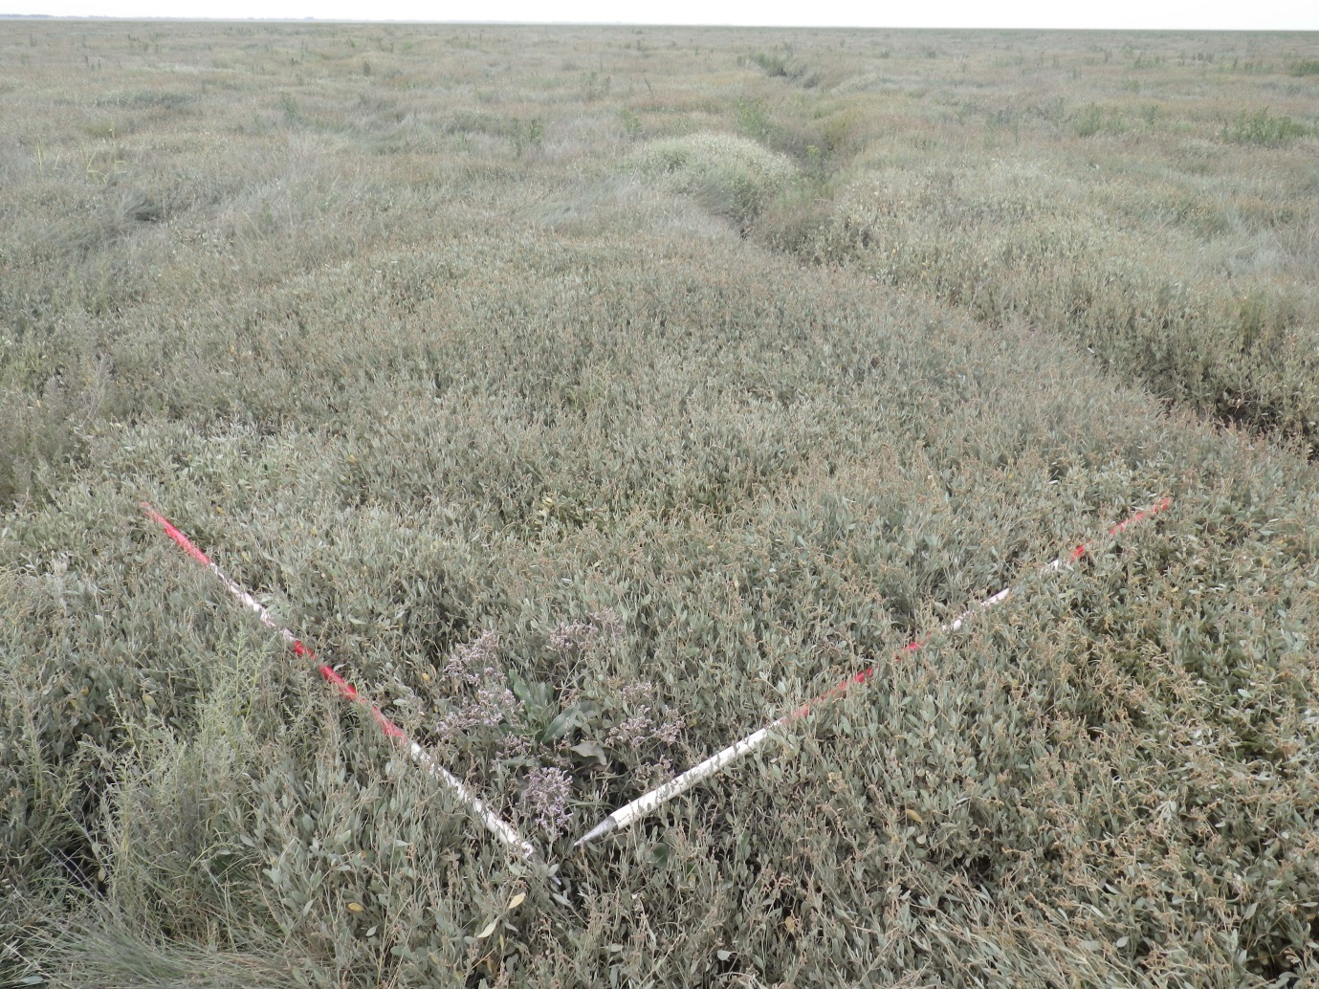
Figure 3-50 Example quadrats for NVC community SM14 (L4C4_761)
Table 3-69 NOB4 Wolferton SM14a
 | MAVIS species | Constancy
 | Elytrigia atherica | I
 | Aster tripolium | III
 | Atriplex portulacoides | V
 | Limonium vulgare | I
 | Suaeda vera | II
 | Suaeda maritima | IV
 | Atriplex prostrata | I
 | Bare ground/litter/water/rock/mud | I
 | MAVIS species | Constancy
 | Aster tripolium | V
 | Atriplex portulacoides | V
 | Suaeda maritima | V
 | Salicornia europaea | II
 | Bare ground/litter/water/rock/mud | II

Table 3-70 NOB5 SM14
 | MAVIS species | Constancy
 | Elytrigia atherica | II
 | Aster tripolium | V
 | Atriplex portulacoides | V
 | Puccinellia maritima | V
 | Spartina anglica | IV
 | Suaeda maritima | III
 | Triglochin maritimum | III
 | Atriplex prostrata | I
 | Salicornia europaea | II
 | Bare ground/litter/water/rock/mud | III

Table 3-71 NOC4 Wolferton SM14c
 | MAVIS species | Constancy
 | Elytrigia atherica | V
 | Aster tripolium | IV
 | Atriplex portulacoides | IV
 | Puccinellia maritima | V
 | Spartina anglica | II

Table 3-72 NOD4 Terrington SM14c
 | MAVIS species | Constancy
 | Aster tripolium | IV
 | Atriplex portulacoides | V
 | Puccinellia maritima | IV
 | Suaeda maritima | IV
 | Salicornia europaea | IV
 | Bare ground/litter/water/rock/mud | II

Table 3-73 L4B2 Gedney Drove End SM14
 | MAVIS species | Constancy
 | Elytrigia atherica | V
 | Aster tripolium | III
 | Atriplex portulacoides | IV
 | Puccinellia maritima | V
 | Spergularia media | I
 | Suaeda maritima | I
 | Cochlearia officinalis | II

Table 3-74 L4B2 Gedney Drove SM14c
 | MAVIS species | Constancy
 | Aster tripolium | V
 | Cochlearia anglica | I
 | Atriplex portulacoides | V
 | Puccinellia maritima | V
 | Suaeda maritima | V
 | Atriplex prostrata | I
 | Salicornia europaea | III
 | Bare ground/litter/water/rock/mud | V

Table 3-75 L4C4 Holbeach SM14
 | MAVIS species | Constancy
 | Elytrigia atherica | I
 | Aster tripolium | IV
 | Atriplex portulacoides | V
 | Limonium vulgare | I
 | Puccinellia maritima | V
 | Spergularia media | I
 | Suaeda maritima | V
 | Atriplex prostrata | I
 | Salicornia europaea | II

Table 3-76 L4C5 SM14a
 | MAVIS species | Constancy
 | Elytrigia atherica | V
 | Aster tripolium | III
 | Glaux maritima | I
 | Atriplex portulacoides | V
 | Limonium vulgare | I
 | Puccinellia maritima | IV
 | Suaeda maritima | II
 | Triglochin maritimum | I
 | Salicornia europaea | I
 | Bare ground/litter/water/rock/mud | V

Table 3-77 L4C5a SM14
 | MAVIS species | Constancy
 | Elytrigia atherica | I
 | Aster tripolium | V
 | Atriplex portulacoides | IV
 | Puccinellia maritima | V
 | Spartina anglica | I
 | Stellaria media | I
 | Suaeda maritima | IV
 | Triglochin maritimum | I
 | Atriplex prostrata | I
 | Salicornia europaea | I

Table 3-78 Frampton SM14
 | MAVIS species | Constancy
 | Elytrigia atherica | II
 | Aster tripolium | IV
 | Cochlearia anglica | I
 | Atriplex portulacoides | IV
 | Limonium vulgare | I
 | Puccinellia maritima | V
 | Spartina anglica | I
 | Spergularia media | I
 | Suaeda maritima | II
 | Triglochin maritimum | I
 | Atriplex prostrata | III
 | Salicornia europaea | I
 | Bare ground/litter/water/rock/mud | II

Table 3-79 Frampton SM14a
 | MAVIS species | Constancy
 | Aster tripolium | V
 | Atriplex portulacoides | IV
 | Puccinellia maritima | II
 | Suaeda maritima | V
 | Salicornia europaea | V
 | Bare ground/litter/water/rock/mud | III

Table 3-80 L3A3a SM14
 | MAVIS species | Constancy
 | Aster tripolium | III
 | Atriplex portulacoides | V
 | Puccinellia maritima | I
 | Suaeda maritima | IV
 | Salicornia europaea | III
 | Bare ground/litter/water/rock/mud | III
Table 3-81 L3A4 SM14
 | MAVIS species | Constancy
 | Aster tripolium | V
 | Cochlearia anglica | I
 | Atriplex portulacoides | V
 | Limonium vulgare | I
 | Puccinellia maritima | V
 | Spartina anglica | III
 | Spergularia media | II
 | Suaeda maritima | V
 | Triglochin maritimum | I
 | Salicornia europaea | IV
 | Bare ground/litter/water/rock/mud | IV

Table 3-82 L3A5 SM14c
 | MAVIS species | Constancy
 | Seriphidium maritimum | I
 | Aster tripolium | III
 | Cochlearia anglica | II
 | Glaux maritima | I
 | Atriplex portulacoides | IV
 | Limonium humile | I
 | Limonium vulgare | III
 | Plantago maritima | II
 | Puccinellia maritima | V
 | Spartina anglica | II
 | Spergularia media | IV
 | Suaeda maritima | V
 | Triglochin maritimum | I
 | Atriplex prostrata | I
 | Salicornia europaea | V
 | Bare ground/litter/water/rock/mud | III

Table 3-83 L3B6 Wrangle SM14c
 | MAVIS species | Constancy
 | Aster tripolium | V
 | Atriplex portulacoides | V
 | Limonium vulgare | I
 | Puccinellia maritima | V
 | Spartina anglica | III
 | Spergularia media | I
 | Suaeda maritima | IV
 | Cochlearia officinalis | I
 | Salicornia europaea | V
 | Bare ground/litter/water/rock/mud | V

Table 3-84 L3B8 SM14c
 | MAVIS species | Constancy
 | Elytrigia atherica | II
 | Aster tripolium | V
 | Atriplex portulacoides | V
 | Limonium vulgare | II
 | Puccinellia maritima | V
 | Spartina anglica | I
 | Suaeda maritima | IV
 | Salicornia europaea | IV
 | Bare ground/litter/water/rock/mud | II

Table 3-85 L3C6 Wainfleet SM14c
 | MAVIS species | Constancy
 | Aster tripolium | V
 | Cochlearia anglica | I
 | Atriplex portulacoides | V
 | Limonium humile | I
 | Limonium vulgare | IV
 | Puccinellia maritima | V
 | Spergularia media | I
 | Suaeda maritima | III
 | Triglochin maritimum | I
 | Salicornia europaea | II
 | Bare ground/litter/water/rock/mud | III
 | MAVIS species | Constancy
 | Aster tripolium | V
 | Cochlearia anglica | II
 | Atriplex portulacoides | IV
 | Limonium humile | II
 | Limonium vulgare | I
 | Puccinellia maritima | V
 | Spartina anglica | I
 | Suaeda maritima | IV
 | Salicornia europaea | III
 | Bare ground/litter/water/rock/mud | IV

Table 3-86 L3C6 Wainfleet SM14a
 | MAVIS species | Constancy
 | Aster tripolium | IV
 | Cochlearia anglica | I
 | Atriplex portulacoides | IV
 | Limonium humile | II
 | Puccinellia maritima | V
 | Spartina anglica | II
 | Suaeda maritima | IV
 | Salicornia europaea | V
 | Bare ground/litter/water/rock/mud | IV

Table 3-87 Seacroft SM14a
 | MAVIS species | Constancy
 | Elytrigia atherica | I
 | Aster tripolium | III
 | Atriplex portulacoides | V
 | Limonium vulgare | I
 | Puccinellia maritima | V
 | Spergularia media | I
 | Suaeda maritima | III
 | Salicornia europaea | III
 | Bare ground/litter/water/rock/mud | IV

SM14 communities were extensive and abundant throughout the mid/upper marsh. It was also present as a creekside community at almost all sites surveyed.

SM23 Spergularia marina - Puccinellia distans saltmarsh community Puccinellietum distantis Feekes (1934) 1945
SM23 is an open association of scattered individuals of S marina and P.maritima/distans. The community is characteristic of disturbed conditions, along paths and in areas poached by cattle. Without constant disturbance, the community is usually overtaken by grasses.
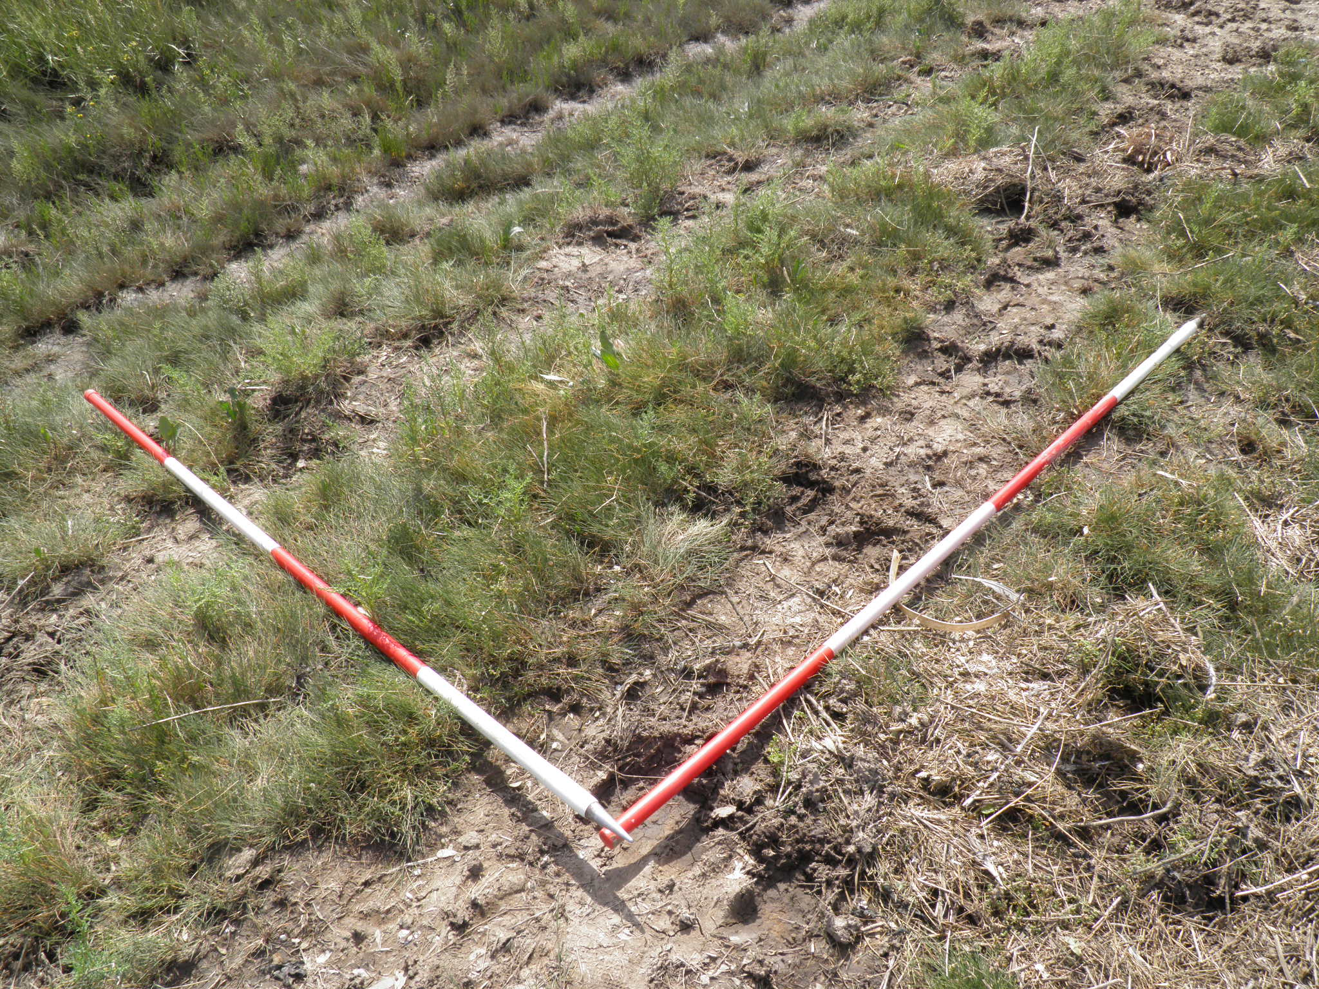
Figure 3-51 Example quadrats for NVC community SM23 (L3A4_54)
Table 3-88 L3A4 SM23
 | MAVIS species | Constancy
 | Elytrigia atherica | III
 | Aster tripolium | IV
 | Atriplex portulacoides | III
 | Hordeum marinum | III
 | Plantago maritima | III
 | Puccinellia maritima | III
 | Spergularia marina | V
 | Suaeda maritima | III
 | Atriplex prostrata | IV
 | Salicornia europaea | III
 | Bare ground/litter/water/rock/mud | IV

SM23 was found at the base of the seawall at a single site (L3A4) where regular grazing and poaching had allowed the community to thrive.

SM24 Elymus pycnanthus saltmarsh community Atriplici-Elymetum pycnanthi Beeftink & Westhoff 1962
This community is dominated by the grass E.atherica, which may form a monoculture. Other species regularly occur as an understorey, but in low abundance. SM24 is an upper marsh drift-line community. It may form a thin zone at the tidal limit or an extensive stand of the upper marsh; it can also colonise unmown seawalls. This community may also appear throughout the marsh as part of mosaics with other communities. SM24 is not sensitive to cattle grazing (Rodwell, 2000).
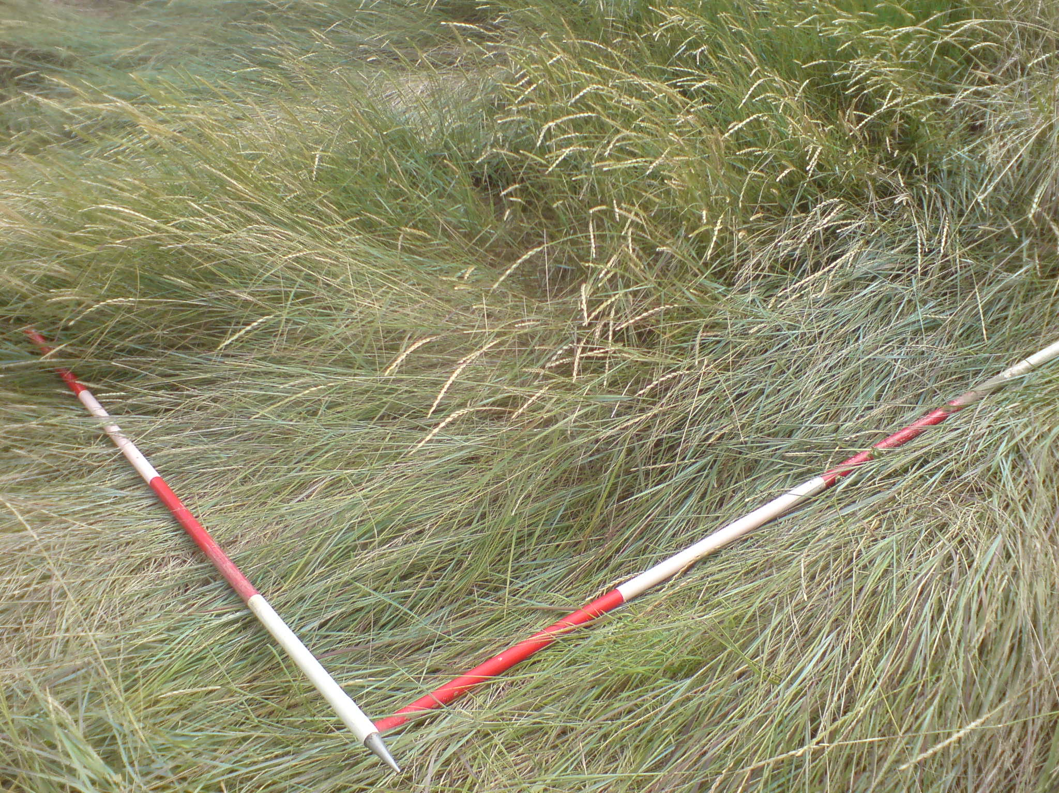
Figure 3-52 Example quadrats for NVC community SM24 (L3B7_6446)
Table 3-89 NOB4 Wolferton SM24
 | MAVIS species | Constancy
 | Elytrigia atherica | V
 | MAVIS species | Constancy
 | Elytrigia atherica | V
 | Atriplex littoralis | II
 | Atriplex prostrata | II

Table 3-90 NOB5 SM24
 | MAVIS species | Constancy
 | Elytrigia atherica | V
 | Atriplex littoralis | II
 | Beta vulgaris | III
 | Atriplex prostrata | III
 | MAVIS species | Constancy
 | Elytrigia atherica | V
 | Atriplex portulacoides | IV
 | Atriplex prostrata | III

Table 3-91 NOC4 Wolferton SM24
 | MAVIS species | Constancy
 | Elytrigia atherica | V
 | Aster tripolium | I
 | Puccinellia maritima | I
 | Atriplex prostrata | I

Table 3-92 NOD1 Terrington SM24
 | MAVIS species | Constancy
 | Elytrigia atherica | V
 | Hordeum marinum | V
 | Atriplex prostrata | V
 | MAVIS species | Constancy
 | Elytrigia atherica | V
 | Aster tripolium | III
 | Puccinellia maritima | III
 | Cochlearia officinalis | III
 | Atriplex prostrata | V
 | MAVIS species | Constancy
 | Elytrigia atherica | V
 | Aster tripolium | II
 | Atriplex portulacoides | III
 | Puccinellia maritima | I
 | Spergularia media | I
 | Atriplex prostrata | III

Table 3-93 NOD4 Terrington SM24
 | MAVIS species | Constancy
 | Elytrigia atherica | V
 | MAVIS species | Constancy
 | Elytrigia atherica | V
 | Atriplex portulacoides | V

Table 3-94 L4A3 SM24
 | MAVIS species | Constancy
 | Algal mat | I
 | Elytrigia atherica | IV
 | Atriplex portulacoides | II
 | Spartina anglica | I
 | Atriplex prostrata | II
 | Salicornia europaea | I
 | Bare ground/litter/water/rock/mud | III

Table 3-95 L4B2 Gedney Drove End SM24
 | MAVIS species | Constancy
 | Elytrigia atherica | V
 | Bare ground/litter/water/rock/mud | V
Table 3-96 L4C4 Holbeach SM24
 | MAVIS species | Constancy
 | Elytrigia atherica | V
 | Aster tripolium | I
 | Atriplex portulacoides | I
 | Suaeda maritima | I
 | Triglochin maritimum | I
 | MAVIS species | Constancy
 | Elytrigia atherica | V
 | Aster tripolium | III
 | Cochlearia anglica | I
 | Atriplex portulacoides | III
 | Puccinellia maritima | III
 | Suaeda maritima | III
 | Atriplex prostrata | II
 | Bare ground/litter/water/rock/mud | II

Table 3-97 L4C5 SM24
 | MAVIS species | Constancy
 | Elytrigia atherica | V

Table 3-98 L4C5a SM24
 | MAVIS species | Constancy
 | Elytrigia atherica | V
 | Suaeda maritima | I

Table 3-99 Frampton SM24
 | MAVIS species | Constancy
 | Elytrigia atherica | V
 | Aster tripolium | III
 | Atriplex portulacoides | I
 | Limonium humile | II
 | Triglochin maritimum | I
 | Atriplex prostrata | V
 | Bare ground/litter/water/rock/mud | IV

Table 3-100 L3A3a SM24
 | MAVIS species | Constancy
 | Elytrigia atherica | V
 | Aster tripolium | II
 | Atriplex littoralis | IV
 | Glaux maritima | II
 | Puccinellia maritima | II
 | Suaeda maritima | II
 | Atriplex prostrata | V
 | Salicornia europaea | II
 | Bare ground/litter/water/rock/mud | II
Table 3-101 L3A5 SM24
 | MAVIS species | Constancy
 | Elytrigia atherica | V
 | Seriphidium maritimum | III
 | Aster tripolium | I
 | Cochlearia anglica | I
 | Glaux maritima | II
 | Atriplex portulacoides | V
 | Limonium vulgare | I
 | Plantago maritima | II
 | Puccinellia maritima | I
 | Suaeda maritima | I
 | Salicornia europaea | I

Table 3-102 L3B7 Wrangle SM24
 | MAVIS species | Constancy
 | Elytrigia atherica | V
 | Aster tripolium | III

Table 3-103 L3C6 Wainfleet SM24
 | MAVIS species | Constancy
 | Elytrigia atherica | V
 | MAVIS species | Constancy
 | Elytrigia atherica | V
 | Aster tripolium | III
 | Atriplex portulacoides | V
 | Limonium vulgare | I
 | Puccinellia maritima | I
 | Suaeda maritima | II
 | Bare ground/litter/water/rock/mud | V

Table 3-104 L3D5 Wainfleet SM24
 | MAVIS species | Constancy
 | Elytrigia atherica | V
 | Atriplex portulacoides | II
 | Suaeda maritima | II

SM24 was found at almost all sites within The Wash, usually as a narrow band at the base of the seawall, and on the seawall itself (where it was not mown). In some drier areas, the SM24 community extended a long distance out into the marsh or was present throughout the marsh on areas of higher ground and old sea defences.

SM25 Suaeda vera drift-line community Elymo pycnanthi - Suaedetum verae (Arènes 1933) Géhu 1975
- Includes sub-community SM25b
SM25 is characterised by the constant species A.portulacoides and S.vera, usually forming a tall, shrubby cover. This is a drift-line community usually found at the saltmarsh/shingle interface. The SM25b sub-community (Atriplex portulacoides sub-community) is characterised by co-dominance of the two constant species.
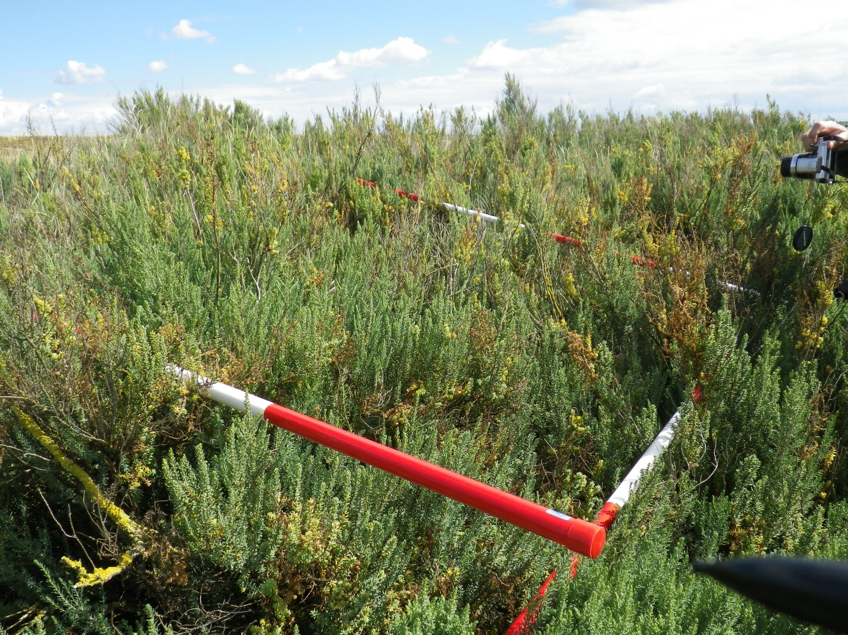
Figure 3-53 Example quadrats for NVC community SM25 (NOB4_351)

Table 3-105 NOB4 Wolferton SM25
 | MAVIS species | Constancy
 | Elytrigia atherica | III
 | Atriplex portulacoides | II
 | Suaeda vera | IV
 | Bare ground/litter/water/rock/mud | I
 | MAVIS species | Constancy
 | Elytrigia atherica | III
 | Aster tripolium | III
 | Atriplex littoralis | III
 | Beta vulgaris | III
 | Glaux maritima | III
 | Suaeda vera | V
 | Suaeda maritima | III
 | Atriplex prostrata | III
 | Bare ground/litter/water/rock/mud | V

Table 3-106 NOD4 Terrington SM25b
 | MAVIS species | Constancy
 | Aster tripolium | III
 | Cochlearia anglica | II
 | Atriplex portulacoides | IV
 | Puccinellia maritima | V
 | Suaeda vera | II
 | Suaeda maritima | IV
 | Cochlearia officinalis | II
 | Salicornia europaea | II
 | Bare ground/litter/water/rock/mud | IV

SM25 was only found at two sites on the Eastern side of The Wash. At NOB4 Wolferton, it formed a characteristic tall, shrubby cover. SM25 and S.vera was absent from most of The Wash sites.

Local and Nationally scarce species
Figure 3-54 Map showing location of local and nationally scarce species
The locations of all local and nationally scarce species recorded are reported as Appendix 4. Noteworthy species recorded were:
Shrubby Sea-blite Suaeda vera NHMSYS0000464067
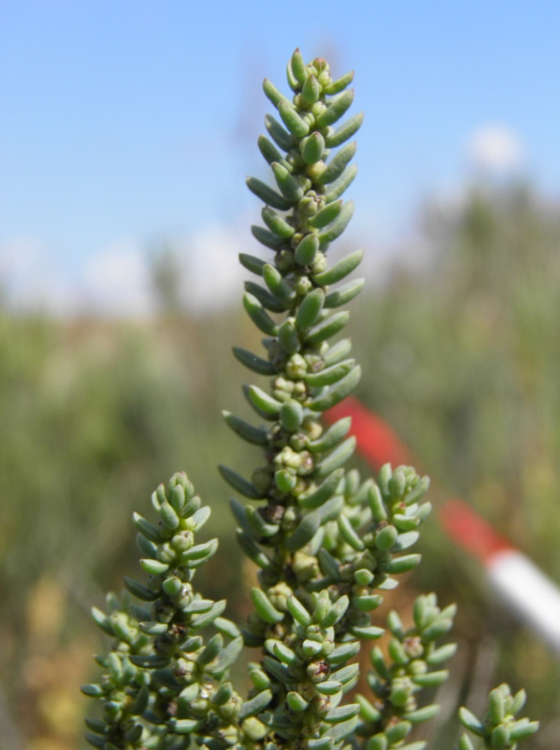
Figure 3-55 Shrubby Sea Blite Suaeda vera
- Nationally scarce (From: 2007-01-01) Occurring in 16-100 hectads in Great Britain.
This species is an occasional native of South England from Dorset to South Lincs – locally abundant on shingle above high water mark (Rose et al, 2006)
It is an evergreen shrub of shingle drift-lines and the dry upper zones of saltmarshes, especially where these adjoin shingle banks or sand dunes; also found along sea-wall drift-lines and, more rarely, beside brackish creeks and ditches in coastal grazing marshes (BRC, 2014)
This species was found at two sites (NOB4 & NOD4) in the south-western area of The Wash; associated with shingle banks.

Perennial Glasswort Sarcocornia perennis NHMSYS0000463218
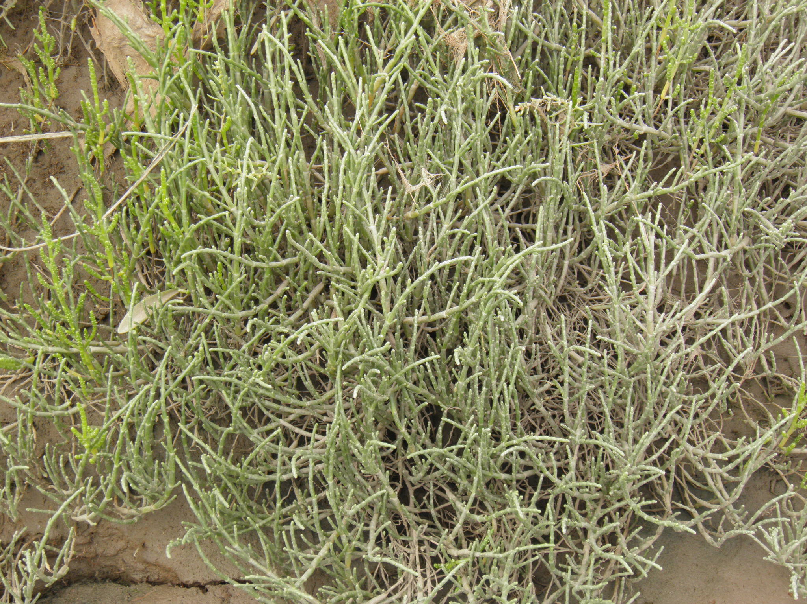
Figure 3-56 Perennial Glasswort Sarcocornia perennis
- Nationally scarce (From: 2007-01-01) Occurring in 16-100 hectads in Great Britain.
An occasional but locally abundant species of SE England. Found on upper firmer, gravelly parts of saltmarshes (Rose et al, 2006). A woody perennial subshrub of saltmarshes, especially in bare or sparsely vegetated areas on firm, muddy sand and gravel. S. perennis occurs on eroding lower parts of saltmarshes, at higher elevations on saltmarsh drift-lines and on shell and shingle banks; sometimes also on bare ground behind sea-walls (BRC, 2014).
This nationally scarce species appears to be an uncommon plant of the mid (and occasionally upper and lower) marsh, strongly associated with the sides of smaller creeks and occasionally also on the open marsh. S.perennis was recorded from a number of locations within transects and in at least one quadrat (lower marsh, Gibraltar Point), with notable populations within the Bennington and Freiston areas. S.perennis was recorded on creeksides at a number of the eastern sites, including L4C5a, L3A3, L3A4 and L3D5. It was infrequent at all these sites.

Rock Sea Lavender Limonium binervosum subsp. binervosum NHMSYS0000460355
- No UK designation – but recorded as Nationally Notable by Posford.
This species is locally abundant in England – found on sea cliffs and shingle in drier saltmarshes (Rose et al, 2006). It is a perennial herb which is almost entirely restricted to chalk sea-cliffs with a few tiny colonies on adjoining shingle and the drier parts of saltmarshes (BRC, 2014).
This species was found at 2 sites at the north-western extent of The Wash (L3D5 and Seacroft). It was associated with areas of rabbit-grazed vegetation fringing dune habitat.
Lax-flowered Sea-lavender Limonium humile NHMSYS0000459827
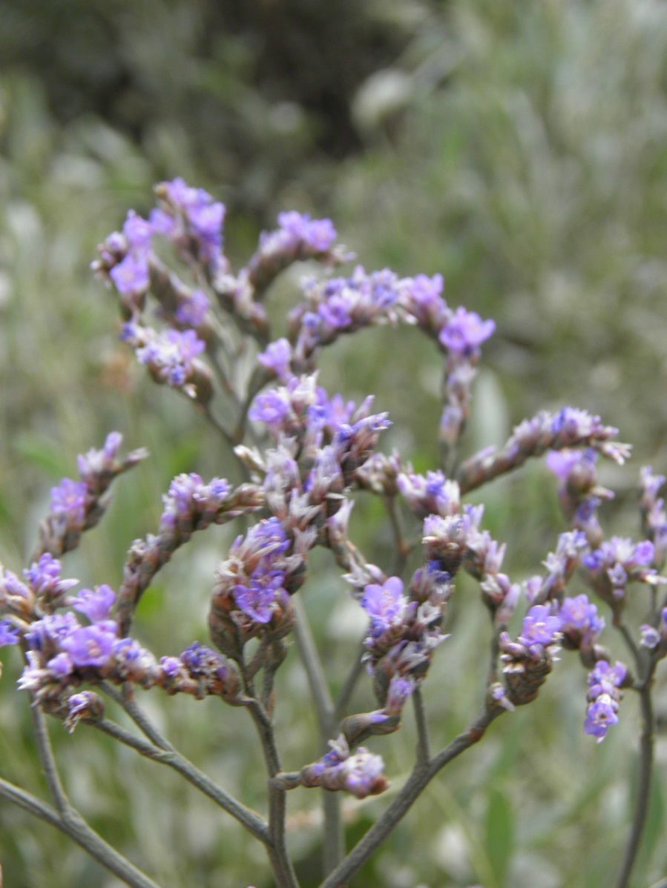
Figure 3-57 Lax-flowered Sea-lavender Limonium humile
- Nationally scarce (From: 2007-01-01) Occurring in 16-100 hectads in Great Britain.
This species is occasional and locally common in GB – it is variable and hybridizes with L.vulgare; requiring microscopic examination of pollen and stigmas for accurate identification (Rose et al, 2006). It is a perennial herb of ungrazed or lightly grazed muddy estuarine saltmarshes, often growing in close proximity to its commoner relative, L.vulgare, but replacing it in some areas. (BRC, 2014)
This species was only officially identified from some of the western sites (Frampton, L3A5, L3B8, L3C6 and L3C7). It was considered to be infrequent, but issues with field identification mean that it may have been under recorded.
Sea Barley Hordeum marinum NHMSYS0000459748
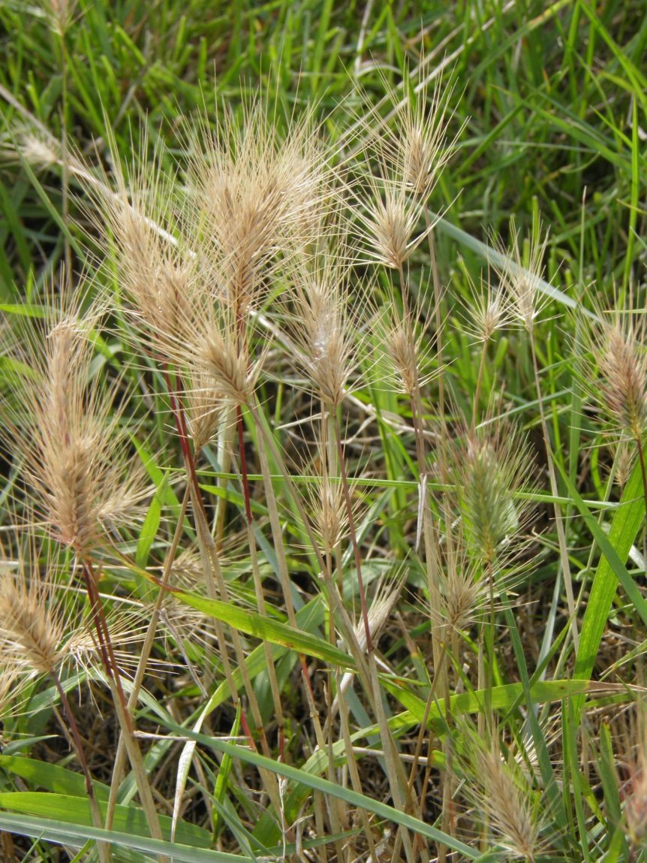
Figure 3-58 Sea Barley Hordeum marinum
- Nationally scarce (From: 2007-01-01) Occurring in 16-100 hectads in Great Britain.
- IUCN (2001) – Vulnerable (From: 2005-05-09) A taxon is Vulnerable when it is not Critically Endangered or Endangered but is facing a high risk of extinction in the wild in the medium term future.
- Natural Environment and Rural Communities Act 2006 - Species of Principal Importance in England (From: 2008-11-01) Species of principal importance for the purpose of conserving biodiversity covered under section 41 (England) of the NERC Act (2006) and therefore need to be taken into consideration by a public body when performing any of its functions with a view to conserving biodiversity.
- UK Biodiversity Action Plan priority species (From: 2007-08-28) The UK List of Priority Species and Habitats contains 1150 species and 65 habitats that have been listed as priorities for conservation action under the UK Biodiversity Action Plan (UK BAP).
This species is an annual of barish places by the sea, on the trampled margins of dried-up pools and ditches in grazing marshes, on tracks and sea walls, and in the uppermost parts of saltmarshes; also, very locally, beside salt-treated roads inland (BRC, 2014).
The distribution of sea barley around the south coast of England has become patchy as populations at the limits of its distribution disappear. These local extinctions are due to loss of appropriate habitat through filling-in of brackish land, land improvement, conversion of marshland grazing sites and construction of sea defences. These habitat losses have led to sea barley being listed as Vulnerable in the Vascular Plant Red Data List for Great Britain 2005 (Kew, 2014).
Another reason for its decline is that annuals such as Hordeum marinum are susceptible to competition from perennial species. Elytrigia atherica may take over the saline habitats previously occupied by H. marinum, a problem that can be alleviated by the continuous creation of open areas, which are essential for the establishment and persistence of sea barley (Kew, 2014).
This species was found at two sites (NOD1 & L3A4) in a disturbed area at the base of the seawall.
Yellow Glasswort Salicornia fragilis NHMSYS0000463065
- Nationally scarce (From: 2007-01-01) Occurring in 16-100 hectads in Great Britain.
This species is part of S.procumbens agg. – found on South coasts of GB; locally common on lower unconsolidated salt marshes on mud (Rose et al, 2006). An annual largely restricted to open mud and muddy sand on intertidal flats and in the lowest parts of saltmarshes (BRC, 2014).
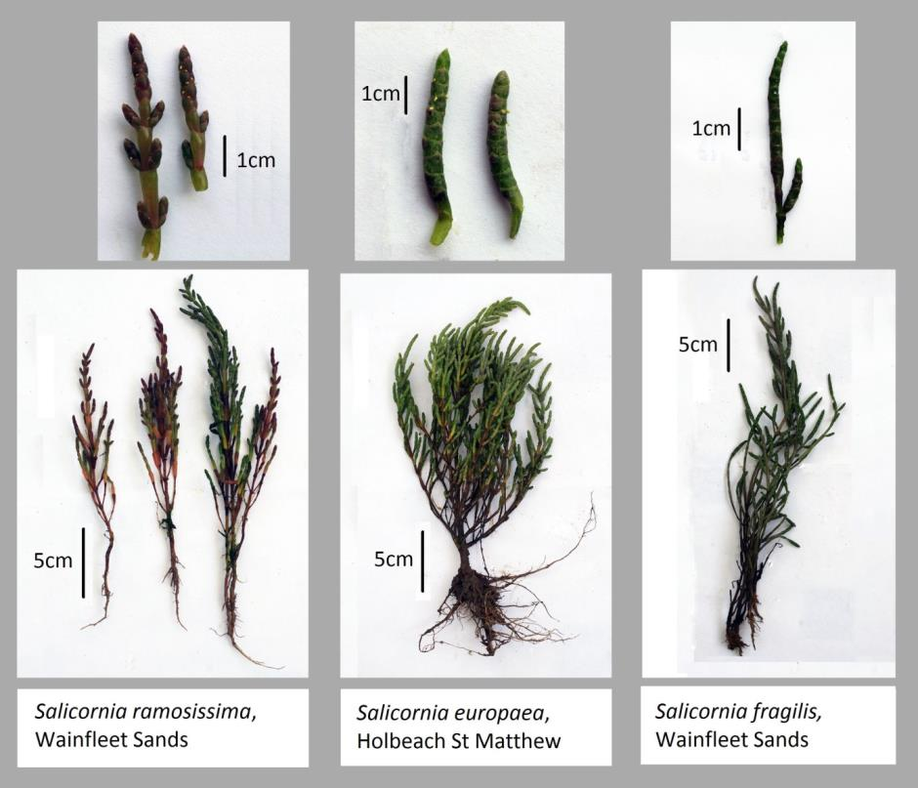
Figure 3-59 Salicornia species identified during surveys. Yellow Glasswort Salicornia fragilis furthest right
This species was officially identified at two sites (L3A3 & L3C7) but may have been under recorded due to noted issues with field identification.

Comparison with 2001/2002 Posford Haskoning surveys
This section provides a comparison of data collected during this survey with that collected in 2001/2002 by Posford Haskoning (Posford Haskoning, 2003).

Annex 1 habitats
The saltmarsh communities and subcommunities identified during the 2013 surveys were aggregated to Annex 1 habitat types based on JNCC (2005) classifications. The table presents this data for The Wash.
Table 3-107 Total transect length and percentages of NVC communities and Annex 1 habitats in The Wash during 2013 surveys
Annex 1 Habitat | NVC Community | NVC Subcommunity | Length along transect (m) | Percentage
Salicornia and other annuals colonising mud and sand | SM6 | SM6 | 1905 | 2.9
Salicornia and other annuals colonising mud and sand | SM8 | SM8 | 6237 | 9.6
Atlantic salt meadows (Glauco-Puccinellietalia maritimae) | SM10 | SM10 | 11969 | 18.4
Atlantic salt meadows (Glauco-Puccinellietalia maritimae) | SM12 | SM12 | 1857 | 2.8
Atlantic salt meadows (Glauco-Puccinellietalia maritimae) | SM13 | SM13 | 412 | 0.6
Atlantic salt meadows (Glauco-Puccinellietalia maritimae) | SM13 | SM13a | 6603 | 10.1
Atlantic salt meadows (Glauco-Puccinellietalia maritimae) | SM13 | SM13b | 8873 | 13.6
Atlantic salt meadows (Glauco-Puccinellietalia maritimae) | SM13 | SM13c | 1025 | 1.6
Atlantic salt meadows (Glauco-Puccinellietalia maritimae) | SM14 | SM14 | 9765 | 15.0
Atlantic salt meadows (Glauco-Puccinellietalia maritimae) | SM14 | SM14a | 3191 | 4.9
Atlantic salt meadows (Glauco-Puccinellietalia maritimae) | SM14 | SM14c | 4797 | 7.4
Mediterranean and thermo-Atlantic halophilous scrubs (Sarcocornetea fruticosi) | SM25 | SM25 | 604 | 0.9
 | SM25 | SM25b | 296 | 0.5
Other | SM23 | SM23 | 197 | 0.3
Other | SM24 | SM24 | 7458 | 11.4

The NVC transect data was used to calculate the relative abundances of each Annex 1 habitat type. This was based on length (m) of each community along the transects and therefore can only provide an indicative representation of abundance. Additional transect locations were included in the 2013 study. The table below compares the relative percentage contribution of each Annex 1 habitat to The Wash saltmarsh in 2001/2002 and 2013.

Table 3-108 Comparison of total percentages of Annex 1 habitats in The Wash between Posford (2003) and 2013 surveys
Annex 1 Habitat | 2001/2002 | 2013
Salicornia and other annuals colonising mud and sand | 26.0 | 12.5
Atlantic salt meadows (Glauco-Puccinellietalia maritimae) | 63.5 | 74.4
Mediterranean and thermo-Atlantic halophilous scrubs (Sarcocornetea fruticosi) | 0.1 | 1.4
Other | 10.4 | 11.7
Total | 100 | 100

Percentage of ‘Salicornia and other annuals colonising mud and sand’ has decreased from 26% to 12.5% since 2001/2002. This is a result of a reduction of SM6 and SM8 communities. This reduction in pioneer communities may be a result of erosion at the saltmarsh edge.
Atlantic salt meadows (Glauco-Puccinellietalia maritimae) has increased from 63.5% to 74.4% since 2001/2002.
Mediterranean and thermo-Atlantic halophilous scrubs (Sarcocornetea fruticosi) has increased from 0.1% to 1.4% since 2001/2002. This Annex 1 habitat was only recorded on two transects surveyed during 2001/2002 and repeated in 2013. This habitat is rare in the Wash as it is usually associated with an area of transition between saltmarsh and dune.
Figure 3-60 Map showing extent of saltmarsh feature in south-east area of The Wash
Figure 3-61Map showing extent of saltmarsh feature in north-western area of The Wash
The maps show an approximation of the geographical extent of the saltmarsh feature of The Wash. This is divided into pioneer, low/mid and upper/drift line communities.
Pioneer/Lower Vegetation
The 2001/2002 survey recorded large stands of Salicornia at the base of all saltmarshes, covering extensive mudflats. This SM8 community was found at all survey sites in 2013, except for noted exceptions with dune communities or exceptionally steep pioneer zones. As with the 2001/2002 surveys, SM6 Spartina communities were found at few sites and often only in small clumps. SM9 A.portulacoides communities were not recorded during the 2013 survey, but were found frequently during the 2001-2002 surveys. This community was not recorded in 1988 by Hill and this discrepancy may be the result of differences in NVC classification technique. This community was likely classified as SM10 or SM8 during the 2013 and 1988 surveys. SM10 was recorded as considerably more frequent during the 2013 surveys.
The SM11/SM12 Aster communities were recorded as less frequent in 2013 than during the 2001/2002 surveys. This may suggest that the marsh has matured or has been impacted by grazing.
No new saltmarsh communities were found in 2013.
Low/Middle Marsh Vegetation
SM13 and SM14 communities were frequent throughout the low/mid areas of the marshes surveyed. SM14 was mostly absent from the marsh during the 2001/2002 surveys, found only as a creek edge community. This community tolerates cattle grazing and stands may have increased due to observed grazing pressure.
The middle marsh area was more species-rich than recorded during 2001/2002 with extensive areas of SM13 and SM14.
Sub-communities SM13b and SM13c were found in 2013, but not during the 2001/2002 surveys.
Upper/Drift-line Vegetation
SM24 was found at almost all sites, at the seawall base and in raised areas throughout the marsh. The same pattern of distribution was recorded in 2001/2002. SM23 was found only at a single heavily cattle grazed site in 2013, marking a reduction in frequency of this community since 2001/2002. This community requires constant disturbance and may have been replaced by SM13 in the absence of sustained grazing pressure.
SM25 was recorded during the 2013 surveys at two sites, but was absent during the 2001/2002 surveys. This may indicate that the community has only recently spread to suitable areas in The Wash despite historically being recorded on the North Norfolk coast. These records suggest a spread of the community to shingle areas in the eastern Wash.

Evidence of disturbance/damage
The study area showed evidence of light to moderate cattle grazing. At all sites, the vegetation community maintained good structural diversity and the sequence of saltmarsh zonation was intact. The impact was most pronounced close to the seawall where intensity of poaching was higher. At these more heavily grazed sites a mosaic of pools, tussocks and short P.maritima turf was present in this upper marsh area. Grazing sensitive species were frequent and abundant throughout the survey area, including A.portulacoides (tolerates light cattle grazing) and L.vulgare.
There appears to have been no expansion of the SM6 S.anglica community in the study area.
Footpaths were mostly limited to areas along the top of sea walls. Noted exceptions were tarmac tracks in the military area, farm access and minor footpaths and wooden jetties to houseboats. There was evidence of recreational access throughout the marsh, but tracks were not heavily worn.

Conclusion

Summary of findings
- Saltmarsh communities recorded included SM6 Spartina anglica saltmarsh community, SM8 Annual Salicornia saltmarsh community, SM10 Transitional low-marsh vegetation with Puccinellia maritima, annual Salicornia species and Suaeda maritima, SM11 Aster tripolium var. discoideus saltmarsh, SM13 Puccinellia maritima saltmarsh community, SM14 Halimione portaculoides saltmarsh community, SM23 Spergularia marina - Puccinellia distans saltmarsh community, SM24 Elymus pycnanthus saltmarsh community, SM25 Suaeda vera drift-line community.
- Several nationally Notable/Scarce plant species were found during the surveys, including Suaeda vera, Sarcoconia perennis, Limonium humile and Hordeum marinum.
- Light to moderate cattle grazing was recorded in areas 1, 3, and 5. The impact was most pronounced in the area between the seawall and borrow pits. Increases in NVC community SM14 may be due to increased grazing pressure at some sites since 2001/2002.
- Footpaths were mostly limited to areas along the top of sea walls. Noted exceptions were tarmac tracks in the military area and minor footpaths and wooden jetties to houseboats. There was evidence of recreational access throughout the marsh, but tracks were not heavily worn.
- Pioneer communities have decreased since 2001/2002, possibly due to erosion.
This report presents the survey methods and results for NVC surveys of The Wash SAC. The report has mapped the distribution of NVC communities, the extent of the saltmarsh feature and has recorded the presence of rare species. This data can be used by Natural England to complete condition monitoring of the saltmarsh feature of The Wash SAC.

Bibliography
Biological Records Centre, 2014. Plant Atlas [online], URL: http://www.brc.ac.uk/plantatlas/ [Accessed January 2014].
Cheffings C. M. & Farrell L. 2005. The vascular plant red data list for Great Britain. JNCC.
Dawson, H.J & Ingrouille, J. 1995. A biometric survey of Limonium vulgare Miller and L. humile Miller in the British Isles. Watsonia 20: 239-254.
English Nature, 1981. Reasons for designating the SSSI Natural England, [online], URL: http://www.sssi.naturalengland.org.uk/citation/citation_photo/1002591.pdf [Accessed December 2013].
English Nature, 2005. The Wash Views About Management, Countryside and Rights of Way Act 2000, Schedule 11(6), [online], URL: http://www.sssi.naturalengland.org.uk/special/sssi/vam/VAM%201002591.pdf [Accessed December 2013].
JNCC, 2001. The Wash SPA description, [online], URL: http://jncc.defra.gov.uk/default.aspx?page=2003 [Accessed December 2013].
JNCC, 2004. Common Standards Monitoring Guidance for Saltmarsh Habitats. JNCC.
JNCC, 2005. Natura 2000 Standard data form – The Wash and North Norfolk Coast SAC, [online], URL: http://jncc.defra.gov.uk/protectedsites/sacselection/n2kforms/UK0017075.pdf [Accessed December 2013].
Kadereit, G., Ball, P., Beer, S.3, Mucina, L., Sokoloff, D.,Teege, P., Yaprak, A.E. & Freitag, H. 2007. A taxonomic nightmare comes true: phylogeny and biogeography of glassworts (Salicornia L., Chenopodiaceae). TAXON 56 (4) 1143.
Kew Gardens 2014. Plants & Fungi, [online], URL: http://www.kew.org/plants-fungi/ [Accessed January 2014].
Posford Haskoning, 2003. NVC Survey of Saltmarsh and Other Habitats in The Wash European Marine Site Volume 2. English Nature.
Rodwell, J.S. 1995. British Plant Communities. Volume 4. Aquatic Communities, Swamps and Tall-herb Fens. Cambridge University Press, Cambridge, UK.
Rodwell, J.S. 2000. British Plant Communities. Volume 5. Maritima Communities and Vegetation of Open Habitats. Cambridge University Press, Cambridge, UK.
Rodwell, J. S. 2006. National Vegetation Classification: Users’ handbook. JNCC.
Rose, F., O'Reilly, C., Smith, D., & Collings, M. 2006. The wild flower key: how to identify wild flowers, trees and shrubs in Britain and Ireland. Frederick Warne.
Stace, C. 1997. New Flora of the British Isles. Second edition. Cambridge University Press, Cambridge, UK.
Stace, C. 2010. New Flora of the British Isles. Cambridge: Cambridge University Press.

Appendices

Appendix 1 Risk assessment
Task element | Hazard and harmful effect | Likelihood information | Initial risk level |  |  | Control measures | Controlled risk level to employee
Task element | Hazard and harmful effect | Likelihood information | Severity (S) | Likelihood (L) | Risk level (RL) | Control measures | Severity (S) | Likelihood (L) | Risk level (RL)
Shoreline conditions | Cut off by the tide on marsh/beach. | Fieldwork is often undertaken in intertidal zones year round (e.g. Bird surveys). | 2 | 3 | 6 | Check tide timetable.  Know where the nearest high ground is.  Be aware of the state of the tide; watch for tidal surges and overtopping of banks. | 2 | 2 | 2
Shoreline conditions | Blocked return pathway by filling of creek system. | Fieldwork is often undertaken in intertidal zones year round (e.g. Bird surveys). | 2 | 3 | 4 | Check tide timetable.  Know where the nearest high ground is.  Be aware of the state of the tide; watch for tidal surges and overtopping of banks. | 2 | 2 | 2
Shoreline conditions | Slipping into a creek – risk of major injury e.g. twisted ankle, risk of drowning. | Algae covered rocks can be slippery and uneven. | 2 | 3 | 6 | Always work in pairs.  Be aware of trip hazards, blustery winds and slippery surfaces. | 2 | 2 | 2
Shoreline conditions | Getting stuck in soft mud, quick sand – risk of injury, death. | Intertidal sediment may vary depending on composition and structure. | 2 | 2 | 3 | Always work in pairs.  Be aware of trip hazards, blustery winds and slippery surfaces.  Never allow people in dubious areas at the same time. | 1 | 1 | 2
Shoreline conditions | Risk of getting lost on the marsh. | Limited visual reference and tidal fluctuations can be disorientating on large areas of marsh. | 2 | 2 | 3 | Always carry a compass and make note of which direction will lead to high ground and safety.  Carry handheld GPS and mobile mapper. | 1 | 1 | 2
Loading / unloading equipment. | Manual handling leading to musculoskeletal injury such as a prolapsed intervertebral disc. | Staff carry a large range of equipment to do work on site. | 2 | 2 | 4 | All fieldworkers must have received manual handling training.  Must be competent to assess the task for manual handling risk and to identify suitable control measure.  Assess the task for manual handling risk.  Provide first aid kit and knowledge of emergency first aid. | 2 | 1 | 2
Site access and egress | Slips, trips and falls on level leading to fractured limbs. | Staff work outdoors – often on uneven ground, slopes and when it is wet or icy. | 2 | 3 | 6 | All fieldworkers must complete the DRA.  Wear footwear with good grip on sole and ankle support when walking on uneven ground.  Consider use of walking pole. | 2 | 2 | 4
Site access and egress | Falls from height leading to death. | Staff need to use stiles and ladders to access sites. | 3 | 2 | 6 | Ensure stiles, ladders, walkways and temporary platforms are safe before use. Report unsafe structures to site owner.  All fieldworkers must use the DRA. | 3 | 1 | 3
Site access and egress | Trapping hand when opening gates or barriers leading to fractured hand. | Many of the gates and barriers are heavy and open / close in an unusual manner. Some are in a poor condition. | 2 | 2 | 4 | Look out for places where hands can get trapped when opening or closing gates or barriers.  All fieldworkers must use the DRA.  Report unsafe structures to line manager / site or land owner. | 2 | 1 | 2
Site access and egress | Branches striking face leading to moderate eye injury. | Staff are often working in areas where there is overgrown vegetation with poorly defined routes. | 2 | 2 | 4 | Fieldworkers to wear eye protection when working on site where this is a risk.  All fieldworkers must use the DRA. | 2 | 1 | 2
Site access and egress | Livestock stampede leading to fatality. | Farms visited frequently during fieldwork. | 3 | 2 | 6 | Where possible, avoid fields with cows in them and take alternative route. Be aware of triggers for stampeding in cattle – presence of dogs, cows with calves, young cattle, early spring when first released into fields, low flying aircraft or emergency services sirens. Avoid close proximity to all bulls. | 3 | 1 | 3
Site access and egress | Hazardous plants such as Giant Hogweed – contact causes blistering. | Such plants may be found on any flood bank. | 2 | 2 | 4 | Knowledge of which plants are hazardous to avoid contact. | 2 | 1 | 2.
Working on site | Hostile site owner leading to physical assault. | Occasional. | 2 | 2 | 4 | Obtaining owners approval and make presence on site known and carry ID at all times.  All fieldworkers must use the DRA. | 2 | 1 | 2
Working on site | Hepatitis A leading to liver disease / failure. | Staff may work in environments where they may be in presence of untreated sewage. | 3 | 2 | 6 | Good hygiene practices and use of gloves to EN374 that are waterproof. | 3 | 1 | 3
Working on site | Contracting tetanus – leading to fatality. | Could be caused by infection in existing wound or by new injury. | 3 | 2 | 6 | Tetanus immunisation up to date. Seek medical advice if you have a penetrating puncture wound or burn. | 3 | 1 | 3
Working on site | Lymes disease leading to systemic illness. | Staff may work in environments where they may be bitten by ticks. | 2 | 2 | 4 | Cover arms and legs. Check for ticks and if you find one, use the provided tick removal kit to remove it. See your doctor or local hospital for wound assessment following the completion of fieldwork. | 2 | 1 | 2
Working on site | Contact with sharps contaminated with blood leading Hep B, C and HIV. | These may be found in watercourses as well as fly tipped material. | 2 | 2 | 4 | Use the local authority sharps hotline who can often deal with the hazard.  Employees should seek immediate medical attention in case of a needle-stick injury. | 2 | 1 | 2
Working on site | Sun and heat leading to heat stroke and skin cancer. | Fieldwork undertaken outdoors throughout the spring and summer. | 3 | 2 | 6 | Long trousers.  Use at least Factor 30 sun block on exposed areas.  Consider adjusting the working day to avoid the hottest part of the day.  Wear sunglasses with UVA & UVB protection. Consider wide brimmed hat.  Drink plenty of water and take regular breaks. | 3 | 1 | 3
Working on site | Insect stings leading to anaphylactic shock. | Fieldwork undertaken outdoors throughout the spring and summer. | 3 | 1 | 3 | Inform manager if you have had a reaction to a sting in the past. | 2 | 1 | 2
Working on site | Working in cold and wet conditions leading to exposure & hypothermia. | Fieldwork undertaken outdoors throughout autumn and winter. | 3 | 2 | 4 | Wear warm clothing and waterproofs.  Take a spare set of clothes and flask of hot drink. | 3 | 1 | 3
Working near to water | Stumble, slips. trips and falls causing accidental partial or total immersion in water.  Drowning.  Cold water shock.  Hypothermia. | Many fieldworkers undertake work in the vicinity of water.  Site conditions can be slippery and uneven.  Water edge may be unclear due to overhanging vegetation.  Watercourses will vary in terms of depth, flow and, turbidity. | 3 | 2 | 6 | Field workers who regularly work next to water must undertake Water Safety Training.  All others to be accompanied by person who has done the water safety training and is suitably capable to brief them on hazards & be able to check any lifejackets.  You must wear a lifejacket or buoyancy aid, for additional buoyancy when:  you're working in or near turbid water where the bottom is not visible;  you're working in water that is higher than knee depth;  worn with thigh and chest waders and dry suits unless risk assessment identifies this is not necessary;  before getting on or off any vessel which can’t be securely moored, or if there’s no gangplank available  there's a reasonably foreseeable risk of immersion or drowning as identified through site or dynamic risk assessment. (As a guide not a rule if you are within 3 metres of water).  All others Buoyancy Aid only to be used if justified by written risk assessment. | 3 | 1 | 3
 |  |  |  |  |  | Footwear with good grip on sole. Also spare set of clothes and foil blanket.
Working near to water | Blue-green algae bloom and scum can produce toxins, called Harmful Algal Blooms which can cause rashes after skin contact and illnesses, including eye irritation, vomiting, diarrhoea, fever and muscle and joint pain. | Not all blue-green algae blooms and scum are toxic, but you can't tell just by looking at them, so it's best to assume they are. | 2 | 2 | 4 | Postpone task and avoid working near blue-green algae and treat as toxic and avoid skin contact.  Blue green algae on watercourses should be reported to the Environment Agency incident line 0800 807060. | 2 | 1 | 2
Working near to water | Leptospirosis (Weils Disease) potentially fatal infection causing flu like symptoms, vomiting, high temperature and muscle pains. | Bacteria may be present in any watercourse where infected animals have urinated (mainly rodents, also cattle and pigs). | 3 | 2 | 6 | Consider wearing water-resistant gloves if you’re likely to come into contact with water.  Cover all cuts, abrasions with a waterproof dressing.  Pay particular attention to personal hygiene after contact with river, lake or pond water and wash hands thoroughly.  Issue Leptospirosis cards and carry this – present to GP if feeling unwell. | 3 | 1 | 3

Appendix 2 Glossary
abundance (or cover/abundance):
The term used to describe how much of a species is present in a sample or stand, irrespective of how frequent or otherwise it is in moving from sample to sample or stand to stand.
associates:
Species recorded in less than 60% of the samples of a vegetation type, in frequency class III (41–60%), II (21–40%) or I (1–20%).
condition
The condition of the SSSI land in England is assessed by Natural England, using categories agreed across England, Scotland, Wales, and Northern Ireland through the Joint Nature Conservation Committee. There are six reportable condition categories: favourable; unfavourable recovering; unfavourable no change; unfavourable declining; part destroyed and destroyed.
constants:
Species recorded in over 60% of the samples of a vegetation type, either frequency class IV (61–80%) or V (81–100%).
Domin scale:
A ten-point scale of cover/abundance used to record the extent of species in NVC samples.
frequency:
The term used to describe how often a species is encountered in different samples or stands of vegetation, irrespective of its abundance.
homogeneous:
Used to describe uniformity of floristic composition and structure in a stand of vegetation.
mosaic:
A pattern of two or more vegetation types disposed in intimate relationship to one another.
stand:
An area of vegetation of any size.

Appendix 3 Plant species list
Table 0-1 List of saltmarsh plants identified during surveys
Latin Name | Common Name | NBN code
Armeria maritima | Sea Pink/Thrift | NHMSYS0000456077
Aster tripolium agg. | Sea Aster | NBNSYS0000004422
Atriplex littoralis | Grass-leaved Orache | NBNSYS0000003110
Atriplex portulacoides | Sea-purslane | NBNSYS0000003119
Atriplex prostrata | Spear-leaved Orache | NBNSYS0000003112
Beta vulgaris | Beet | NBNSYS0000003106
Cochlearia anglica | English Scurvygrass | NBNSYS0000002855
Cochlearia officinalis | Common Scurvygrass | NHMSYS0000457397
Elytrigia atherica | Sea Couch | NHMSYS0000458356
Festuca rubra | Red Fescue | NHMSYS0000458790
Glaux maritima | Sea-milkwort | NHMSYS0020823763
Hordeum marinum | Sea Barley | NHMSYS0000459748
Limonium binervosum | Rock Sea-lavender | NHMSYS0000460353
Limonium humile | Lax-flowered Sea-lavender | NHMSYS0000459827
Limonium vulgare | Common Sea-lavender | NHMSYS0000460364
Plantago maritima | Sea Plantain | NBNSYS0000004276
Puccinellia maritima | Common Saltmarsh-grass | NHMSYS0000462136
Salicornia agg. | Glasswort | NHMSYS0000463062
Salicornia europaea agg. | Glasswort | NHMSYS0000463064
Salicornia fragilis | Yellow Glasswort | NHMSYS0000463065
Salicornia ramosissima | Purple Glasswort | NHMSYS0000463076
Sarcocornia perennis | Perennial Glasswort | NHMSYS0000463218
Seriphidium maritimum | Sea Wormwood | NHMSYS0000463463
Silene uniflora | Sea Campion | NBNSYS0000002987
Spartina agg. | Cord-grass | NHMSYS0000463853
Spergularia marina | Lesser Sea-spurrey | NBNSYS0000003072
Spergularia media | Greater Sea-spurrey | NHMSYS0000463881
Stellaria media | Common Chickweed | NHMSYS0000464009
Suaeda maritima | Annual Sea-blite | NBNSYS0000003121
Suaeda vera | Shrubby Sea-blite | NHMSYS0000464067
Triglochin maritimum | Sea Arrowgrass | NBNSYS0000002121
Algal mat | N/A | N/A
Open Water | N/A | N/A
Sand/mud | N/A | N/A

Appendix 4 Local and Nationally Scarce Species
Table 0-2 Location data for notable plant species
Plant Species | NGR
Hordeum marinum | TF4253045640
Hordeum marinum | TF4253945661
Hordeum marinum | TF4254245666
Hordeum marinum | TF5709025901
Hordeum marinum | TF5709525895
Limonium binervosum | TF5620057600
Limonium binervosum | TF5662861009
Limonium binervosum | TF5672160954
Limonium humile | TF5320056300
Limonium humile | TF5620057600
Limonium humile | TF3614337789
Limonium humile | TF3617837785
Limonium humile | TF3631637630
Limonium humile | TF4427548165
Limonium humile | TF5036253480
Limonium humile | TF5181055059
Limonium humile | TF5200254940
Limonium humile | TF5203254926
Limonium humile | TF5212554871
Limonium humile | TF5220754808
Limonium humile | TF4427548165
Salicornia fragilis | TF4100041100
Salicornia fragilis | TF5350056100
Sarcocornia perennis | TF4030042000
Sarcocornia perennis | TF4269045560
Sarcocornia perennis | TF3748336630
Sarcocornia perennis | TF5601257447
Suaeda vera | TF6488430397
Suaeda vera | TF6488130396
Suaeda vera | TF6487330397
Suaeda vera | TF6486630402
Suaeda vera | TF6478830437
Suaeda vera | TF6477430475
Suaeda vera | TF6476030479
Suaeda vera | TF6467530732
Suaeda vera | TF6467430765
Suaeda vera | TF5431126514
Suaeda vera | TF5431126514

