[Document title - limit to 10 words]
[Document subheading - optional, delete if not needed]
[Month] [Year]
Natural England Commissioned Report [NECRXXX]
www.gov.uk/natural-england

About Natural England
Natural England is here to secure a healthy natural environment for people to enjoy, where wildlife is protected and England’s traditional landscapes are safeguarded for future generations.

Further Information
This report can be downloaded from the Natural England Access to Evidence Catalogue. For information on Natural England publications or if you require an alternative format, please contact the Natural England Enquiry Service on 0300 060 3900 or email enquiries@naturalengland.org.uk.

Copyright
This publication is published by Natural England under the Open Government Licence v3.0 for public sector information. You are encouraged to use, and reuse, information subject to certain conditions.
Natural England images and photographs are only available for non-commercial purposes. If any other photographs, images, or information such as maps, or data cannot be used commercially this will be made clear within the report.
For information regarding the use of maps or data see our guidance on how to access Natural England’s maps and data.
© Natural England [202X]
Catalogue code: [NECRXXX]

Report details
Author(s)
[List author details]
Natural England Project Manager
[List Natural England Project Manager details]
Contractor
[List contractor details. You can also include the contractor’s logo on this page in the bottom right corner.]
Keywords
[List keywords related to the content, separated by commas]
Acknowledgements
[Name any individuals or organisations you wish to acknowledge for contributing to the report. Delete this section if it is not required.]
Citation
[AUTHOR]. [Year]. [Title]. [NECRXXX]. Natural England.

Foreword
[All commissioned reports must include a foreword explaining why Natural England commissioned the work and how the findings have been, or will be, used. This should be written by the Natural England project manager.
The foreword must also include the following disclaimer text:
Natural England commission a range of reports from external contractors to provide evidence and advice to assist us in delivering our duties. The views in this report are those of the authors and do not necessarily represent those of Natural England.]

Executive summary
[All technical reports require an executive summary. Write in plain English and break up the content, for example with meaningful sub-headings and lists of key points.
Where you need to use technical terms, explain what they mean at first usage. For more information refer to Writing well for specialists (GOV.UK).
The summary should be no more than two pages long.]

Contents
Document guidance 7
Accessibility 7
Audience first 7
Document properties 8
Structure and headings 9
Visual content 10
Tables 13
Lists 15
Abbreviations 15
Links 15
References 17
Referencing online material 17
In-text citations 18
Glossary 19
Appendices 20

Document guidance
[Guidance and prompts for information in this template are displayed in square brackets.
You must follow this guidance if you plan to publish a document on the Natural England Access to Evidence Catalogue. Then delete this entire ‘Document guidance’ section.
You must:
- follow the template and do not make any changes of your own, including to heading styles and font sizes
- submit the final version as a Word file (not PDF) to the Natural England project manager.
If you believe you have a genuine need to deviate from the styling of these templates, you must gain approval from the Defra Branding Team before starting work.

Accessibility
All content published on the Access to Evidence Catalogue must be accessible. This means making sure that anyone can use it, regardless of differences or impairments. All content must meet level AA of the Web Content Accessibility Guidelines (WCAG 2.1) as a minimum, in line with government accessibility requirements (Public Sector Bodies Accessibility Regulations (2018)).
Follow the guidance in this report template to ensure you produce a properly structured document. A properly structured Word document will convert into an accessible PDF publication. This is essential for meeting legal requirements.
Use Word’s in-built accessibility checker to check your report (go to ‘Review’ in the ribbon menu and choose ‘Check Accessibility’) and correct any issues before submitting it for publication.

Audience first
Use plain English and be concise. Do not use opinion that is not backed up with evidence. We have provided specific guidance within this template.
Key points:
- text should always be left aligned (not justified) for maximum legibility
- use bold for emphasis or to highlight important information, but use it sparingly
- only underline text for links
- avoid using italics
- do not use italics for quotes and blocks of text
- avoid using all capital letters for words
- use descriptive text for hyperlinks, never “click here” or “read more”
- use meaningful headings and sub-headings
- avoid unnecessary jargon
- include a glossary if technical terminology is used and provide definitions in simpler language

Document properties
You must remove your personal information and add the title of the document to its properties:
- save and rename your document, then right-click the file name
- select 'Properties' > 'Details' > 'Remove Properties and Personal Information'
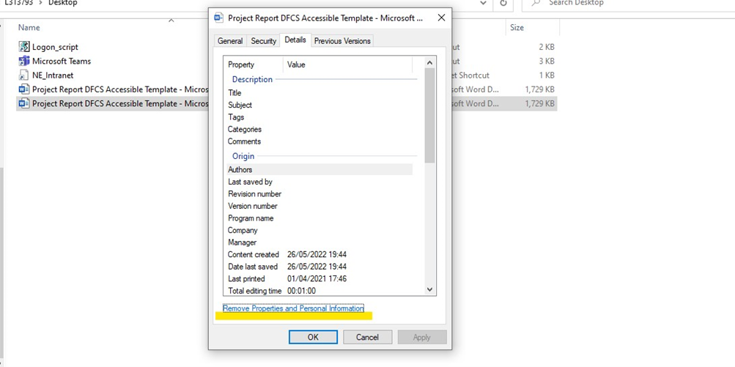
- select the option to 'Remove the following properties from this file'
- tick the boxes for 'Authors' and 'Last saved by'
- add your document ‘Title’, ‘Subject’ and ‘Tags/Keywords’, then click OK.
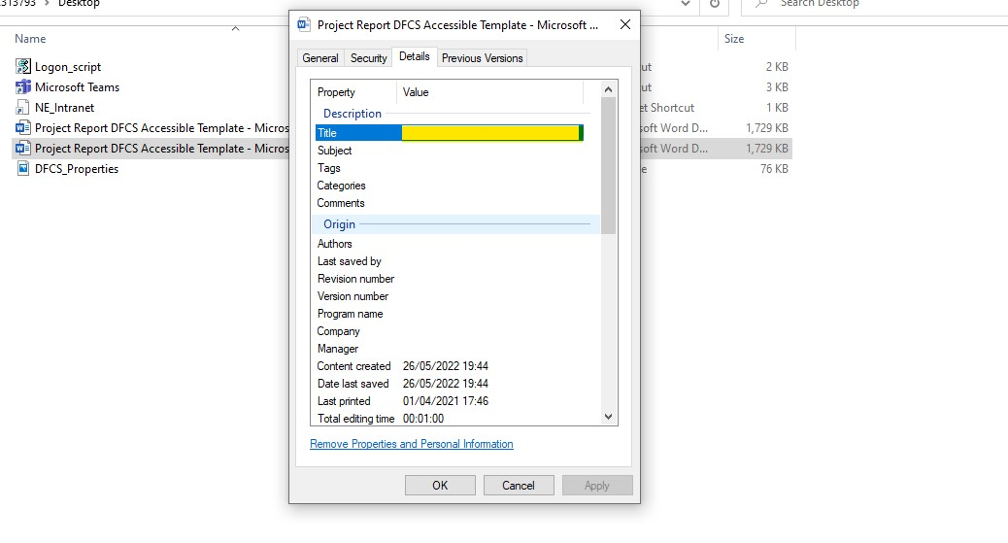
The title must be completed correctly and meaningfully. The author is always Natural England.
Screen reader users rely on descriptive title properties to inform them of the document’s purpose and content. Title and author fields are also used by search engines to index PDF files.

Catalogue codes
All technical reports must have a Natural England catalogue code (e.g., NECR001). A catalogue code will be assigned to the report by a Natural England staff member before publication.

Structure and headings
You must use heading levels to break up your content and provide a sensible structure.
Headings must be meaningful to help users navigate the document and find the information they need.
You must use the heading styles (for chapters, sections, subsections, annexes) provided in this template. These can be found in the ‘Styles’ section of the ‘Home’ tab in the ribbon menu. You should not modify these.
The body text should be in ‘Normal’ style.
There are five heading styles:

Heading 1 (H1)

Heading 2 (H2)

Heading 3 (H3)

Heading 4 (H4)

Heading 5 (H5)
Use ‘Heading 1’ style for main headings. Use heading levels 2-5 for sub-headings that follow in a logical hierarchical structure.
When writing headings, you should:
- use headings in order – do not skip a heading level (for example, do not go from H2 to H4)
- keep headings short and descriptive
- start with a capital letter and then continue in lower case.
You should not use:
- questions as headings
- technical terms, unless you have already explained them
- heading styles based on how they look – you need to use them in order.

Visual content
Only use visual content (for example images, charts, graphs, diagrams), if it:
- provides context for your content
- helps users understand information in a different way
Visual content should be high resolution and as large as possible without being grainy.
Images must be aligned left and positioned in line with text.
Do not use images of text, assistive technology will not pick it up. Instead, write out the text in the body of the report (referencing the source if necessary).
If images of text must be used, ensure that the text is clear at 200% zoom and the information is reproduced either in the body text or in the alternative (alt) text field (see the Alternative (alt) text section.
Add a caption to visual content and format the text using the ‘Caption’ style. Use captions to:
- label and explain visual content
- include copyright attributions
- name a person in a photo
Do not use phrases such as “see below” or “the figure above highlights…” when referring to visual content in the body text. This can be confusing for people using assistive technology who may be navigating the content differently. Instead, be specific, for example, “see Section 2.1” or “Figure 1 highlights…” and use the cross-reference function.

Describing visual content
Make sure key information is not presented using visuals or graphics alone. This allows all users, including those who cannot see, to access the content provided.
You can describe visual content either by:
- putting a written explanation in the body text (this is the preferred option)
- writing ‘alt text’ – this sits behind the image and is picked up by assistive technology.
Decorative images do not need describing.

Alternative (alt) text
Alt text is only necessary if you cannot provide a written explanation of visual content within the body text.
To add alt text right-click on the object and choose ‘Edit alt text…’.
Do not use the automatically generated alt text Word offers, it is often inadequate.
Do not duplicate alt text if you have written a description in the body text. This causes ‘auditory clutter’ for screen reader users.
If you can, describe the content of the image as though there is no image on the page. For example, write “the health minister tweeted…”, instead of “an image of a tweet by the health minister”.

Colour
Do not rely on colour alone to convey information (for example in graphs, maps, or colour coding). Instead use a combination of colour, shape, and text. This ensures it is accessible for users who have a colour vision deficiency. For example, people with moderate colour vision deficiency will only be able to accurately identify five or so coloured pencils from a standard box of 24. One way to check the content is to determine if it would be fully understandable in black and white.
In visuals which use different colours next to each other, ensure there is a high enough colour contrast ratio between segments, lines, text, and background colour. Use the WebAIM contrast checker tool to ensure the contrast ratio of colours meets WCAG 2.1 level AA requirements for text and graphics. This ensures users, especially those with moderately low vision, can determine between the different coloured elements.

Maps
Include a title and description of the map written in text (not included as part of the image) that details the key information and findings.
If the map presents multiple locations, provide an accompanying list of locations in the text.
Ensure that all elements of the map, such as text, are clear at 100% zoom and still legible at 200%.
Present copyright or license information that accompanies the map as text in the caption (not included as part of the image).
Check that all content presented using colour achieves a contrast ratio of at least 3:1 against background colours (use the WebAIM contrast checker tool). This also applies to their related legends and keys.
Make sure there is enough contrast between the text and the background for any colour-coded regions. Ensure there is also sufficient contrast at the boundaries between adjoining colours so that users can distinguish between them.

Charts and graphs
Create a chart or graph by clicking ‘Insert’ in the ribbon menu and choosing ‘Chart’.
Do not copy and paste a chart or graph from another document.
Summarise patterns, trends and anomalies in graphs and charts in the body text near the graph.
If you do use alt text to describe charts or graphs, refer to the Office for National Statistic’s alt text guidance for further advice.

Image copyright
If you are using images or photographs, make sure you hold the copyright or have permission to re-use the image. For more details see Defra’s Image Copyright Standards.
Always attribute images correctly to their source.
You do not need permission to reuse or adapt Open Government Licence images. Open Government Licence images are covered by ‘Open Government Licence v3.0’, referred to in the Copyright section of this template.
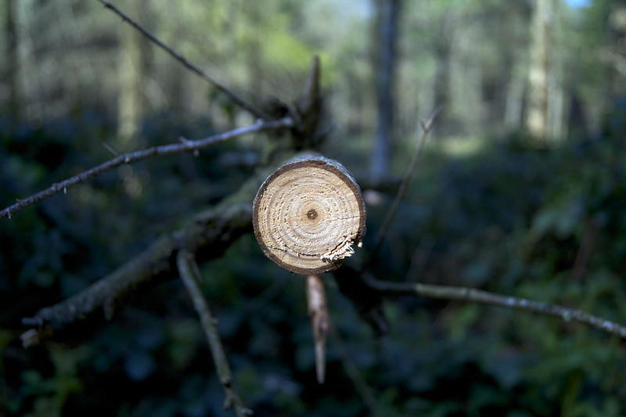
You must credit all Creative Commons images and all third-party images you have used. Make sure you meet all the terms of the licence. For Creative Commons images, link to the original photo with the photographer’s name and link to the specific licence (for example ‘CC BY 2.0’) with the words ‘Creative Commons’. For example:
Photo: The Circle of Life by Phil Dolby on Flickr. Used under Creative Commons (CC BY 2.0).
For third-party images that require permission to republish, ensure that you receive written permission from the rights holder. This should then be stored in the report’s TRIM file for a clear audit trail.
For further advice about copyright please contact Defra Library Services or Natural England Publications.

Tables
Tables should only be used to present data.
Never use tables for cosmetic changes to layout, for example, to present a list.
Keep tables simple and use our default table style (refer to the 'Inserting a Table' section).
Do not include images of tables, these will likely fail accessibility requirements.
Make sure you use descriptive headings.
Ensure that the header row is marked and repeats over pages.
Wrap text within cells to ensure all text is visible.
Do not merge or split cells, it makes navigation difficult and table structure hard to understand for assistive technology.
Remove any blank rows and columns.
Do not leave cells empty. If cells must be left without data, include a note above the table explaining that some cells are left blank and why. Otherwise, users may not be able to determine if empty cells are intentionally blank or if the data is missing. They can also cause confusion for users of assistive technology.
If you need to add notes to a table, do not use symbols (such as ‘*’ or ‘†’) or superscript. Instead, put information at the point of need or use a letter as shorthand. Use square brackets to refer to notes within a table.
Use the word ‘note’ and a number when referring to detailed notes, for example: ‘[note 1]’. Refer to Symbols, footnotes and codes (Government Analysis Function) for further guidance.

Inserting a table
To create a table:
- click on ‘Insert’
- then ‘Table’ and choose how many cells you need
Table 1 Example of a table
Country | 2018 | 2019 | 2020 | 2021  [note 1] | 2022
Example 1 | 1 | 1 | 2 | 2 | 1
Example 2 | 1 | 2 | 2 | 1 | 4
Example 3 | 1 | 3 | 2 | 1 | 4
Source: [include reference and copyright information relating to data].
Note 1: [note 1 explanation].

Lists
- use round bullet points for short, snappy content for lists
- only use numbered bullets for a sequential list.

Abbreviations
- Only use an abbreviation if it improves readability for the user.
- Do not abbreviate a term if it is repeated less than three times in the text.
- Expand all abbreviations in parenthesis after their first use (unless they are well known and in common use, for example, UK, EU, VAT).
- If several abbreviations are included within the body text, compile them in a separate list of abbreviations at the beginning of the report, after the table of contents.

Links
Links must be accessible and take users to trusted information.
Make links descriptive so that the user knows where they are going, and they make sense in isolation.
Keep link text concise.
Use them in context, not in a list at the bottom of a section.
Check all your links are working and they are formatted using the ‘Hyperlink’ style before submitting for publication.

Websites
When linking to websites you should:
- Make sure that all links in the body text contain descriptive link text.
- Use the title of the document or destination page being linked to. This allows all users to understand the link’s purpose and destination. For example, “Read the 25 year environment plan”.
- Link to the page that contains the relevant information, not a homepage.
- Direct users to where the user can find the PDF, not the PDF itself – this can cause broken links.
You should not:
- List full URLs in body text. Screen reader users must listen to the entire link text which can often be a lengthy mix of letters, numbers, and slashes.
- Use phrases such as “click here” or “read more”, these are not descriptive and do not provide enough context in isolation.
- Link to short-lived webpages.
- Use the same link text to link to different pages.
For websites in references see the ‘References’ section.

Cross-references
Cross-references make it easier for readers to navigate the report. Use them to link to other parts of the document, such as a figure or a different section of the document.
To insert a cross-reference, click the ‘Insert’ tab and choose ‘Cross-reference’. Visit Microsoft's ‘Create a Cross-reference’ page for more guidance.]

References
[Include the list of references in this section and sort alphabetically by author, for example:
Campbell-Palmer, R., Puttock, A., Graham, H., Wilson, K., Schwab, G., Gaywood, M., and Brazier, R. 2018. SNH Research Report 1013 - Survey of the Tayside area Beaver population 2017-2018. Scottish Natural Heritage.
Gaywood, M. (Ed.). 2015. Beavers in Scotland: A Report to the Scottish Government. Scottish Natural Heritage, Inverness. Available at: www.nature.scot/doc/beavers-scotland-report-scottish-government (Accessed: 01.01.2022).
Hartman, G. 1995. Patterns of spread of a reintroduced beaver (Castor fiber) population in Sweden. Wildlife Biology, 1, 97-103.
Hartman, G. 1997. Notes on age at dispersal of beaver (Castor fiber) in an expanding population. Canadian journal of Zoology, 75, 959-962.
All authors' names should be listed (no matter how many there are) for each entry in the reference list.
For three or more authors always separate the final two authors with ‘and’ (not ‘&’) as shown in the example list.
Ensure all third-party material has been accurately cited, both in the body text and within the reference list.

Referencing online material
All links in the main body of the report should contain descriptive text (refer to the 'Websites' section). However, in the reference list, you should spell out the website addresses of your links.
Do not include “http://” when spelling out the address (unless the URL does not contain “www.”). For example, we would write www.gov.uk and not https://www.gov.uk.
Include the document’s Digital Object Identifier (DOI) when available. If this is not available, link to the publication’s page on the publisher’s website. Avoid linking to the PDF document, which is more likely to be removed or changed.
Include the date last accessed in brackets after the link when referencing webpages. For example: (Accessed: 01.01.2022).

In-text citations
In-text citations should consist of the author's surname and relevant year within brackets. For example (Smith, 2022).
Where more than one reference is cited at the same time, separate them with a semi-colon. For example (Smith, 2022; Defra, 2020).
Where the author’s name is mentioned as part of the text, only include the date of the reference in brackets. For example, ‘Smith (2022) reported that…’.
Where two authors are responsible for a reference their names should be linked with an ampersand. For example (Smith & Jones, 2022).
If three authors are responsible for a reference, link the last two names with an ampersand. For example (Smith, Jones & Graham, 2022)
Where more than three authors are responsible for a reference, remove all but the first name and add ‘and others’. For example (Smith and others, 2022).
Where an author is responsible for two or more references in the same year, distinguish them with letters. For example, (Defra, 2022a; Defra, 2022b). Ensure the letters are also included in the full references.
You must include the full details of all in-text citations in the reference list.]

Glossary
[This is optional. Use a glossary to alphabetically list words, phrases, and abbreviations with their definitions in plain English.
Avoid jargon and only use technical terms when necessary. Where you need to use technical terms, explain what they mean at first usage in the body text and if there are only a few definitions, do not add a separate list.]

Appendices
[Number each appendix or annex and make sure they are referred to within the main body of the report.
Appendices/annexes can either be included within the report itself or published as a separate document (if appropriate).
If an appendix is published separately, you should still refer to it in the main report. It will be published under the same Natural England catalogue code as the main report and be available for download on the same Access to Evidence Catalogue webpage. However, it requires its own copyright statement.]
www.gov.uk/natural-england

